Balancing Clean Energy Transitions

and

Revenue-Raising Strategies

A Conceptual Tool for Policymakers

By: Gariel Toscano, Lucie Christian, Meghan Durkin, Ryan Hutchins

**Duke University, Sanford School of Public Policy**

Spring 2025

Most Native American land is trust land, with around 56 million acres of land being held in trusts for various tribes and individuals by the U.S. government.[29](https://docs.google.com/document/d/1Tng4jrmN1WNZ2GesDEHIEzQMZd77Y-E-xqK3g0b_J08/edit#bookmark%3Did.7q94epooc0kp) Similarly, natural resources on Native American land can be held in trust for a tribe or individual, or it can be owned by them as restricted-fee land. While new types of legal agreements have given greater control to tribes over their natural resources, approval by the federal government remains necessary at some point in the process.[30](https://docs.google.com/document/d/1Tng4jrmN1WNZ2GesDEHIEzQMZd77Y-E-xqK3g0b_J08/edit#bookmark%3Did.foyn53jmtoc0) Revenue from natural resource extraction is collected through royalty payments and land leases by the Department of the Interior (DOI) and deposited into trust accounts managed by the Office of the Special Trustee for American Indians (OST), where it can then be collected directly by tribes.[31](https://docs.google.com/document/d/1Tng4jrmN1WNZ2GesDEHIEzQMZd77Y-E-xqK3g0b_J08/edit#bookmark%3Did.pj3gbq1nuu81) [32](https://docs.google.com/document/d/1Tng4jrmN1WNZ2GesDEHIEzQMZd77Y-E-xqK3g0b_J08/edit#bookmark%3Did.la2e4w9dwl30) Tribes may request that payments from natural resource extraction be made directly to them, but these requests must be approved by the Bureau of Indian Affairs (BIA).[33](https://docs.google.com/document/d/1Tng4jrmN1WNZ2GesDEHIEzQMZd77Y-E-xqK3g0b_J08/edit#bookmark%3Did.dsk6oh6rsv2i)

### Tribal Revenue from Fossil Fuels

There are huge quantities of fossil fuels located on tribal lands. 20 percent of the United States’ known reserves of oil and gas are on tribal lands.[34](https://docs.google.com/document/d/1Tng4jrmN1WNZ2GesDEHIEzQMZd77Y-E-xqK3g0b_J08/edit#bookmark%3Did.ip1tysy5o69f) Natural resources such as fossil fuels are an important source of revenue for many of these tribal communities. In 2019, the Department of the Interior dispersed $1 billion dollars in natural resource revenue to tribes and allottees.[35](https://docs.google.com/document/d/1Tng4jrmN1WNZ2GesDEHIEzQMZd77Y-E-xqK3g0b_J08/edit#bookmark%3Did.k8995h5b38g0) The Bakken shale formation generates billions of dollars in revenue for the Mandan, Hidatsa, and Arikara Nation in North Dakota. Other tribes with significant oil assets include the Osage in Oklahoma, the Navajo (Diné) in the Southwest, and various Native corporations in Alaska. The Southern Ute Indian Tribe operates one of the most advanced natural gas production systems in the country. The Navajo-owned operation in the Aneth field of southern Utah earns between $28 million and $35 million annually. Native American lands also contain significant coal reserves, mines, and power plants. The Navajo, Hopi, and Crow tribes have both active and untapped coal deposits. The Uintah, Ouray, Fort Berthold, Northern Cheyenne, and Zuni also possess coal reserves with development potential.[36](https://docs.google.com/document/d/1Tng4jrmN1WNZ2GesDEHIEzQMZd77Y-E-xqK3g0b_J08/edit#bookmark%3Did.osmpexjygyc2) The extraction of these fossil fuels contributes to local economies, provides jobs, and is a major source of revenue for many tribal nations.[37](https://docs.google.com/document/d/1Tng4jrmN1WNZ2GesDEHIEzQMZd77Y-E-xqK3g0b_J08/edit#bookmark%3Did.6zexxsldv69q)

### Clean Energy Transitions in Tribal Communities

Approximately 6.5 percent of the total utility-scale energy potential in the U.S. is on tribal lands. For many tribes, this represents an opportunity to reduce dependence on fossil fuels and increase the sovereignty of their nations. Some tribal nations are already transitioning away from fossil fuels. In 2019, both the Kayenta coal mine and the coal-fired Navajo Generating Station in northern Arizona were closed by the majority owning utility company, Salt River Project, due to a decline in the coal industry and increased competition from clean energy. These closures resulted in the loss of tens of millions of dollars in tax revenue for the Navajo Nation and hundreds of jobs for its citizens.[38](https://docs.google.com/document/d/1Tng4jrmN1WNZ2GesDEHIEzQMZd77Y-E-xqK3g0b_J08/edit#bookmark%3Did.ek8lv8kddjyr) The Hopi Tribe also faced a sudden economic shift after these closures, which resulted in the loss of over 1,000 jobs and an 85% decline in tribal revenue.[39](https://docs.google.com/document/d/1Tng4jrmN1WNZ2GesDEHIEzQMZd77Y-E-xqK3g0b_J08/edit#bookmark%3Did.9fh8clfxmsuc) Fortunately, these losses were offset by the opening of two major solar farms, collectively known as the Kayenta Solar Farm, which is the largest tribally-owned solar plant in the U.S. It will generate 55 megawatts of utility-scale electricity and has created thousands of jobs during construction, 90% of which went to tribal citizens.[40](https://docs.google.com/document/d/1Tng4jrmN1WNZ2GesDEHIEzQMZd77Y-E-xqK3g0b_J08/edit#bookmark%3Did.k69wgoii79h6) The low cost of generating solar power along with the high demand for clean energy in western states is driving a significant increase in tribal interest in solar energy, especially among tribes that do not have access to natural resource reserves.

|  |  |
| --- | --- |
| **Table of Contents**  [**Executive Summary**](https://docs.google.com/document/d/1Tng4jrmN1WNZ2GesDEHIEzQMZd77Y-E-xqK3g0b_J08/edit?tab=t.0&heading=h.2ntpjjfjnbc8) | [**2**](https://docs.google.com/document/d/1Tng4jrmN1WNZ2GesDEHIEzQMZd77Y-E-xqK3g0b_J08/edit?tab=t.0&heading=h.2ntpjjfjnbc8) |
| [**Background**](https://docs.google.com/document/d/1Tng4jrmN1WNZ2GesDEHIEzQMZd77Y-E-xqK3g0b_J08/edit?tab=t.0&heading=h.s2kcn5ne1yuv) | [**3**](https://docs.google.com/document/d/1Tng4jrmN1WNZ2GesDEHIEzQMZd77Y-E-xqK3g0b_J08/edit?tab=t.0&heading=h.s2kcn5ne1yuv) |
| [**Conceptual Analysis Framework**](https://docs.google.com/document/d/1Tng4jrmN1WNZ2GesDEHIEzQMZd77Y-E-xqK3g0b_J08/edit?tab=t.0&heading=h.q8z003y8c6n1) | [**3**](https://docs.google.com/document/d/1Tng4jrmN1WNZ2GesDEHIEzQMZd77Y-E-xqK3g0b_J08/edit?tab=t.0&heading=h.q8z003y8c6n1) |
| [**Methodology**](https://docs.google.com/document/d/1Tng4jrmN1WNZ2GesDEHIEzQMZd77Y-E-xqK3g0b_J08/edit?tab=t.0&heading=h.hdd77vixk8s) | **6** |
| [Literature Review](https://docs.google.com/document/d/1Tng4jrmN1WNZ2GesDEHIEzQMZd77Y-E-xqK3g0b_J08/edit?tab=t.0&heading=h.gz57dhnc7it6) | 6 |
| [Interviews](https://docs.google.com/document/d/1Tng4jrmN1WNZ2GesDEHIEzQMZd77Y-E-xqK3g0b_J08/edit?tab=t.0&heading=h.4pvuafy61k6i) | 6 |
| [Case Studies](https://docs.google.com/document/d/1Tng4jrmN1WNZ2GesDEHIEzQMZd77Y-E-xqK3g0b_J08/edit?tab=t.0&heading=h.x79yn2kwi5qe) | 6 |
| [Financial Data Analysis](https://docs.google.com/document/d/1Tng4jrmN1WNZ2GesDEHIEzQMZd77Y-E-xqK3g0b_J08/edit?tab=t.0&heading=h.cylyx14yyiuh) | [6](https://docs.google.com/document/d/1Tng4jrmN1WNZ2GesDEHIEzQMZd77Y-E-xqK3g0b_J08/edit?tab=t.0&heading=h.cylyx14yyiuh) |
| [**Literature Review**](https://docs.google.com/document/d/1Tng4jrmN1WNZ2GesDEHIEzQMZd77Y-E-xqK3g0b_J08/edit?tab=t.0&heading=h.7prki217yenx) | **7** |
| [Fiscal & Social Impacts](https://docs.google.com/document/d/1Tng4jrmN1WNZ2GesDEHIEzQMZd77Y-E-xqK3g0b_J08/edit?tab=t.0&heading=h.cxuhzjre4973) | 7 |
| [Tribal Considerations](https://docs.google.com/document/d/1Tng4jrmN1WNZ2GesDEHIEzQMZd77Y-E-xqK3g0b_J08/edit?tab=t.0&heading=h.bz03bjs9ep4f) | 8 |
| [Revenue Raising Options](https://docs.google.com/document/d/1Tng4jrmN1WNZ2GesDEHIEzQMZd77Y-E-xqK3g0b_J08/edit?tab=t.0&heading=h.bougigsrf6gf) | 10 |
| [Clean Energy Incentive Options](https://docs.google.com/document/d/1Tng4jrmN1WNZ2GesDEHIEzQMZd77Y-E-xqK3g0b_J08/edit?tab=t.0&heading=h.sa1xyoxsj8vn) | 11 |
| [Diversification Strategies](https://docs.google.com/document/d/1Tng4jrmN1WNZ2GesDEHIEzQMZd77Y-E-xqK3g0b_J08/edit?tab=t.0&heading=h.8monv6tp2ma3) | [16](https://docs.google.com/document/d/1Tng4jrmN1WNZ2GesDEHIEzQMZd77Y-E-xqK3g0b_J08/edit?tab=t.0&heading=h.8monv6tp2ma3) |
| [**Case Studies**](https://docs.google.com/document/d/1Tng4jrmN1WNZ2GesDEHIEzQMZd77Y-E-xqK3g0b_J08/edit?tab=t.0&heading=h.1g2anv63oz9u) | [**1**](https://docs.google.com/document/d/1Tng4jrmN1WNZ2GesDEHIEzQMZd77Y-E-xqK3g0b_J08/edit?tab=t.0&heading=h.1g2anv63oz9u)**4** |
| [Texas](https://docs.google.com/document/d/1Tng4jrmN1WNZ2GesDEHIEzQMZd77Y-E-xqK3g0b_J08/edit?tab=t.0&heading=h.pd8ayk4gv29k) | 14 |
| [New Mexico](https://docs.google.com/document/d/1Tng4jrmN1WNZ2GesDEHIEzQMZd77Y-E-xqK3g0b_J08/edit?tab=t.0&heading=h.ybyu4hdewaee) | 20 |
| [Colorado](https://docs.google.com/document/d/1Tng4jrmN1WNZ2GesDEHIEzQMZd77Y-E-xqK3g0b_J08/edit?tab=t.0&heading=h.kml9vjem9vi5) | [25](https://docs.google.com/document/d/1Tng4jrmN1WNZ2GesDEHIEzQMZd77Y-E-xqK3g0b_J08/edit?tab=t.0&heading=h.kml9vjem9vi5) |
| [**Financial Data Analysis**](https://docs.google.com/document/d/1Tng4jrmN1WNZ2GesDEHIEzQMZd77Y-E-xqK3g0b_J08/edit?tab=t.0&heading=h.zaeqacgd7m4m) | [**31**](https://docs.google.com/document/d/1Tng4jrmN1WNZ2GesDEHIEzQMZd77Y-E-xqK3g0b_J08/edit?tab=t.0&heading=h.zaeqacgd7m4m) |
| [Revenues](https://docs.google.com/document/d/1Tng4jrmN1WNZ2GesDEHIEzQMZd77Y-E-xqK3g0b_J08/edit?tab=t.0&heading=h.1g8lnipqcu8l) | [3](https://docs.google.com/document/d/1Tng4jrmN1WNZ2GesDEHIEzQMZd77Y-E-xqK3g0b_J08/edit?tab=t.0&heading=h.1g8lnipqcu8l)1 |
| [Recipients](https://docs.google.com/document/d/1Tng4jrmN1WNZ2GesDEHIEzQMZd77Y-E-xqK3g0b_J08/edit?tab=t.0&heading=h.gywecbj3f1am) | [33](https://docs.google.com/document/d/1Tng4jrmN1WNZ2GesDEHIEzQMZd77Y-E-xqK3g0b_J08/edit?tab=t.0&heading=h.gywecbj3f1am) |
| [**Appendix A: Interviews**](https://docs.google.com/document/d/1Tng4jrmN1WNZ2GesDEHIEzQMZd77Y-E-xqK3g0b_J08/edit?tab=t.0&heading=h.vuir20htujof) | **34** |
| [Clean Energy Experts](https://docs.google.com/document/d/1Tng4jrmN1WNZ2GesDEHIEzQMZd77Y-E-xqK3g0b_J08/edit?tab=t.0&heading=h.it74dck4dhy8) | [3](https://docs.google.com/document/d/1Tng4jrmN1WNZ2GesDEHIEzQMZd77Y-E-xqK3g0b_J08/edit?tab=t.0&heading=h.it74dck4dhy8)4 |
| [Tax Experts](https://docs.google.com/document/d/1Tng4jrmN1WNZ2GesDEHIEzQMZd77Y-E-xqK3g0b_J08/edit?tab=t.0&heading=h.qm79xlpjayza) | [3](https://docs.google.com/document/d/1Tng4jrmN1WNZ2GesDEHIEzQMZd77Y-E-xqK3g0b_J08/edit?tab=t.0&heading=h.qm79xlpjayza)5 |
| [State Experts](https://docs.google.com/document/d/1Tng4jrmN1WNZ2GesDEHIEzQMZd77Y-E-xqK3g0b_J08/edit?tab=t.0&heading=h.3w4z1b7576qb) | [36](https://docs.google.com/document/d/1Tng4jrmN1WNZ2GesDEHIEzQMZd77Y-E-xqK3g0b_J08/edit?tab=t.0&heading=h.3w4z1b7576qb) |
| [**Appendix B: Case Study Revenue Figures**](https://docs.google.com/document/d/1Tng4jrmN1WNZ2GesDEHIEzQMZd77Y-E-xqK3g0b_J08/edit?tab=t.0&heading=h.l8cii9c4zzk9) | **37** |
| **Endnotes** | **43** |
| **Bibliography** | **52** |

# Executive Summary

As states adjust to shifting sustainability and financial priorities, the Center for Budget and Policy Priorities (CBPP) is helping them explore revenue and incentive strategies that promote clean energy while balancing the need to fund essential public services. Research is limited surrounding the balance between incentivizing renewable energy, transitioning away from fossil fuels, and ensuring adequate revenue.

The CBPP proposed the following policy question:

**For many states in the U.S., fossil-fuel-related activities are a major source of revenue that fund essential government services. What incentives (e.g. property tax credits) and revenue raising (e.g. production or capacity taxes) do states need to consider when designing policies that balance clean energy transitions with the need to replace lost revenue from fossil fuels?**

To answer the client’s question, the Duke Sanford Student Consulting Team constructed a conceptual framework that provides a visual analysis of the variables, guiding questions, and tradeoffs that state policymakers need to consider when balancing clean energy incentives with revenue-raising. To inform the conceptual framework, the team constructed a literature review, conducted interviews with five experts, analyzed case studies in three states––Texas, New Mexico, and Colorado–– and conducted a financial data analysis on variables impacting clean energy incentives and revenue-raising.

The team’s analysis determined the following findings:

1. Energy-dependent revenue streams, particularly from fossil fuels, create volatility and long-term risk for public service funding, emphasizing the need for diverse revenue portfolios. Diversification stabilizes these volatile revenue streams and creates long-term wealth for state and local governments.
2. Clean energy cannot fully replace fossil fuel revenues.
3. Energy demand outpaces new clean energy capacity despite ongoing transition efforts.
4. Tribal clean energy development faces unique opportunities and challenges particularly related to land ownership agreements and approval from the Bureau of Indian Affairs.
5. Tax incentives for energy projects go to both renewable and nonrenewable projects.
6. Clean energy transition strategies and policies pose significant equity concerns, including job loss, low-income community impact, and effects on tribal nations and territories.
7. Clean energy production is mediated through several factors including geography, political environment, existing energy production facilities, and existing incentives for both renewable and nonrenewable energy production.
8. Land use is a limiting factor for clean energy production, which directly relates to regional and equity concerns.

# Background

Energy demand in the United States is expected to grow between 2024 and 2026, with a new emphasis in national industry and manufacturing. Over a third of this growth is attributed to the rise in the data center sector. Residential energy demand in the U.S. largely depends on the strength of the economy and weather conditions. Net demand is increasing with increased manufacturing and the electrification of the transportation and building sectors[.1](https://docs.google.com/document/d/1Tng4jrmN1WNZ2GesDEHIEzQMZd77Y-E-xqK3g0b_J08/edit#bookmark%3Did.lenw9kynt2cg)

Because of this, efforts in the energy *transition* are less prevalent than efforts for energy *addition*. Energy addition necessitates an increase in renewable energy, but it does not necessarily signal a decline in fossil fuel production in the near term. However, demand signals that are not governed by policymaking, such as weather conditions and overall economic growth, have a role in shifting the share of energy coming from nonrenewables. In all circumstances, production and revenues from oil and gas are expected to decline, albeit slowly.[2](https://docs.google.com/document/d/1Tng4jrmN1WNZ2GesDEHIEzQMZd77Y-E-xqK3g0b_J08/edit#bookmark%3Did.b8s8jml4qgp5) Even without any policies to reduce CO2 emissions, revenues from fossil fuels are predicted to decrease by as much as 30% from 2025 to 2050.[3](https://docs.google.com/document/d/1Tng4jrmN1WNZ2GesDEHIEzQMZd77Y-E-xqK3g0b_J08/edit#bookmark%3Did.b8p8k69oo68c) Policymakers should consider that this decline will have differing effects for different regions, specifically for regions heavily dependent on oil and gas.

Our report aims to guide policymakers faced with the tradeoffs of incentivizing clean energy, increasing net energy production, raising adequate revenues, and ensuring an equitable distribution of benefits and burdens surrounding the changing energy landscape.

# Conceptual Analysis Framework

Our team, along with the CBPP, has created a conceptual analysis framework for state-level policymakers faced with complex decision-making surrounding the transition to clean energy. Our team structured this framework to identify and distinguish and connect variables, tradeoffs, and priorities that govern state energy policy.

Independent Variable: **Clean Energy Incentives**

* Financial clean energy incentive structures are the chief mechanism used by policymakers to promote clean energy production in the form of tax abatements, credits, and exceptions
* State or local level incentives are funded by taxpayers in exchange for increased energy production, jobs, and community development
* Our team discusses the different types of incentive policies broadly in the “Clean Energy Incentives” section, as well as specific incentives employed by Texas, New Mexico, and Colorado in the “Case Studies” section

Dependent Variables: **New Clean Energy Production & Stable Tax Revenue**

* These dependent variables represent critical outcomes of interest for policymakers
* Our team found that these outcomes are connected but distinct and are affected by the mediating and moderating variables in distinct ways.

Mediating Variables:

* These variables are both affected by the independent variable and explain the relationship between the independent and dependent variable(s)

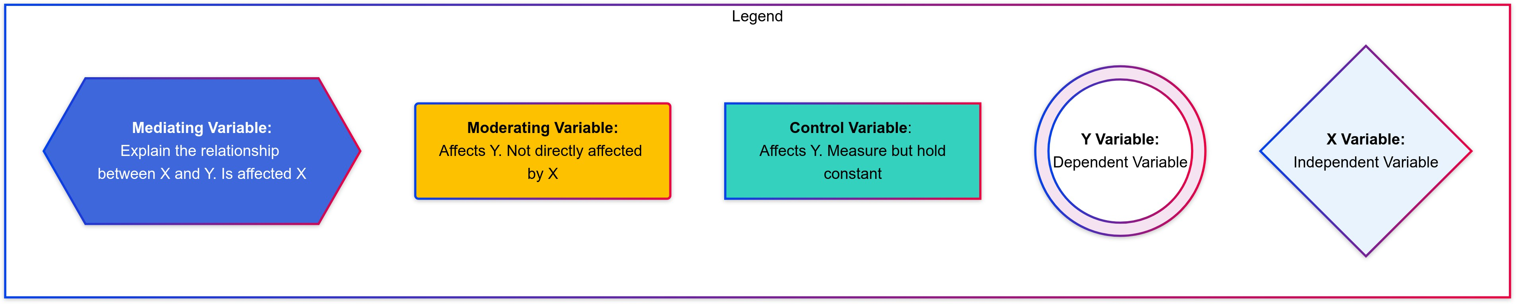**Conceptual Analysis Framework**



Scan QR or visit: shorturl.at/p3zCy

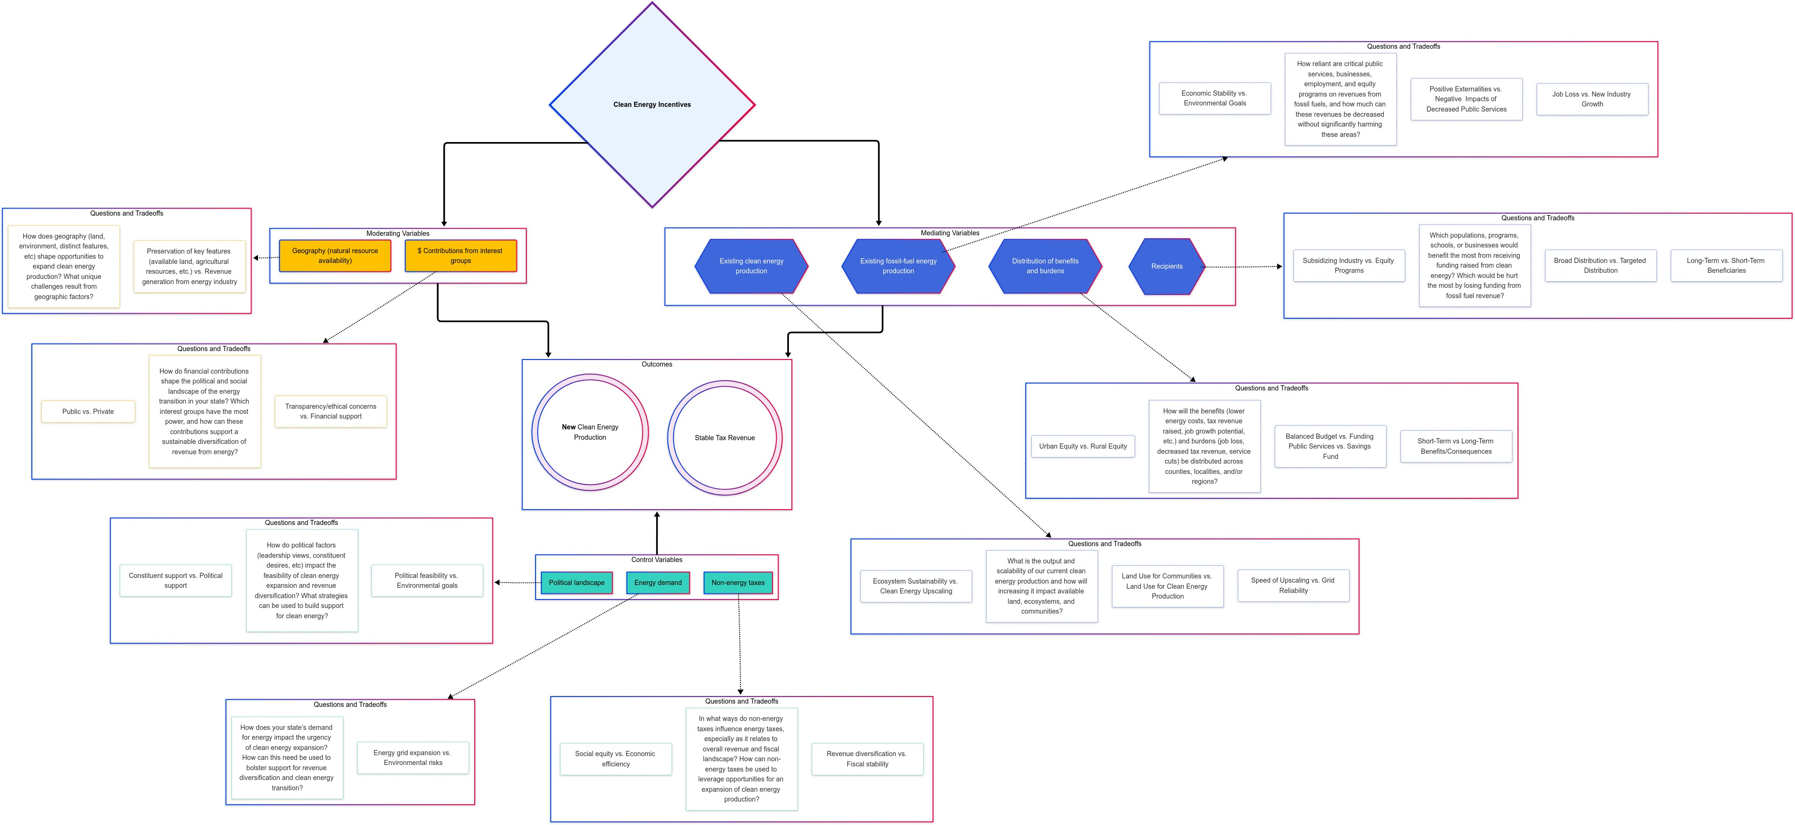

5

* These factors are key elements policymakers must consider when designing and implementing clean energy incentive structures:
  + Distribution of benefits and burdens
  + Recipients
  + Existing fossil fuel energy production
  + Existing clean energy production

Moderating Variables:

* These are variables that alter the effect of the dependant variable but are not affected by the independent variable
* Moderating variables are factors in decision-making, but they are not directly affected by clean energy incentive policies:
  + Geography (natural resource availability)
  + Financial contributions from interest groups

Control Variables:

* These are variables that are either i. out of the control of policymakers or ii. beyond the scope of this report, so they are held constant in this model. However, we do discuss these controls further in the “Case Studies” section. Policymakers should consider their impact and influence:
  + Net energy demand
  + Political landscape
  + Non-energy tax structures

# Methodology

## Literature Review

Our team completed a literature review to establish a comprehensive policy background and explore critical research on the clean energy transition. Our review focused on the fiscal impacts of the clean energy transition, impacts of federal clean energy incentives, tribal considerations, state tax revenue raising strategies, and state-level clean energy incentive options.

## Interviews

Our team conducted one-hour interviews with five experts involved in state-level energy policy, fiscal planning, and clean energy transitions. We used these interviews to elicit insights into the unique challenges states face in balancing clean energy transitions with fiscal stability. We interviewed the following experts:

1. Daniel Raimi, *Fellow at the Resources for the Future and lecturer at the Gerald R. Ford School of Public Policy at the University of Michigan*
2. Sarah Mills, *Director, Center for EmPowering Communities, Graham Sustainability Institute, University of Michigan*
3. Anna Phillips, P*olicy Analyst, State Fiscal Policy Team, Center on Budget and Policy Priorities* and Wesley Tharpe, *Senior Advisor for State Tax Policy, Center on Budget and Policy Priorities*
4. Javier Balmaceda, *Senior Policy Analyst on Puerto Rico, Federal Fiscal Policy Team, Center on Budget and Policy Priorities*
5. Paige Knight, *Deputy Policy Director, New Mexico Voices for Children*

Our interviews were conducted via Zoom. Each interview had two team members present, allowing one member to take detailed notes. Interviews were structured by a predetermined set of questions based on expertise (tax policy, regional issue, or clean energy).

## Case Studies

We used case studies to examine the energy transition policies and fiscal responses in three states: Texas, New Mexico, and Colorado. In each state, we analyzed the following topics:

1. Energy Production and Capacity
2. Energy Revenue Breakdown
3. Key Stakeholders
4. Key Governing Policies
5. Political Landscape

## Financial Data Analysis

Our team conducted financial data analysis focused on understanding the fiscal impact of clean energy policies at the state level. For each of our case study states, we analyzed data on tax revenues, expenditures, and clean energy investments, aiming to quantify the fiscal implications of clean energy policies.

# Literature Review

## Fiscal & Social Impacts

### Fiscal Impacts of the Clean Energy Transition

The clean energy transition has varying fiscal impacts on communities across the U.S, which are most significant in states that heavily rely on the fossil fuel industry for economic activity.

Daniel Raimi, a fellow at Resources for the Future and lecturer at the Gerald R. Ford School of Public Policy at the University of Michigan, recently examined the extent to which clean energy technologies can replace revenues from fossil fuels. By examining local revenues in 79 U.S. counties, Raimi found that, unsurprisingly, local fossil fuel revenues “dominate those from renewables,” providing over half of all local property tax revenues in 15 counties.[4](https://docs.google.com/document/d/1Tng4jrmN1WNZ2GesDEHIEzQMZd77Y-E-xqK3g0b_J08/edit#bookmark%3Did.nlaey95h2hg0) While revenue from solar energy could replace fossil fuel revenues in most counties, solar development would require a significant share of available land.[5](https://docs.google.com/document/d/1Tng4jrmN1WNZ2GesDEHIEzQMZd77Y-E-xqK3g0b_J08/edit#bookmark%3Did.lkldsf9y87gc)

Raimi also suggests that the clean energy transition “will create fiscal pressures, particularly in rural regions where fossil fuels are an economic and fiscal linchpin.”[6](https://docs.google.com/document/d/1Tng4jrmN1WNZ2GesDEHIEzQMZd77Y-E-xqK3g0b_J08/edit#bookmark%3Did.8iuybsf8hiz2) For example, more than 10% of state and local government own-source revenue in Wyoming, North Dakota, Alaska, and New Mexico is from fossil fuels.[7](https://docs.google.com/document/d/1Tng4jrmN1WNZ2GesDEHIEzQMZd77Y-E-xqK3g0b_J08/edit#bookmark%3Did.ogzohlxii6ev) Even in states that, as a whole, do not heavily rely on the fossil fuel industry for revenue (e.g., California, Colorado, and Utah), some areas do generate a majority of their revenue from the industry (e.g. Kern County, California; Weld County, Colorado; and Uintah County, Utah).[8](https://docs.google.com/document/d/1Tng4jrmN1WNZ2GesDEHIEzQMZd77Y-E-xqK3g0b_J08/edit#bookmark%3Did.4qefba9jl3fp)

Existing literature also suggests that the economic impact of reducing fossil fuel use extends to community life, including school and public service resources, retail, and construction.[9](https://docs.google.com/document/d/1Tng4jrmN1WNZ2GesDEHIEzQMZd77Y-E-xqK3g0b_J08/edit#bookmark%3Did.vnzac9br5iw6) These impacts will be most severe in Appalachia, Texas, the Gulf Coast region, and the Intermountain West.[10](https://docs.google.com/document/d/1Tng4jrmN1WNZ2GesDEHIEzQMZd77Y-E-xqK3g0b_J08/edit#bookmark%3Did.cvdb3a7vq5cj) Jolley et al. examined the impact of coal-fired power plant closures in Appalachian Ohio, finding that local governments and school districts would lose a total of $8.5 million in annual tax revenues as a result of closures.[11](https://docs.google.com/document/d/1Tng4jrmN1WNZ2GesDEHIEzQMZd77Y-E-xqK3g0b_J08/edit#bookmark%3Did.3a9l3uxdbwtc) For example, the Manchester, Ohio school district is predicted to lose $5.6 million annual tax revenue, over half of their current revenue stream.[12](https://docs.google.com/document/d/1Tng4jrmN1WNZ2GesDEHIEzQMZd77Y-E-xqK3g0b_J08/edit#bookmark%3Did.z6fa56nd10ng)

Energy et al. also explored how clean energy will impact oil and gas communities in the U.S., focusing particularly on West Virginia, Ohio, New Mexico, North Dakota, and Wyoming. They used three future climate change mitigation scenarios—the International Energy Agency’s Stated Policies Scenarios (STEPS), the Intergovernmental Panel on Climate Change’s Shared Socioeconomic Pathways scenario (SSP), and the IEA Sustainable Development Scenario (SDS)—to determine how oil and gas production will change as a result of each mitigation strategy.[13](https://docs.google.com/document/d/1Tng4jrmN1WNZ2GesDEHIEzQMZd77Y-E-xqK3g0b_J08/edit#bookmark%3Did.8ce0c4guh3yk) For example, the high-cost, oil-dependent states of North Dakota and Wyoming will be highly affected by high mitigation scenarios, such as SDS. Under the SDS, Wyoming and North Dakota will face uneconomic (or unprofitable) oil and gas production of 59% and 84%, respectively.[14](https://docs.google.com/document/d/1Tng4jrmN1WNZ2GesDEHIEzQMZd77Y-E-xqK3g0b_J08/edit#bookmark%3Did.fy6jlhyxnwv2)

Raimi et. al used similar methods to examine the fiscal implications of the U.S. transition away from fossil fuels. These researchers used three scenarios to estimate changes in fossil fuel revenue, including business as usual (BAU), 2C, and 1.5C. The 2C and 1.5C scenarios are “designed to reduce emissions consistent with long-term global temperature rises of 2ºC and

1.5ºC.”[15](https://docs.google.com/document/d/1Tng4jrmN1WNZ2GesDEHIEzQMZd77Y-E-xqK3g0b_J08/edit#bookmark%3Did.qnxdd3oqotv4) They found that, by 2030, the gap in annual revenues compared with BAU will be $14

billion and $29 billion for the 2C and 1.5C scenarios, respectively.[16](https://docs.google.com/document/d/1Tng4jrmN1WNZ2GesDEHIEzQMZd77Y-E-xqK3g0b_J08/edit#bookmark%3Did.5sg7991tjw0d) From 2021 to 2050, revenues for all governments from fossil fuels will decrease by $906 billion under the 1.5C scenario and $491 billion under the 2C scenario, as compared to BAU.[17](https://docs.google.com/document/d/1Tng4jrmN1WNZ2GesDEHIEzQMZd77Y-E-xqK3g0b_J08/edit#bookmark%3Did.bjq1o1qzjg3y)

### Fiscal Benefits of the Clean Energy Transition

Simultaneously, however, scholars suggest that clean energy growth can bolster regional economies in the medium to long-term. For example, Costas Arkolasis of Yale University and Conor Walsh of Columbia University estimate that the clean energy transition will reduce wholesale electricity prices by up to 80% through 2040.[18](https://docs.google.com/document/d/1Tng4jrmN1WNZ2GesDEHIEzQMZd77Y-E-xqK3g0b_J08/edit#bookmark%3Did.ki4j446vs6cc) This price reduction is linked to a 2% to 3% wage increase across the country, varying by region.[19](https://docs.google.com/document/d/1Tng4jrmN1WNZ2GesDEHIEzQMZd77Y-E-xqK3g0b_J08/edit#bookmark%3Did.7h2v3q98gi0t)

Dr. Joshua D. Rhodes, a research scientist at The University of Texas at Austin, also explored the positive impact of renewable energy and energy storage in rural Texas. His research suggests that rural counties in Texas will experience significant positive economic benefits from wind, solar, and energy storage development, as they are likely to receive more than 60% of the estimated tens of billions of dollars in tax revenue and landowner payments.[20](https://docs.google.com/document/d/1Tng4jrmN1WNZ2GesDEHIEzQMZd77Y-E-xqK3g0b_J08/edit#bookmark%3Did.hpdevlky5svq)

### Impacts of Federal Clean Energy Incentives

The Inflation Reduction Act (IRA) of 2022 includes provisions to promote clean energy through tax credits, including the Clean Electricity Production Credit and the Clean Electricity Investment Credit. American Clean Power found that the IRA, in total, will provide $3 trillion in economic and emission benefits.[21](https://docs.google.com/document/d/1Tng4jrmN1WNZ2GesDEHIEzQMZd77Y-E-xqK3g0b_J08/edit#bookmark%3Did.niyfyvdtfm7) Nicholas Roy et al found that the IRA will reduce electricity prices and provide “a progressive cost shift from consumers to taxpayers to pay for the program.”[22](https://docs.google.com/document/d/1Tng4jrmN1WNZ2GesDEHIEzQMZd77Y-E-xqK3g0b_J08/edit#bookmark%3Did.pjio4j7yob0g) These researchers predict a reduction in net annual household costs of up to $123 for the three lowest income quintiles and an $1,014 increase for the top income bracket.[23](https://docs.google.com/document/d/1Tng4jrmN1WNZ2GesDEHIEzQMZd77Y-E-xqK3g0b_J08/edit#bookmark%3Did.l78khcijywt7)

John Bistline et. al also studied the economic implications of the IRA’s climate provisions. They found that the IRA, including both climate and non-climate provisions, will increase federal tax revenue by $58 billion through 2031.[24](https://docs.google.com/document/d/1Tng4jrmN1WNZ2GesDEHIEzQMZd77Y-E-xqK3g0b_J08/edit#bookmark%3Did.2n32soefgv95) At the household level, the Natural Resources Defense Council (NRDC) found that the average residential energy bill will be lowered by 3.4% by 2030 and 4.6% by 2035.[25](https://docs.google.com/document/d/1Tng4jrmN1WNZ2GesDEHIEzQMZd77Y-E-xqK3g0b_J08/edit#bookmark%3Did.1t2ukqjb2cg3) The tax credits, in total, will save households $60 billion on electricity bills over 15 years and help create up to 169,000 clean energy jobs by 2030.[26](https://docs.google.com/document/d/1Tng4jrmN1WNZ2GesDEHIEzQMZd77Y-E-xqK3g0b_J08/edit#bookmark%3Did.nriv33qdrhoe)

## Tribal Considerations

### Tribal Land and Natural Resource Ownership

Ownership of Native American Land is complex. It consists of a mix of titles, restrictions, obligations, laws, and regulations. Natural resources are extracted from Native American lands, and the resulting revenue is distributed. This process is distinctive and involves multiple stakeholders.[27](https://docs.google.com/document/d/1Tng4jrmN1WNZ2GesDEHIEzQMZd77Y-E-xqK3g0b_J08/edit#bookmark%3Did.yifg0dgjzy75) Generally, there are two significant types of Native American land ownership:

* **Trust Land:** The federal government holds legal title, but the beneficial interest remains with the individual or tribe. Trust lands that are held on behalf of individuals are called allotments.
* **Fee Land Purchased by Tribes:** The tribe acquires legal title under specific statutory authority.[28](https://docs.google.com/document/d/1Tng4jrmN1WNZ2GesDEHIEzQMZd77Y-E-xqK3g0b_J08/edit#bookmark%3Did.z3ggazjbkqpy)

Tribal nations are also showing significant interest in utility-scale wind power. Multiple tribes are currently utilizing wind energy or working on new projects, such as the Standing Rock Sioux and Spirit Lake Tribes, the Cherokee Nation, and various Native Alaskan communities. There is also a coalition of seven South Dakota Sioux tribes called the Octet Sakowin Power Authority (OSPA), which was created to develop major wind capacity on tribal lands in the state.[41](https://docs.google.com/document/d/1Tng4jrmN1WNZ2GesDEHIEzQMZd77Y-E-xqK3g0b_J08/edit#bookmark%3Did.wx1xuw1wknyl)

### Federal Support of Tribal Clean Energy Transition

Under the Biden Administration, there has been strong federal support for clean energy projects on tribal lands. In 2022, DOI gave a historic first-time approval for the establishment of a Tribal Energy Development Organization (TEDO) by the Red Lake Band of Chippewa Indians.

TEDO’s are certified business organizations that are either majority owned or fully owned by a tribe. They give tribes the ability to enter into and manage their own energy-related leases,

rights-of-way, and business agreements without needing the approval of DOI’s secretary for each of these individual agreements.[42](https://docs.google.com/document/d/1Tng4jrmN1WNZ2GesDEHIEzQMZd77Y-E-xqK3g0b_J08/edit#bookmark%3Did.ched3nht3mwb) In 2023, the Department of Energy (DOE) awarded $34 million to 18 different tribes to support clean energy projects. The Navajo Nation recently entered into a Memorandum of Understanding (MOU) with the DOE to support funding for a solar-powered clean energy transition. Meanwhile, the Hopi Tribe has been selected as a finalist for an Economic Development Administration (EDA) award and has secured $1.2 million for solar infrastructure planning and design.[43](https://docs.google.com/document/d/1Tng4jrmN1WNZ2GesDEHIEzQMZd77Y-E-xqK3g0b_J08/edit#bookmark%3Did.9h4g4850z3az)

The Trump administration’s recent stop on federal funding for climate related projects through the IRA, as well as funding considered under the general category of social equity, have left tribal nations uncertain about future federal support. The Hopi have over $25 million in funding from the EPA’s Solar for All program on hold, intended to provide rooftop solar panels and battery storage for approximately 550 homes on the Hopi Reservation. Additionally, $12 million from the Energy Department’s Office of Clean Energy Demonstrations is designated for a solar- and-battery microgrid powering government buildings. Another $20 million in EPA funding from the Climate Pollution Reduction Grant program is set aside to support the integration of solar energy into the electric distribution system.[44](https://docs.google.com/document/d/1Tng4jrmN1WNZ2GesDEHIEzQMZd77Y-E-xqK3g0b_J08/edit#bookmark%3Did.xety34ykht5m) Despite a federal ruling to remove the funding freeze, many tribal nations report that they are not receiving already promised federal resources.[45](https://docs.google.com/document/d/1Tng4jrmN1WNZ2GesDEHIEzQMZd77Y-E-xqK3g0b_J08/edit#bookmark%3Did.39uokyk3nvsp) The future of federal support for tribal clean energy transitions will largely depend on the outcome of federal court decisions that determine the legality of federal funding freezes.

## Revenue Raising Options

The extraction of oil and natural gas plays a crucial role in funding vital state programs, including education, public health, and infrastructure. Federal and state governments rely on a number of strategies to generate revenue from these fossil fuels.[46](https://docs.google.com/document/d/1Tng4jrmN1WNZ2GesDEHIEzQMZd77Y-E-xqK3g0b_J08/edit#bookmark%3Did.qp4ag04ftfyu)

### Severance Taxes

Severance taxes apply to the extraction of natural resources, including oil and gas.[47](https://docs.google.com/document/d/1Tng4jrmN1WNZ2GesDEHIEzQMZd77Y-E-xqK3g0b_J08/edit#bookmark%3Did.a6lfpvf4buid) While severance taxes typically make up less than one percent of state revenue, in some resource-rich states, including North Dakota and New Mexico, they contribute over five percent.[48](https://docs.google.com/document/d/1Tng4jrmN1WNZ2GesDEHIEzQMZd77Y-E-xqK3g0b_J08/edit#bookmark%3Did.evcj1gp5sdkc)

### Lease Revenues from Public Lands

The federal government and individual states can collect revenue by leasing public land to private companies for fossil fuel extraction.[49](https://docs.google.com/document/d/1Tng4jrmN1WNZ2GesDEHIEzQMZd77Y-E-xqK3g0b_J08/edit#bookmark%3Did.8vokobg6k5xq) Governments can generate more revenue by revising leasing terms to require coal, oil, and natural gas producers on public lands to pay higher royalty rates or additional fees, such as “carbon adders.” This approach could both boost revenue

and help lower emissions. Research indicates that increasing severance tax rates has a limited impact on oil and gas production and would typically lead to higher government revenue, even if production declines slightly.[50](https://docs.google.com/document/d/1Tng4jrmN1WNZ2GesDEHIEzQMZd77Y-E-xqK3g0b_J08/edit#bookmark%3Did.5ozbx1fph31a)

### Pollution taxes

Pollution taxes, also known as carbon taxes, are taxes on past or current greenhouse gas emissions. These taxes may also be levied on goods and services that are linked to pollution (i.e. taxes on gasoline). In 2024, Vermont became the first state to pass a law requiring fossil fuel companies to pay for their current and historical emissions[.51](https://docs.google.com/document/d/1Tng4jrmN1WNZ2GesDEHIEzQMZd77Y-E-xqK3g0b_J08/edit#bookmark%3Did.815qq8tx69gf) A small number of states, including New York and Maryland, are currently pursuing similar policies.[52](https://docs.google.com/document/d/1Tng4jrmN1WNZ2GesDEHIEzQMZd77Y-E-xqK3g0b_J08/edit#bookmark%3Did.6ri78mreaz9i)

### Cap-and-Invest Policies

Cap-and-invest policies set limits (or caps) on greenhouse gas emissions for polluters.[53](https://docs.google.com/document/d/1Tng4jrmN1WNZ2GesDEHIEzQMZd77Y-E-xqK3g0b_J08/edit#bookmark%3Did.ok6iurkiiccq) Companies may also trade their emissions allowances.[54](https://docs.google.com/document/d/1Tng4jrmN1WNZ2GesDEHIEzQMZd77Y-E-xqK3g0b_J08/edit#bookmark%3Did.r10r382umef5) Fifteen states across the U.S. have implemented cap-and-invest policies, including 12 northeastern states that are members of the Regional Greenhouse Gas Initiative (RGGI).[55](https://docs.google.com/document/d/1Tng4jrmN1WNZ2GesDEHIEzQMZd77Y-E-xqK3g0b_J08/edit#bookmark%3Did.o1ysp66qsdtd)

### Royalty Rates

Energy companies are required to pay percentages of their revenue to the federal government when extracting natural resources from public lands.[56](https://docs.google.com/document/d/1Tng4jrmN1WNZ2GesDEHIEzQMZd77Y-E-xqK3g0b_J08/edit#bookmark%3Did.fwcrb1ni1x4g) Raising royalty rates helps boost revenue streams while cutting greenhouse gas emissions.[57](https://docs.google.com/document/d/1Tng4jrmN1WNZ2GesDEHIEzQMZd77Y-E-xqK3g0b_J08/edit#bookmark%3Did.rujlnigg5m36)

### VMT Tax

A vehicle miles traveled (VMT) tax could be designed to account for factors like vehicle weight, road usage, and other variables to address externalities such as pollution, congestion, and accidents. Additionally, it could help reduce the regressive impact of existing tax policies on electric vehicles. The adoption of VMT taxes faces political obstacles, including resistance to new taxation and concerns about privacy and fair distribution.[58](https://docs.google.com/document/d/1Tng4jrmN1WNZ2GesDEHIEzQMZd77Y-E-xqK3g0b_J08/edit#bookmark%3Did.r0kr2am6vbul)

### Windfall Profit Taxes

Windfall profits are unexpected economic gains that are a result of external circumstances (i.e. international conflicts, pandemics, etc.). Windfall profit taxes are taxes on these excess profits.[59](https://docs.google.com/document/d/1Tng4jrmN1WNZ2GesDEHIEzQMZd77Y-E-xqK3g0b_J08/edit#bookmark%3Did.azk28cd03hkd) Currently, California is the only state with windfall profit taxes on gas and oil industries.[60](https://docs.google.com/document/d/1Tng4jrmN1WNZ2GesDEHIEzQMZd77Y-E-xqK3g0b_J08/edit#bookmark%3Did.xjcars2xe01i)

### Removing Direct Subsidies and Tax Incentives

States can increase revenue by removing direct subsidies for fossil fuel producers, which could generate approximately $35 billion between 2022 and 2031. Additionally, states could eliminate tax incentives, such as Texas’s reduced severance tax rate for “high-cost” natural gas wells.[61](https://docs.google.com/document/d/1Tng4jrmN1WNZ2GesDEHIEzQMZd77Y-E-xqK3g0b_J08/edit#bookmark%3Did.v1gvjjgeca6)

## Clean Energy Incentive Options

Governments at the federal, state, and local levels, along with electric utilities, promote investment in and use of renewable energy—sometimes mandating its adoption. Below is an overview of key programs and incentives supporting renewable energy generation and utilization in the U.S.[62](https://docs.google.com/document/d/1Tng4jrmN1WNZ2GesDEHIEzQMZd77Y-E-xqK3g0b_J08/edit#bookmark%3Did.capnmvv0ywum)

### Government Financial Incentives

Various tax credits, grants, and loan programs are available for eligible renewable energy technologies and projects. Federal tax incentives include the Renewable Electricity Production Tax Credit (PTC), the Investment Tax Credit (ITC), the Residential Energy Credit, and the Modified Accelerated Cost-Recovery System (MACRS). Grants and loans are also provided by agencies such as the U.S. Department of Agriculture, the DOE, and the Department of the Interior. Additionally, many states offer financial incentives to promote renewable energy adoption.[63](https://docs.google.com/document/d/1Tng4jrmN1WNZ2GesDEHIEzQMZd77Y-E-xqK3g0b_J08/edit#bookmark%3Did.dq4kkgmdvd1n)

### Renewable Portfolio Standards (RPS) and Goals

A renewable portfolio standard (RPS) mandates that a certain percentage of a state's electricity sales come from renewable sources. Some states set mandatory targets, while others establish voluntary goals within a specified timeframe. Utilities may be required or permitted to trade renewable energy certificates to comply with RPS regulations.[64](https://docs.google.com/document/d/1Tng4jrmN1WNZ2GesDEHIEzQMZd77Y-E-xqK3g0b_J08/edit#bookmark%3Did.hu59ktz54yrr)

### Renewable Energy Certificates (RECs)

Renewable energy certificates (RECs), also known as green tags or tradable renewable certificates, enable individuals or businesses to financially support renewable energy production without directly generating or purchasing the energy. Utilities use RECs to meet state RPS requirements, while companies often purchase them voluntarily to offset carbon emissions.[65](https://docs.google.com/document/d/1Tng4jrmN1WNZ2GesDEHIEzQMZd77Y-E-xqK3g0b_J08/edit#bookmark%3Did.nddrdcyyvfgp)

### Net Metering

Net metering allows utility customers to install renewable energy systems, such as solar panels, and connect them to the grid. Customers are billed based on their net electricity usage—the difference between total consumption and the electricity their system feeds into the grid. As of 2022, 44 states and the District of Columbia have statewide net metering policies, while utilities in Idaho and Texas offer their own programs. Most net metered systems are solar photovoltaic (PV) systems[.66](https://docs.google.com/document/d/1Tng4jrmN1WNZ2GesDEHIEzQMZd77Y-E-xqK3g0b_J08/edit#bookmark%3Did.9wdj9vbkpx2p)

### Feed-In Tariffs (FITs)

Some states and utilities offer special rates, known as feed-in tariffs (FITs), for electricity generated from renewable sources. These rates, which are typically higher than standard electricity prices, aim to encourage investment in specific renewable energy technologies.[67](https://docs.google.com/document/d/1Tng4jrmN1WNZ2GesDEHIEzQMZd77Y-E-xqK3g0b_J08/edit#bookmark%3Did.psodgw7mv8dg)

### Consumer Options for Renewable Electricity

Since the U.S. electricity grid integrates power from multiple sources, all consumers indirectly use some renewable energy. However, consumers in deregulated states may choose electricity providers that supply power exclusively from renewable sources. Additionally, voluntary green power programs allow customers to support renewable energy generation through contractual agreements, even if retail electricity choice is unavailable in their area.[68](https://docs.google.com/document/d/1Tng4jrmN1WNZ2GesDEHIEzQMZd77Y-E-xqK3g0b_J08/edit#bookmark%3Did.f5yzpziixg2)

### Biofuels and Alternative Fuels

Federal and state programs support the production, sale, and use of biofuels and alternative vehicle fuels. Federal law mandates the inclusion of biofuels or their substitutes in the U.S.

transportation fuel supply, with the EPA setting annual volume requirements. Other federal and state initiatives provide financial assistance to biofuel producers. The DOE’s Alternative Fuel Data Center offers information on related programs.[69](https://docs.google.com/document/d/1Tng4jrmN1WNZ2GesDEHIEzQMZd77Y-E-xqK3g0b_J08/edit#bookmark%3Did.bn1aqe2mt9pb)

### Renewable Energy Research and Development

The DOE and other federal agencies fund research and development (R&D) efforts for renewable energy technologies, primarily conducted through national laboratories in partnership with academic institutions and private companies. Funding for these programs depends on congressional appropriations.[70](https://docs.google.com/document/d/1Tng4jrmN1WNZ2GesDEHIEzQMZd77Y-E-xqK3g0b_J08/edit#bookmark%3Did.ixz4qrjavjp3)

## Diversification Strategies

The diversification of state revenue streams is a developing strategy to ease the economic impact of the transition away from fossil fuels and reduce over-reliance on energy-related revenue sources. Diversification stabilizes these volatile revenue streams and can create long-term wealth for state and local governments.[71](https://docs.google.com/document/d/1Tng4jrmN1WNZ2GesDEHIEzQMZd77Y-E-xqK3g0b_J08/edit#bookmark%3Did.pw8mmdl6n3b8)

### Diversifying tax structures

Sources of tax revenue can be expanded to broaden the streams of revenue available to state governments. This provides additional revenue as well as a safe-guard from over-reliance on a single revenue source.[72](https://docs.google.com/document/d/1Tng4jrmN1WNZ2GesDEHIEzQMZd77Y-E-xqK3g0b_J08/edit#bookmark%3Did.psbiakz1qas3) For example, states can raise income and property taxes. Another option is a value-added tax (VAT), a type of consumption tax widely used across the world and often recommended by tax experts but which faces significant political opposition in the U.S.[73](https://docs.google.com/document/d/1Tng4jrmN1WNZ2GesDEHIEzQMZd77Y-E-xqK3g0b_J08/edit#bookmark%3Did.7apbdjrb6mzd) A value-added tax (VAT) is a consumption tax applied to the added value at each stage of production for goods and services.[74](https://docs.google.com/document/d/1Tng4jrmN1WNZ2GesDEHIEzQMZd77Y-E-xqK3g0b_J08/edit#bookmark%3Did.e7yprkl8jd0k)

### Supply Chain Support

Establishing supply chains for clean energy technologies provides ongoing support for their adoption. There are an increasing number of investments that bolster the link between clean energy and manufacturing. Examples include Toyota’s $13.9 billion battery manufacturing plant in North Carolina and Pattern Energy Group’s $11 billion wind electricity and transmission project in New Mexico.[75](https://docs.google.com/document/d/1Tng4jrmN1WNZ2GesDEHIEzQMZd77Y-E-xqK3g0b_J08/edit#bookmark%3Did.orfpyv3djzgt)

### Ceding Tax Control to Local Governments

Some states are diversifying their revenue streams by giving more power to local governments to levy additional taxes. This can create additional competition for revenue between state and local governments.[76](https://docs.google.com/document/d/1Tng4jrmN1WNZ2GesDEHIEzQMZd77Y-E-xqK3g0b_J08/edit#bookmark%3Did.cybyxkchsy7e)

### Revenue Saving

States can contribute a certain percentage of revenue income to a savings reserve that can be used to fund critical services during the transition to clean energy. Experts suggest that saving funds remains an underused strategy. In 2020, the average state allocation of federal fossil fuel disbursements to savings was only 11%, totaling $195 million.[77](https://docs.google.com/document/d/1Tng4jrmN1WNZ2GesDEHIEzQMZd77Y-E-xqK3g0b_J08/edit#bookmark%3Did.7mnsyxl0c417)

# Case Studies

An in-depth study into how states are currently incentivizing and collecting revenue from the energy sector assists in understanding how these mechanisms currently operate and how policymakers can leverage existing mechanisms used in other states.

Case studies provide essential information on the different levels of dependence on nonrenewable energy sources in different policy and geographic landscapes. We outline three states—**Texas, New Mexico, and Colorado—**and break down key aspects of the energy transition within these states:

1. Current energy production/capacity
2. Current revenues from the energy sector
3. Key stakeholders
4. Governing energy policies
5. All clean energy incentives
6. Political landscape surrounding the energy transition

## Texas

### Energy production/capacity landscape:

In 2002, Texas deregulated its energy market to promote competition and fair pricing for energy consumers. Texas customers can choose their utilities provider, who contracts with the state and is overseen by the Public Utility Commission of Texas.[78](https://docs.google.com/document/d/1Tng4jrmN1WNZ2GesDEHIEzQMZd77Y-E-xqK3g0b_J08/edit#bookmark%3Did.d8ke1dyztfgm) Texas is both the nation’s largest energy supplier and consumer.

### Petroleum[79](https://docs.google.com/document/d/1Tng4jrmN1WNZ2GesDEHIEzQMZd77Y-E-xqK3g0b_J08/edit#bookmark%3Did.hja8bdm9w7nt):

* + The Texas industrial sector consumes more energy than the residential sector. Key industries include chemical manufacturing, crude oil and petroleum extraction, as well as petroleum refining.
  + In 2023, Texas accounted for 43% of the nation’s petroleum production from both offshore and onshore areas and accounts for two-fifths of the nation’s oil reserves.
  + Texas surpassed a 1972 peak in petroleum production in 2017, and in 2023 annual output rose to record highs at two billion barrels. In 2023, Texas accounted for one-fourth of the nation’s natural gas gross withdrawals.
  + The production, processing, and distribution of natural gas uses around twice as much natural gas as the commercial and residential end-use sectors combined.

### Renewables[80](https://docs.google.com/document/d/1Tng4jrmN1WNZ2GesDEHIEzQMZd77Y-E-xqK3g0b_J08/edit#bookmark%3Did.ovteg7pdgq2f):

* + In 2023, renewable energy sources provided almost three-tenths of total state net electricity generation.
  + Texas leads the nation in utility-scale wind powered electricity generation, and in 2023 the state was the second-largest producer of solar power after California. In 1999, the state passed a rule that requires electricity providers to install a total of 10,000 megawatts of renewable energy capacity by 2025. The state surpassed this goal in 2009 due to its wind farms.

### Energy Revenue Breakdown:

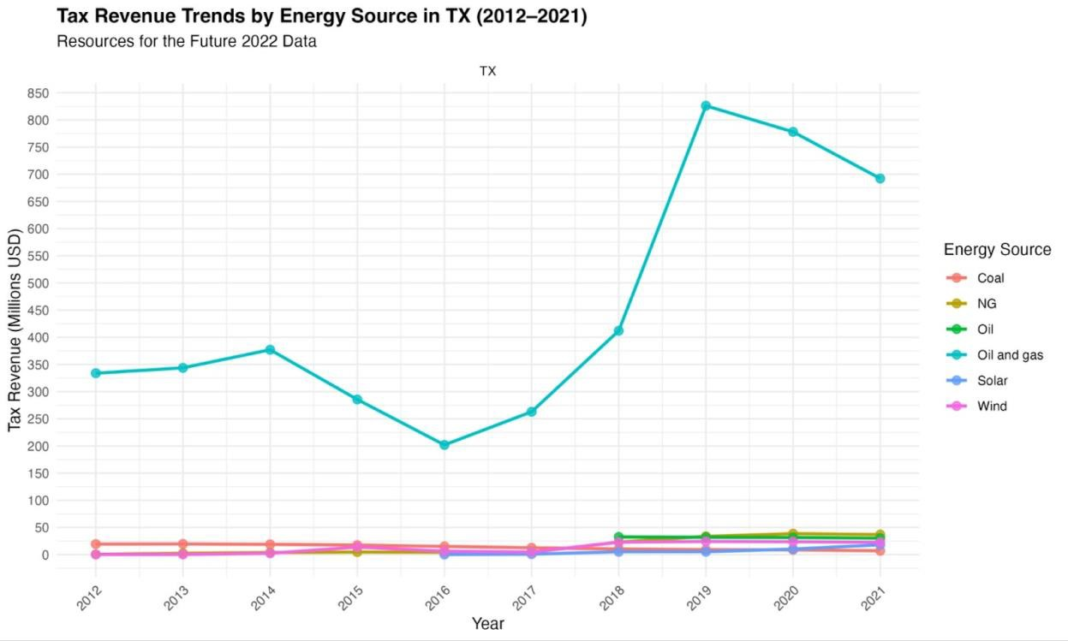

*Figure 1. Tax Revenue Trends by Energy Source in Texas*

Our analysis reveals a w-shaped distribution of energy revenues, with notable decreases in revenue in the fiscal year 2016 followed by larger increases from 2017 on. These decreases are largely due to steep declines in oil and natural gas prices. The monthly average price of oil per barrel fell by more than 50%, from $96 in 2014 to $42 in 2015 as supply outpaced demand.[81](https://docs.google.com/document/d/1Tng4jrmN1WNZ2GesDEHIEzQMZd77Y-E-xqK3g0b_J08/edit#bookmark%3Did.1rumg0ol5hnm) At the same time, the number of gas drilling operations decreased from an average of 103 in 2014 to 70 by 2015.[82](https://docs.google.com/document/d/1Tng4jrmN1WNZ2GesDEHIEzQMZd77Y-E-xqK3g0b_J08/edit#bookmark%3Did.30p8wx19aqqs)

Revenues analysis suggests that despite the relative dominance of oil and gas revenues, 2018 begins a shift toward more diversified energy tax revenues with increases in renewables including solar and wind. Importantly, Texas’s dependence on non-renewable energy tax revenues remains despite tax revenue increases in renewables. The gap grew from approximately

$353 million in 2012 to more than $700 million in 2021.

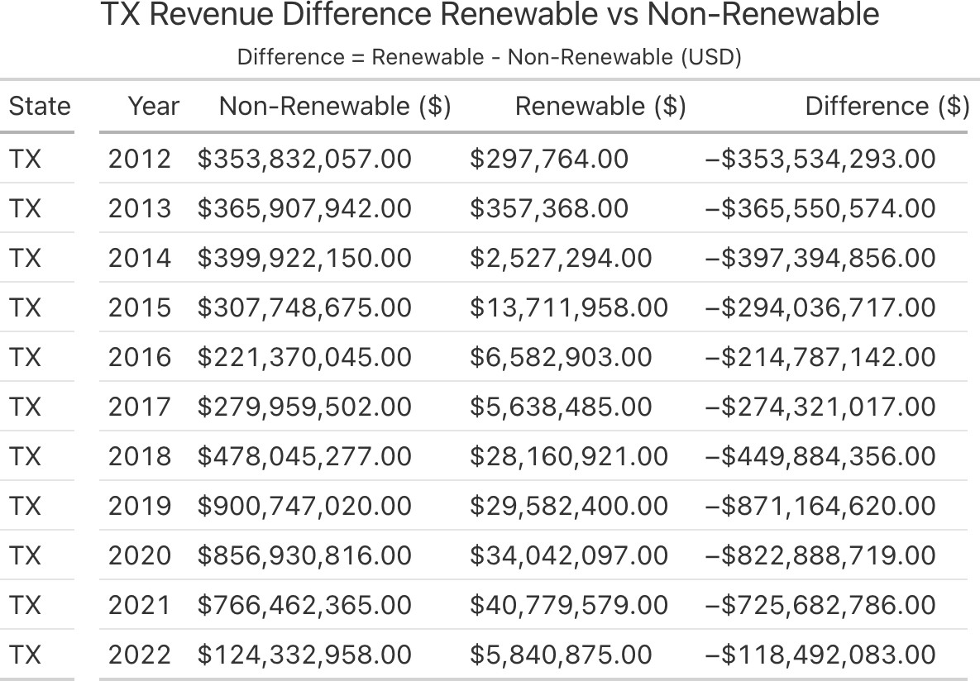

*Figure 2. Renewable and Nonrenewable Tax Revenue Difference in Texas*

### Key Stakeholders:

*Electric Reliability Council of Texas (ERCOT):*[*83*](https://docs.google.com/document/d/1Tng4jrmN1WNZ2GesDEHIEzQMZd77Y-E-xqK3g0b_J08/edit#bookmark%3Did.uffq78s192p2)

* + Non-profit, membership based organization that operates the majority of Texas’s electricity grid.
  + ERCOT is not subject to federal regulations, as the grid is located entirely within Texas and only serves Texans.[84](https://docs.google.com/document/d/1Tng4jrmN1WNZ2GesDEHIEzQMZd77Y-E-xqK3g0b_J08/edit#bookmark%3Did.bzcadwu6jns)
  + In 2002, Texas’s energy market was deregulated, requiring utilities under ERCOT to unbundle and compete in an open market.[85](https://docs.google.com/document/d/1Tng4jrmN1WNZ2GesDEHIEzQMZd77Y-E-xqK3g0b_J08/edit#bookmark%3Did.wbckevnv6db8)

*Public Utility Commission of Texas (PUCT):*[*86*](https://docs.google.com/document/d/1Tng4jrmN1WNZ2GesDEHIEzQMZd77Y-E-xqK3g0b_J08/edit#bookmark%3Did.ft8r0073mgri)

* + State agency responsible for the economic regulation of Texas’ electric, telecommunication, and water and wastewater utilities.
  + Helps identify demand for energy developers and enforces policy to regulate the market and reduce financial risk.
  + Oversees the market-based structure of Texas’s energy sector, enforcing market rules and overseeing the ERCOT.[87](https://docs.google.com/document/d/1Tng4jrmN1WNZ2GesDEHIEzQMZd77Y-E-xqK3g0b_J08/edit#bookmark%3Did.14s5eadkvt7c)

*The Railroad Commission of Texas:*

* + State agency responsible for the regulation over the oil and natural gas industry, pipeline transporters, natural gas and hazardous liquid pipeline industry, natural gas utilities, the

LP-gas industry, critical natural gas infrastructure, and coal and uranium surface mining operations.[88](https://docs.google.com/document/d/1Tng4jrmN1WNZ2GesDEHIEzQMZd77Y-E-xqK3g0b_J08/edit#bookmark%3Did.hs8p3lkkxr41)

*Texas Oil and Gas Association:*

* + Statewide trade association representing the interests of oil and gas producers in Texas.[89](https://docs.google.com/document/d/1Tng4jrmN1WNZ2GesDEHIEzQMZd77Y-E-xqK3g0b_J08/edit#bookmark%3Did.xfca4h8f9o5)

*Power Up Texas:*

* + Coalition of city and local-level stakeholders, including chambers of commerce, economic development organizations, city governments, and local colleges who advance legislation to promote clean energy for economic growth.[90](https://docs.google.com/document/d/1Tng4jrmN1WNZ2GesDEHIEzQMZd77Y-E-xqK3g0b_J08/edit#bookmark%3Did.xucqztfpft0v)

*Localities:*

* + The Texas Natural Resources code requires the Railroad Commission to seek input from stakeholders, namely members of the public, when developing the Oil and Gas Division Monitoring and Enforcement Strategic Plan.[91](https://docs.google.com/document/d/1Tng4jrmN1WNZ2GesDEHIEzQMZd77Y-E-xqK3g0b_J08/edit#bookmark%3Did.8xgud24a2ny1)
  + The top crude oil producing counties in Texas are: Midland, Martin, Upton, Loving, Howard, Karnes, Reeves, Reagan, Andrews and Glasscock.[92](https://docs.google.com/document/d/1Tng4jrmN1WNZ2GesDEHIEzQMZd77Y-E-xqK3g0b_J08/edit#bookmark%3Did.8vg0yjwmdi4p)

### Key Governing Policies:

*Renewable Portfolio Standard:*

* + Texas implemented a Renewable Portfolio Standard (RPS) in 1999, which was revised in 2005. The standard requires 10,000 megawatts of renewable energy installed by 2025, and the revision in 2005 established a 500MW annual renewable energy generation goal for sources other than wind.[93](https://docs.google.com/document/d/1Tng4jrmN1WNZ2GesDEHIEzQMZd77Y-E-xqK3g0b_J08/edit#bookmark%3Did.79cuow5cy99n)
  + The RPS first spurred investment in renewable energy for Texas on account of the vast wind resources available. The legislation required an additional 2,000 MW of renewable energy be produced between 1999 and 2009.[94](https://docs.google.com/document/d/1Tng4jrmN1WNZ2GesDEHIEzQMZd77Y-E-xqK3g0b_J08/edit#bookmark%3Did.m5c7os2ksq7g)
  + Provided legally required demand for renewable projects.[95](https://docs.google.com/document/d/1Tng4jrmN1WNZ2GesDEHIEzQMZd77Y-E-xqK3g0b_J08/edit#bookmark%3Did.mdogyy42181z)
  + PUCT also implemented a renewable energy credit (REC) program along with the RPC when the legislation was updated in 2005 to extend the RPS and raise generation requirements.[96](https://docs.google.com/document/d/1Tng4jrmN1WNZ2GesDEHIEzQMZd77Y-E-xqK3g0b_J08/edit#bookmark%3Did.7w6s3zhlpp12)
  + REC obligations were assigned to all electricity retailers in the Texas market, so nonrenewable generators purchasing RECs acted as a subsidy to renewable generators selling extra RECs.[97](https://docs.google.com/document/d/1Tng4jrmN1WNZ2GesDEHIEzQMZd77Y-E-xqK3g0b_J08/edit#bookmark%3Did.85oqyccglpbx)

*Competitive Renewable Energy Zones (CREZs):*

* + In 2005, the Texas legislature passed a bill to designate competitive renewable energy zones (CREZs) in areas identified as viable for clean energy production.
  + The CREZ policy also developed a plan to deliver renewable power to customers not located in these zones with transmission requirements[.98](https://docs.google.com/document/d/1Tng4jrmN1WNZ2GesDEHIEzQMZd77Y-E-xqK3g0b_J08/edit#bookmark%3Did.uhhgmck9m1sg)
  + CREZs were identified by industry experts in partnership with the state and provided wind developers with assurance of energy potential in these zones. The legislation effectively increased the Texas grid capacity as well as reduced the cost of electricity that stemmed from congestion problems.[99](https://docs.google.com/document/d/1Tng4jrmN1WNZ2GesDEHIEzQMZd77Y-E-xqK3g0b_J08/edit#bookmark%3Did.kpf4m6d51bxn)
  + The project represented 23% of all high-voltage lines added in the U.S. in the past twelve years. The expansion of transmission lines drove down the cost of energy as a whole in

Texas, created jobs in the more sparsely populated eastern panhandle, and created opportunities for increased energy production as a whole due to new transmission lines.[100](https://docs.google.com/document/d/1Tng4jrmN1WNZ2GesDEHIEzQMZd77Y-E-xqK3g0b_J08/edit#bookmark%3Did.awu2vdti5c6h)

The CREZ project overcame significant political and stakeholder hurdles: Firstly, energy developers are hesitant to invest in projects given uncertainty about how energy can reach customers. Simultaneously, transmission developers are reluctant to build power lines that can reach customers in the absence of concrete project plans. There is also the larger concern of who bears the cost of infrastructure development. In the case of CREZs, the zones were identified first by the Public Utility Commission, who then opened the land up to transmission developers once the zone was deemed viable.[101](https://docs.google.com/document/d/1Tng4jrmN1WNZ2GesDEHIEzQMZd77Y-E-xqK3g0b_J08/edit#bookmark%3Did.olhc8c57w9ti) Transmission costs were borne by all Texan ratepayers, regardless of their share of transmission usage.[102](https://docs.google.com/document/d/1Tng4jrmN1WNZ2GesDEHIEzQMZd77Y-E-xqK3g0b_J08/edit#bookmark%3Did.fd6n1n955l01) Wind farm developers were then contracted by the state to develop farms in rural areas of Texas while transmission developers created new power lines to connect that energy source to the rest of the state. There are calls for a “CREZ II” project, as the population and energy demands in Texas continue to increase.[103](https://docs.google.com/document/d/1Tng4jrmN1WNZ2GesDEHIEzQMZd77Y-E-xqK3g0b_J08/edit#bookmark%3Did.atfc6cuqtu8w)

*Tax Code Provisions:*

* + Chapter 312 allows school districts to offer abatements to local large-scale developers’ property tax burden in exchange for development and job creation requirements.[104](https://docs.google.com/document/d/1Tng4jrmN1WNZ2GesDEHIEzQMZd77Y-E-xqK3g0b_J08/edit#bookmark%3Did.duadyjygoxsq)
  + Chapter 313 expands on this, providing school districts with reimbursement of the lost tax revenue through the state comptroller’s office, effectively subsidizing local abatements with state-level tax revenue. The provision also specified that school districts were responsible for negotiating abatement contracts, leading to additional payments made by developers to districts.[105](https://docs.google.com/document/d/1Tng4jrmN1WNZ2GesDEHIEzQMZd77Y-E-xqK3g0b_J08/edit#bookmark%3Did.ppp3l0ox3abj)
  + Abatements are not specific to renewable energy projects. Renewable projects accounted for two-thirds of the projects abated but only one-fourth of lost school district revenue.[106](https://docs.google.com/document/d/1Tng4jrmN1WNZ2GesDEHIEzQMZd77Y-E-xqK3g0b_J08/edit#bookmark%3Did.92gu4uwi68uq) The total cost of Chapter 313 was one billion dollars in FY2023.[107](https://docs.google.com/document/d/1Tng4jrmN1WNZ2GesDEHIEzQMZd77Y-E-xqK3g0b_J08/edit#bookmark%3Did.9or1nis2xv0c)
  + Chapter 313 was heavily criticized due to this state-level reimbursement and additional opportunities for inequitable school funding. The legislature allowed it to expire in 2022.

A replacement to this tax code, known as the “Texas Jobs, Energy, Technology, and Innovation Act,” or HB5, was signed into law in 2023. The law replaces Chapter 313 of the tax code, and most importantly, excludes renewable energy projects from local abatements completely: “eligible projects *do not include* projects to construct or expand new or existing non dispatchable electric generation facilities or electric energy storage facilities [which] includes solar and wind power sources of electricity.”[108](https://docs.google.com/document/d/1Tng4jrmN1WNZ2GesDEHIEzQMZd77Y-E-xqK3g0b_J08/edit#bookmark%3Did.ahdl04mkqt11) Other provisions of the bill address job creation and eliminate the opportunity for developers to pay school districts directly. HB5 also omits the requirement of Chapter 313 for the comptroller to publish the loss of property tax revenue resulting from abatements.[109](https://docs.google.com/document/d/1Tng4jrmN1WNZ2GesDEHIEzQMZd77Y-E-xqK3g0b_J08/edit#bookmark%3Did.6ema26nk3lq1)

### All Renewable Energy Incentives:

|  |  |  |  |
| --- | --- | --- | --- |
| **Name** | **Policy/Incentive** | **Created** | **Last Updated** |
| [Renewable Energy Systems Property Tax](https://programs.dsireusa.org/system/program/detail/173/renewable-energy-systems-property-tax-exemption) [Incentive](https://programs.dsireusa.org/system/program/detail/173/renewable-energy-systems-property-tax-exemption) | Property Tax Incentive | 1/1/2000 | 3/24/2023 |
| [ENERGY STAR Sales Tax Holiday for](https://programs.dsireusa.org/system/program/detail/2766/energy-star-sales-tax-holiday-for-energy-efficient-products) [Energy-Efficient Products](https://programs.dsireusa.org/system/program/detail/2766/energy-star-sales-tax-holiday-for-energy-efficient-products) | Sales Tax Incentive | 10/26/2007 | 3/30/2023 |
| [City of Houston Property Tax Abatement for](https://programs.dsireusa.org/system/program/detail/4720/city-of-houston-property-tax-abatement-for-green-commercial-buildings) [Green Commercial Buildings](https://programs.dsireusa.org/system/program/detail/4720/city-of-houston-property-tax-abatement-for-green-commercial-buildings) | Property Tax Incentive | 3/20/2011 | 2/28/2023 |
| [Harris County - Property Tax Abatement for](https://programs.dsireusa.org/system/program/detail/4911/harris-county-property-tax-abatement-for-green-commercial-buildings) [Green Commercial Buildings](https://programs.dsireusa.org/system/program/detail/4911/harris-county-property-tax-abatement-for-green-commercial-buildings) | Property Tax Incentive | 7/14/2011 | 12/6/2023 |
| [City of Friendswood - Property Tax](https://programs.dsireusa.org/system/program/detail/5008/city-of-friendswood-property-tax-abatement-for-green-commercial-buildings) [Abatement for Green Commercial Buildings](https://programs.dsireusa.org/system/program/detail/5008/city-of-friendswood-property-tax-abatement-for-green-commercial-buildings) | Property Tax Incentive | 9/15/2011 | 7/8/2020 |

*2021 Blackouts and Political Influences:*

In 2021, Texas experienced a mass electrical grid blackout as a result of Winter Storm Uri. The Texas grid capacity was unprepared for this cold snap, causing generators to fail in meeting heightened energy demand.[110](https://docs.google.com/document/d/1Tng4jrmN1WNZ2GesDEHIEzQMZd77Y-E-xqK3g0b_J08/edit#bookmark%3Did.99t8jdk8059x) Because of this, the chief concern surrounding energy generation is eliminating transmission bottlenecks and expanding the grid holistically. Texas has a much larger capacity for renewable energy sources than most states, but the blaming of the blackout on renewable energies (primarily solar and wind) informs current policymaking.[111](https://docs.google.com/document/d/1Tng4jrmN1WNZ2GesDEHIEzQMZd77Y-E-xqK3g0b_J08/edit#bookmark%3Did.15x85usnvsc8) As such, a widespread aversion towards “climate” policy stands, but the ever-increasing demand for energy is driving policymakers towards an “all of the above” approach to incentivize *all* energy production, not solely renewables.[112](https://docs.google.com/document/d/1Tng4jrmN1WNZ2GesDEHIEzQMZd77Y-E-xqK3g0b_J08/edit#bookmark%3Did.exwkjljw1pfq) [113](https://docs.google.com/document/d/1Tng4jrmN1WNZ2GesDEHIEzQMZd77Y-E-xqK3g0b_J08/edit#bookmark%3Did.x6qvn2jgtqaq) [114](https://docs.google.com/document/d/1Tng4jrmN1WNZ2GesDEHIEzQMZd77Y-E-xqK3g0b_J08/edit#bookmark%3Did.2xq5lgy9jnla)

Large amounts of power are demanded not only by residents, but by emerging industries such as crypto mining, data centers, and electrifying oil and gas field operations.[115](https://docs.google.com/document/d/1Tng4jrmN1WNZ2GesDEHIEzQMZd77Y-E-xqK3g0b_J08/edit#bookmark%3Did.9eyotx1hud8r) The rhetoric in Texas, broadly, surrounds meeting this energy demand while minimizing costs to ratepayers. While increasing transmission capacity will come at a cost, an overburdened electrical grid risks repeating the disaster of 2021.

“All of the above” rhetoric is popular within the legislature, but policies that incentivize the development of new energy generation increasingly favor the nonrenewable energy sector. A recent bill, SB388, requires 50% of new energy production after January 1, 2026 to stem from “dispatchable generation,” i.e. nonrenewable energy sources. SB388 also implements a dispatchable generation credits trading program requiring power generation companies, municipally owned utilities, and electric cooperatives to either directly own dispatchable generation capacity or purchase credits to meet the requirement.[116](https://docs.google.com/document/d/1Tng4jrmN1WNZ2GesDEHIEzQMZd77Y-E-xqK3g0b_J08/edit#bookmark%3Did.yyp36eybta9t) According to a letter from the Vice President of the Advanced Power Alliance, this bill curtails the market-based energy production strategy that Texas historically operates under and artificially inflates nonrenewable energy sources.[117](https://docs.google.com/document/d/1Tng4jrmN1WNZ2GesDEHIEzQMZd77Y-E-xqK3g0b_J08/edit#bookmark%3Did.mcenw84ix75c)

SB388 is an example of the broader Texas landscape: commitment to increased energy capacity while disproportionately incentivizing nonrenewable sources. Another example of this is renewable energy exclusion from HB5: Rep. John Smithee offered an amendment to include renewable projects as “grid reliability projects”, but the bill’s author explained that he committed to excluding these projects to “get various groups on board.”[118](https://docs.google.com/document/d/1Tng4jrmN1WNZ2GesDEHIEzQMZd77Y-E-xqK3g0b_J08/edit#bookmark%3Did.9eutwfyfxi6u)

## New Mexico

### Energy Production/Capacity Landscape:

*Petroleum:*[*119*](https://docs.google.com/document/d/1Tng4jrmN1WNZ2GesDEHIEzQMZd77Y-E-xqK3g0b_J08/edit#bookmark%3Did.u0aons1mcfh9)

* + New Mexico is the fifth-largest energy producer in the nation and the second largest crude-oil producing state after Texas.
  + The majority of crude oil production occurs in the Permian Basin, and advanced drilling and extraction techniques in that area have increased crude oil production tenfold since 2010.[120](https://docs.google.com/document/d/1Tng4jrmN1WNZ2GesDEHIEzQMZd77Y-E-xqK3g0b_J08/edit#bookmark%3Did.zcmcdk7eqg1t)
  + This sharp increase has necessarily contributed greatly to New Mexico’s economy. Direct and indirect collections from oil and gas made up 35 percent of the state’s general fund in FY2023.[121](https://docs.google.com/document/d/1Tng4jrmN1WNZ2GesDEHIEzQMZd77Y-E-xqK3g0b_J08/edit#bookmark%3Did.2k0uh5a0zaft)

*Renewables:*

* + In 2023, renewable energy supplied around 47% of New Mexico’s in-state electricity generation, and it is the largest source of the state’s total in-state electricity generation.
  + Total generation from renewables increased sixfold between 2015 and 2023, and 81% of new generation comes from wind energy.[122](https://docs.google.com/document/d/1Tng4jrmN1WNZ2GesDEHIEzQMZd77Y-E-xqK3g0b_J08/edit#bookmark%3Did.hdfui1xm8trj)
  + Renewable energy does not contribute nearly as much to New Mexico’s revenue generation as oil and gas, [contributing less than 1% to state land revenue in FY 2023](https://www.nmlegis.gov/Entity/LFC/Documents/Revenue_Reports/General_Fund_Revenue_Forecast/2023/General%20Fund%20Consensus%20Revenue%20Estimate%2012.9.23.pdf).

*Tribal Land Energy Generation:*[*123*](https://docs.google.com/document/d/1Tng4jrmN1WNZ2GesDEHIEzQMZd77Y-E-xqK3g0b_J08/edit#bookmark%3Did.f1gbjd15s12f)

* + New Mexico’s tribal lands cover more than 7 million acres. The Navajo Nation conducts oil and gas operations, and the Nation owns and operates a crude oil pipeline spanning from New Mexico to Utah.
  + Tribal lands enjoy significant potential for solar energy. The U.S. Dept. of Energy has awarded several grants for solar deployments in the state since 2015. Tribal lands host and benefit from a significant share of the state’s solar development.
  + The only coal-fired power plant in New Mexico is located on Navajo land, where the Navajo Transitional Energy Company is working to keep that plant open and retrofitting it with carbon capture technology[124](https://docs.google.com/document/d/1Tng4jrmN1WNZ2GesDEHIEzQMZd77Y-E-xqK3g0b_J08/edit#bookmark%3Did.us5ucdvu1ucm) [125.](https://docs.google.com/document/d/1Tng4jrmN1WNZ2GesDEHIEzQMZd77Y-E-xqK3g0b_J08/edit#bookmark%3Did.nifgqx1lypit) This effort aligns with tribal goals to invest in jobs and infrastructure.

### Energy Revenue Breakdown:

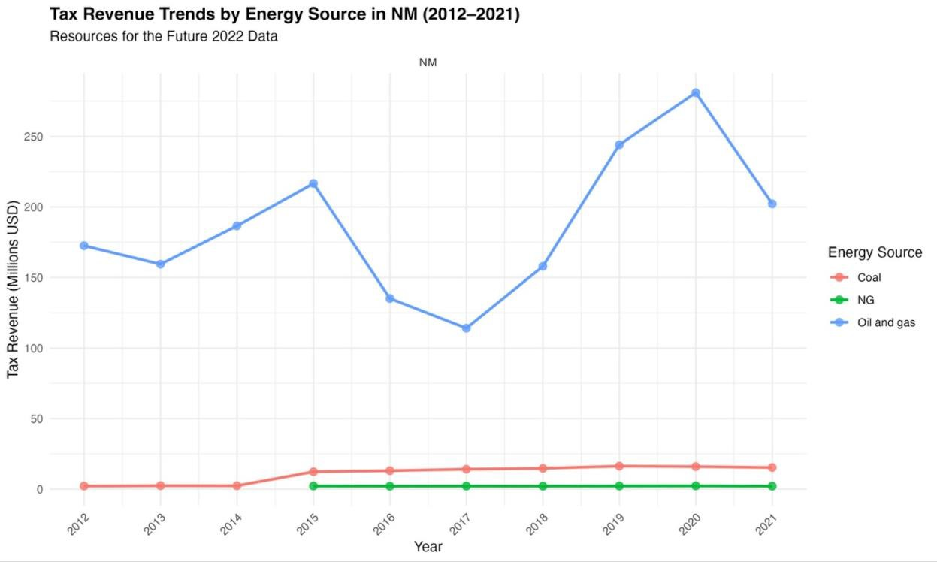

*Figure 3. Tax Revenue Trends by Energy Source in New Mexico*

Decreased oil prices in the mid 2010s resulted in equally decreased tax revenues for oil and gas. Increases post 2017 track along with increased oil production which has been climbing steadily from 406,000 barrels produced per day in 2015 to more than 1 million by 2020 and reached a record 2 million daily-barrels of crude oil production in 2024.[126](https://docs.google.com/document/d/1Tng4jrmN1WNZ2GesDEHIEzQMZd77Y-E-xqK3g0b_J08/edit#bookmark%3Did.l3op29q8umr8)

New Mexico remains one of the least energy diverse states, recording no tax revenues from 2012 to 2021 and few solar and wind projects starting in 2022. Recent projects––Sun Edison, EMCORE, and First Solar––will add 72 megawatts of energy production. These projects benefited from tax incentives, particularly the Renewable Energy Production Tax Credit (REPTC) which limits tax revenues for utility-scale renewable energy production.[127](https://docs.google.com/document/d/1Tng4jrmN1WNZ2GesDEHIEzQMZd77Y-E-xqK3g0b_J08/edit#bookmark%3Did.tbtnmeu5c9v3) The Renewable Energy Production Tax Act introduced in early 2025 is looking to tax renewable energy production at 3.75 of the value of megawatt-hour. If passed, the tax is estimated to result in more than $48 million in recurring revenue.[128](https://docs.google.com/document/d/1Tng4jrmN1WNZ2GesDEHIEzQMZd77Y-E-xqK3g0b_J08/edit#bookmark%3Did.yhv4ynuxhw0q)

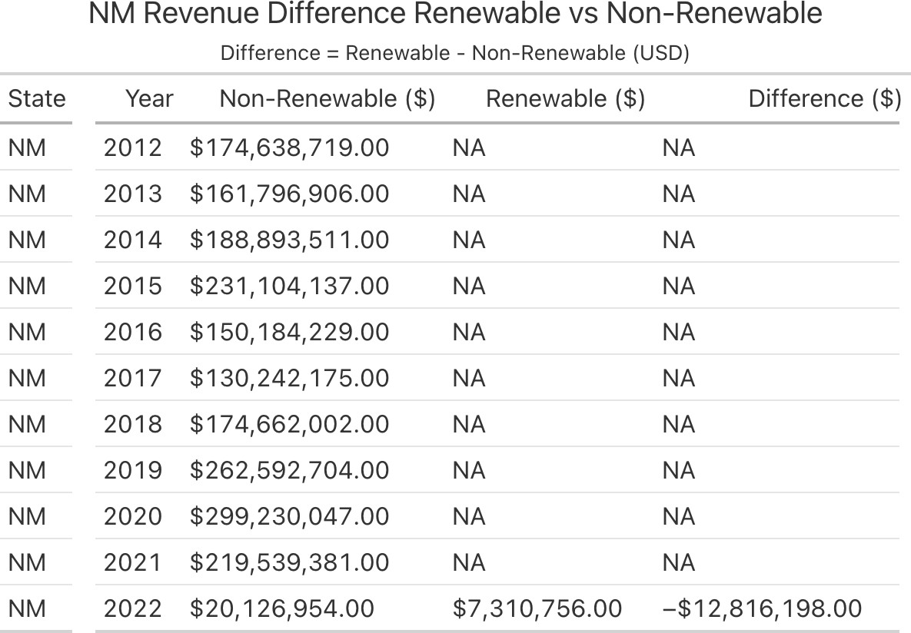

*Figure 4. Renewable and Nonrenewable Tax Revenue Difference in New Mexico*

### Key Stakeholders:

*New Mexico Oil and Gas Association (NMOGA):*

* + A coalition of oil and natural gas companies, individuals, and other stakeholders. NMOGA advocates for “responsible oil and natural gas policies and increased public understanding of industry operations and contributions to the state.”[129](https://docs.google.com/document/d/1Tng4jrmN1WNZ2GesDEHIEzQMZd77Y-E-xqK3g0b_J08/edit#bookmark%3Did.ltkv0ixhtqhz)

*Oil Conservation Division:*

* + A division of New Mexico’s Energy, Minerals, and Natural Resources Department (EMNRD) that regulates oil and gas activity in the state. The division is responsible for upholding and implementing all rules and statutes pertaining to oil and gas.[130](https://docs.google.com/document/d/1Tng4jrmN1WNZ2GesDEHIEzQMZd77Y-E-xqK3g0b_J08/edit#bookmark%3Did.4yqjm89fexy6)

*Navajo Transitional Energy Company (NTEC):*

* + NTEC’s purpose is to “promote the development of the Navajo Nation’s resources and new sources of energy, power, and transmission.”[131](https://docs.google.com/document/d/1Tng4jrmN1WNZ2GesDEHIEzQMZd77Y-E-xqK3g0b_J08/edit#bookmark%3Did.3de00umydkvz) NTEC owns the Navajo Mine as well as mines in Montana and Wyoming. NTEC has a stake in coal production, as they own the state’s only coal-fired power plant. They are currently focused on carbon-capture as opposed to plant closures.[132](https://docs.google.com/document/d/1Tng4jrmN1WNZ2GesDEHIEzQMZd77Y-E-xqK3g0b_J08/edit#bookmark%3Did.oxp17mcz2g88)

*Energy Conservation and Management Division (ECAM):*

* + A division of the EMNRD focused on advancing clean energy production in the state. ECAM is the U.S. Department of Energy’s designated State Energy Office. They receive federal funding from the DOE to support many of its initiatives.[133](https://docs.google.com/document/d/1Tng4jrmN1WNZ2GesDEHIEzQMZd77Y-E-xqK3g0b_J08/edit#bookmark%3Did.td3xlyjzzu0m)

### Key Governing Policies

*Energy Transition Act:*

* + New Mexico enacted the Energy Transition Act (ETA) in 2019, one of the most ambitious climate legislations in the country.[134](https://docs.google.com/document/d/1Tng4jrmN1WNZ2GesDEHIEzQMZd77Y-E-xqK3g0b_J08/edit#bookmark%3Did.d7iczzclz42g)
  + The ETA Requires half the state’s electricity to come from renewables by 2030 and all of its power to come from zero-carbon resources by 2045.
  + It seeks to soften the job and revenue losses from the closure of coal plants by earmarking

$40 million for displaced coal workers and community development projects.[135](https://docs.google.com/document/d/1Tng4jrmN1WNZ2GesDEHIEzQMZd77Y-E-xqK3g0b_J08/edit#bookmark%3Did.33rmrjyqg9f6)

* + Despite implementation challenges, the ETA spurred investments in solar, battery, and wind projects. The majority of New Mexico’s electricity generation comes from renewables currently, and the PNM retired the state’s largest coal-fired power plant in 2022[.136](https://docs.google.com/document/d/1Tng4jrmN1WNZ2GesDEHIEzQMZd77Y-E-xqK3g0b_J08/edit#bookmark%3Did.9zl9goasx8x)

*SB112: “Sustainable Economy Task Force”*

* + Policymakers understand that in New Mexico, heavy reliance on oil and gas for state revenue generation is not a salient method to uphold the state’s economy and provision of public services in the long-term.
  + In 2021, New Mexico passed a law creating the “Sustainable Economy Task Force” to “transition the state economy away from reliance on natural resource extraction.”[137](https://docs.google.com/document/d/1Tng4jrmN1WNZ2GesDEHIEzQMZd77Y-E-xqK3g0b_J08/edit#bookmark%3Did.rd5zn25epqh4)

*Economic Development Department’s Strategic Plan:*

* + In accordance with SB112, the state’s Economic Development Department continuously updates an “Empower and Collaborate” state strategic plan to diversify and stabilize state revenues.
  + In their 2024-25 update overview, the EDD seeks to encourage growth in other prominent sectors: Aerospace, Biosciences, Cybersecurity, Film and TV, Global Trade, Intelligent Manufacturing (AI), Outdoor Recreation, Sustainable & Green Energy, and Sustainable & Value-added Agriculture.[138](https://docs.google.com/document/d/1Tng4jrmN1WNZ2GesDEHIEzQMZd77Y-E-xqK3g0b_J08/edit#bookmark%3Did.1k8idrooa7f1)

The EDD’s strategic plan highlights a policy mechanism for the energy transition that not only focuses on the energy sector itself but on other sectors marked for potential growth. Intentional, policy-driven growth could both diversify revenue streams in the short-term and help the state prepare for the decline of oil & gas in the long-term. It is already doing so in New Mexico.[139](https://docs.google.com/document/d/1Tng4jrmN1WNZ2GesDEHIEzQMZd77Y-E-xqK3g0b_J08/edit#bookmark%3Did.y0op2snyzepl) [140](https://docs.google.com/document/d/1Tng4jrmN1WNZ2GesDEHIEzQMZd77Y-E-xqK3g0b_J08/edit#bookmark%3Did.f8j23nbf93rd)

*Oil & Gas Act*

* + The Oil and Gas Act is the primary governing statute for the regulation of oil and gas production in New Mexico. It became law in 1935 and has not been updated since the 1990s[.141](https://docs.google.com/document/d/1Tng4jrmN1WNZ2GesDEHIEzQMZd77Y-E-xqK3g0b_J08/edit#bookmark%3Did.3scno15er684)
  + Efforts persist to update the Oil & Gas Act. Reforms seek to increase fees and regulations for oil and gas companies surrounding oil well locations and abandoned oil wells.[142](https://docs.google.com/document/d/1Tng4jrmN1WNZ2GesDEHIEzQMZd77Y-E-xqK3g0b_J08/edit#bookmark%3Did.wbllteakrndz)

### All Renewable Energy Incentives:

|  |  |  |  |
| --- | --- | --- | --- |
| **Name** | **Policy/Incentive** | **Created** | **Last Updated** |
| [Biomass Equipment & Materials](https://programs.dsireusa.org/system/program/detail/359/biomass-equipment-materials-compensating-tax-deduction) [Compensating Tax Deduction](https://programs.dsireusa.org/system/program/detail/359/biomass-equipment-materials-compensating-tax-deduction) | Sales Tax Incentive | 4/29/2005 | 12/5/2023 |
| [Solar Energy Gross Receipts Tax Deduction](https://programs.dsireusa.org/system/program/detail/2566/solar-energy-gross-receipts-tax-deduction) | Sales Tax Incentive | 5/25/2007 | 12/5/2023 |
| [Gross Receipts Tax Exemption for Sales of](https://programs.dsireusa.org/system/program/detail/3980/gross-receipts-tax-exemption-for-sales-of-wind-and-solar-systems-to-government-entities) [Wind and Solar Systems to Government](https://programs.dsireusa.org/system/program/detail/3980/gross-receipts-tax-exemption-for-sales-of-wind-and-solar-systems-to-government-entities) [Entities](https://programs.dsireusa.org/system/program/detail/3980/gross-receipts-tax-exemption-for-sales-of-wind-and-solar-systems-to-government-entities) | Sales Tax Incentive | 2/16/2010 | 8/26/2024 |
| [Property Tax Exemption for Residential](https://programs.dsireusa.org/system/program/detail/4043/property-tax-exemption-for-residential-solar-systems) [Solar Systems](https://programs.dsireusa.org/system/program/detail/4043/property-tax-exemption-for-residential-solar-systems) | Property Tax Incentive | 3/24/2010 | 3/24/2023 |
| [Agricultural Biomass Income Tax Credit](https://programs.dsireusa.org/system/program/detail/4495/agricultural-biomass-income-tax-credit-corporate) [(Corporate)](https://programs.dsireusa.org/system/program/detail/4495/agricultural-biomass-income-tax-credit-corporate) | Corporate Tax Credit | 12/14/2010 | 3/8/2023 |
| [Agricultural Biomass Income Tax Credit](https://programs.dsireusa.org/system/program/detail/4496/agricultural-biomass-income-tax-credit-personal) [(Personal)](https://programs.dsireusa.org/system/program/detail/4496/agricultural-biomass-income-tax-credit-personal) | Personal Income Tax Credit | 12/14/2010 | 3/8/2023 |
| [2021 Sustainable Building Tax Credit](https://programs.dsireusa.org/system/program/detail/22423/2021-sustainable-building-tax-credit-corporate) [(Corporate)](https://programs.dsireusa.org/system/program/detail/22423/2021-sustainable-building-tax-credit-corporate) | Corporate Tax Credit | 12/8/2021 | 6/2/2023 |
| [2021 Sustainable Building Tax Credit](https://programs.dsireusa.org/system/program/detail/22424/2021-sustainable-building-tax-credit-personal) [(Personal)](https://programs.dsireusa.org/system/program/detail/22424/2021-sustainable-building-tax-credit-personal) | Personal Tax Credit | 12/8/2021 | 6/2/2023 |
| [New Solar Market Development Tax Credit](https://programs.dsireusa.org/system/program/detail/22472/new-solar-market-development-tax-credit) | Personal Tax Credit | 8/16/2022 | 6/2/2023 |

***Political Influences and Landscape***

Oil and gas revenues make up a significant portion of the state’s general fund budget. However, the oil and gas industry also contributes more than a third of its greenhouse gas emissions.[143](https://docs.google.com/document/d/1Tng4jrmN1WNZ2GesDEHIEzQMZd77Y-E-xqK3g0b_J08/edit#bookmark%3Did.om5khr5pcw5b) As federal climate regulations roll back during the Trump administration, the state legislature will hold greater leverage in holding the oil and gas industry accountable in compliance with the 2019 ETA.[144](https://docs.google.com/document/d/1Tng4jrmN1WNZ2GesDEHIEzQMZd77Y-E-xqK3g0b_J08/edit#bookmark%3Did.mlolsm3bs48c) Historically, largely due to the magnitude of revenues, legislation aiming to regulate at the state-level receives significant opposition from industry lobbyists and Republican legislators.[145](https://docs.google.com/document/d/1Tng4jrmN1WNZ2GesDEHIEzQMZd77Y-E-xqK3g0b_J08/edit#bookmark%3Did.eeaem5yxvhl4)

Democratic governor Lujan Grisham is committed to updating the Oil and Gas Act. As of the completion of this report, SB4, or the “Clean Horizons and Greenhouse Gas Emissions” bill has passed its first committee hearing.[146](https://docs.google.com/document/d/1Tng4jrmN1WNZ2GesDEHIEzQMZd77Y-E-xqK3g0b_J08/edit#bookmark%3Did.lcsyt7tkwgvt) The bill aims to codify the 2019 ETA and pass new climate- based regulations surrounding emissions and oil well locations. The bill also places governance over emissions in the hands of New Mexico’s Environmental Improvement Board.[147](https://docs.google.com/document/d/1Tng4jrmN1WNZ2GesDEHIEzQMZd77Y-E-xqK3g0b_J08/edit#bookmark%3Did.i8bqlpoy4740)

In political contributions for 2024, the top ten oil and gas industry contributors gave $1.2 million to Democratic state candidates while giving $1.1 million to Republicans.[148](https://docs.google.com/document/d/1Tng4jrmN1WNZ2GesDEHIEzQMZd77Y-E-xqK3g0b_J08/edit#bookmark%3Did.tpx3iz11qhji) This illustrates a political paradox when compared to national trends: New Mexico is a democrat-controlled state with a heavy reliance on oil and gas. Thus, industry stakeholders such as Chevron must give money to the most politically viable candidates in order to secure support for their interests.[149](https://docs.google.com/document/d/1Tng4jrmN1WNZ2GesDEHIEzQMZd77Y-E-xqK3g0b_J08/edit#bookmark%3Did.aqp7xgblqf2j)

## Colorado

In 2019, Colorado published a roadmap to 100% renewable energy by 2040 giving directions, policies, and specific actions toward decarbonization in energy production and electrification. This and other related climate initiatives aim to diversify electric and other critical services (e.g. gas) while reducing the risk and impacts of climate-related events including wildfires, drought, flood, and the loss of ecosystems.

### Overall Production and Capacity

According to the U.S. Energy Information Administration, Colorado is among the top 10 states in total energy production. Colorado's geology and geography allow for the exploration of both renewable and non-renewable energy, including solar, wind, crude oil, natural gas, and coal.

*Petroleum:*

* + Colorado is the fourth-largest producer of oil and the eighth-largest producer of natural gas in the U.S., producing 4% of total crude oil. [150](https://docs.google.com/document/d/1Tng4jrmN1WNZ2GesDEHIEzQMZd77Y-E-xqK3g0b_J08/edit#bookmark%3Did.reld7wjt3ug6)
  + Most crude oil production comes from one county, Weld County, where 8 out of every 10 barrels of crude oil are produced. [151](https://docs.google.com/document/d/1Tng4jrmN1WNZ2GesDEHIEzQMZd77Y-E-xqK3g0b_J08/edit#bookmark%3Did.i220r6lvvmzu)
  + Severance tax revenues from oil and gas fell by 48.7 percent in FY 2023-2024. They are forecasted to stabilize but are on a negative trajectory as outlined by the [Economic and](https://leg.colorado.gov/sites/default/files/images/sept2024forecastforposting.pdf) [Revenue Forecast.](https://leg.colorado.gov/sites/default/files/images/sept2024forecastforposting.pdf)

*Coal:*

* + Coal-fired power plants account for 39% of Colorado’s total in-state electricity generation in 2023. This is a decrease of 68% in 2010.[152](https://docs.google.com/document/d/1Tng4jrmN1WNZ2GesDEHIEzQMZd77Y-E-xqK3g0b_J08/edit#bookmark%3Did.xrzkw29apbrc)
  + While demand for coal-powered energy increased in 2022 due to increased oil prices, 2500 megawatts of coal-fired generating capacity in Colorado is scheduled to retire by 2029.[153](https://docs.google.com/document/d/1Tng4jrmN1WNZ2GesDEHIEzQMZd77Y-E-xqK3g0b_J08/edit#bookmark%3Did.5gty5sygt7ii)

*Renewables:*

* + Renewable energy accounted for 39% of Colorado’s total in-state electricity net generation.
  + Wind energy is the dominant renewable energy source in Colorado. The largest share of renewable energy generation (70%) comes from wind power.[154](https://docs.google.com/document/d/1Tng4jrmN1WNZ2GesDEHIEzQMZd77Y-E-xqK3g0b_J08/edit#bookmark%3Did.qo96z1mx58g9) This generates 70,000 MW and nearly $50 million in annual tax and land lease revenue. [155](https://docs.google.com/document/d/1Tng4jrmN1WNZ2GesDEHIEzQMZd77Y-E-xqK3g0b_J08/edit#bookmark%3Did.16zzkpcd1su)

### Energy Revenue Breakdown:

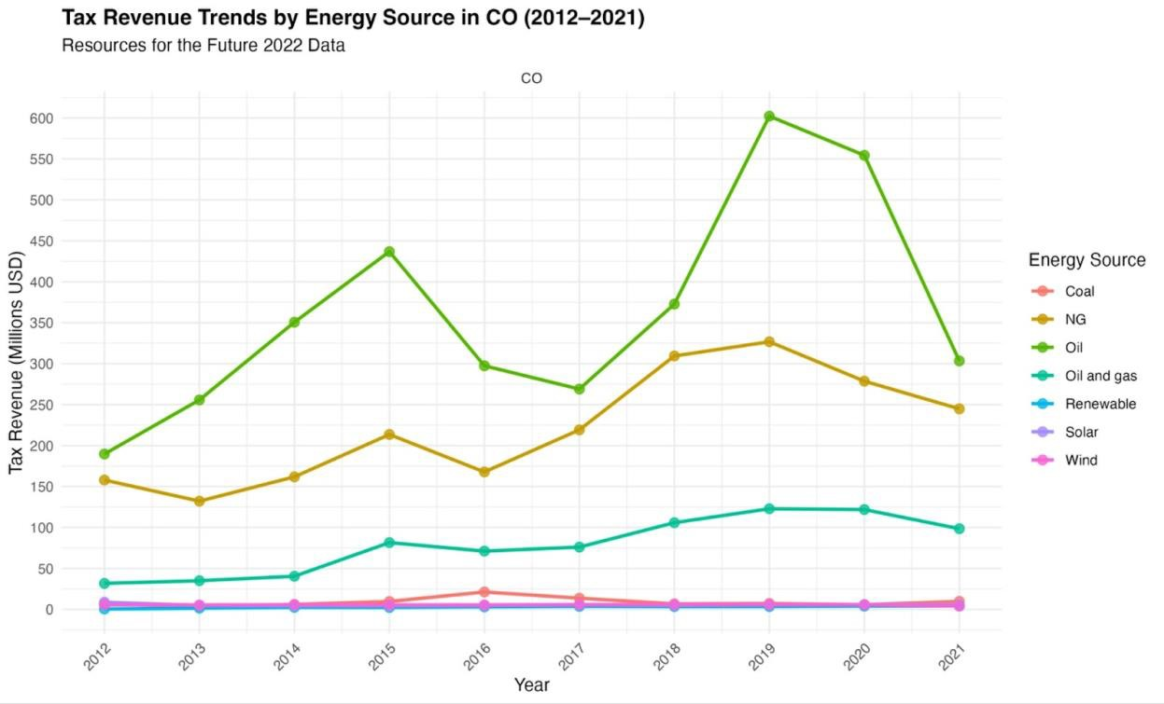

*Figure 5. Tax Revenue Trends by Energy Source in Colorado*

Like all states in our case study analysis, oil and natural gas revenues decreased in 2017 due to decreases in production and decreased prices. As the figure suggests, Colorado enjoys a diverse energy-tax based and production compared to other case-study states, yet remains dependent on non-renewable tax revenues. Despite growing investments and capacity in renewable energy production, gross tax revenues remained stable from 2012 to 2021in large part due to the Components of Renewable Energy (2007 HB-07-1279) exception that allows for “all sales, storage, and use of components used in the production of alternating current electricity from a renewable energy source…[to] be exempt from taxation…”[156](https://docs.google.com/document/d/1Tng4jrmN1WNZ2GesDEHIEzQMZd77Y-E-xqK3g0b_J08/edit#bookmark%3Did.6zzfaehyxhi2) According to a 2019 estimate, Colorado is foregoing approximately $6.2 million in annual tax revenue as a result of this tax exemption. [157](https://docs.google.com/document/d/1Tng4jrmN1WNZ2GesDEHIEzQMZd77Y-E-xqK3g0b_J08/edit#bookmark%3Did.skr30cax4u4t)

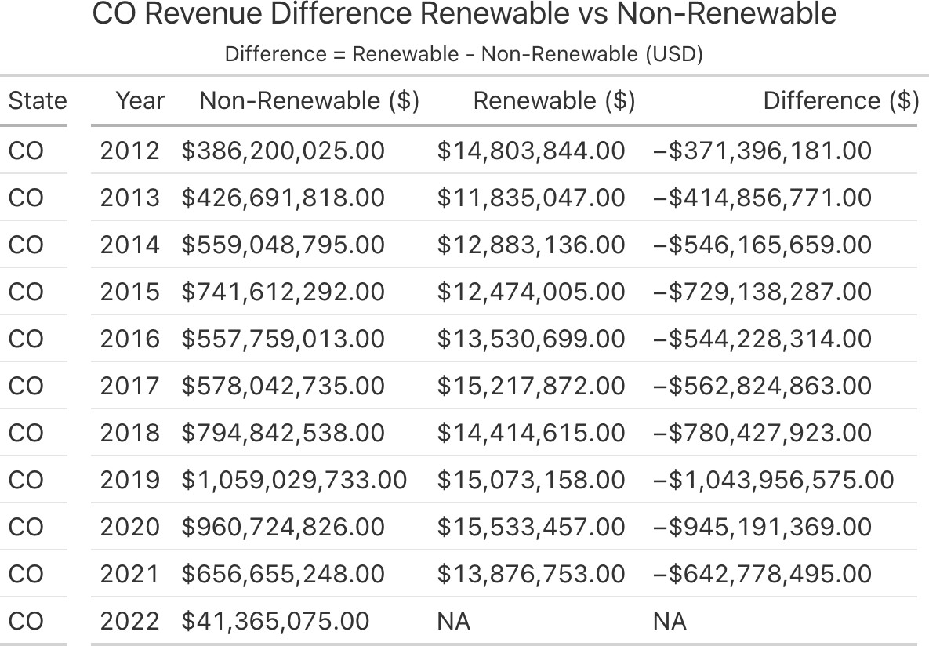

*Figure 6. Renewable and Nonrenewable Tax Revenue Difference in New Mexico*

### Key Stakeholders

*The Colorado Energy Office (CEO):*

* + Develops policy for clean energy with an explicit goal to address marginalized and “disproportionately impacted communities” across the state.[158](https://docs.google.com/document/d/1Tng4jrmN1WNZ2GesDEHIEzQMZd77Y-E-xqK3g0b_J08/edit#bookmark%3Did.1ffq2xlo13zw)
  + Manages programs to subsidize zero-emission tax vehicles through tax credits, provides home weatherization assistance, provides technical, policy, and financial assistance for state and local government energy initiatives, and is the key institution backing the state’s 100% Renewable by 2040 initiative.
  + Composed of 8 teams: (1)Building Decarbonization,(2) Community and Engagement,

(3)Finance and Operations, (4)Policy and Regulatory Affairs, (5)Strategic Initiatives & Financing, (6)Transportation, (7)Weatherization Assistance Program, and (8) Local Government & Climate Solutions. [159](https://docs.google.com/document/d/1Tng4jrmN1WNZ2GesDEHIEzQMZd77Y-E-xqK3g0b_J08/edit#bookmark%3Did.8ivrhtqwisp0)

*Office Just Transition (OJT):*

* + Created through the 2019 decarbonization initiative established in House Bill 19-1314, the Office of Just Transition within the Colorado Department of Labor & Employment works to support coal workers and coal-dependent communities through re-training and job support, broadening the property tax base, and increasing local economic diversity. [160](https://docs.google.com/document/d/1Tng4jrmN1WNZ2GesDEHIEzQMZd77Y-E-xqK3g0b_J08/edit#bookmark%3Did.dxlkb5hre9mu)
  + It is the nation’s first state-level office dedicated to helping communities historically reliant on coal revenues.[161](https://docs.google.com/document/d/1Tng4jrmN1WNZ2GesDEHIEzQMZd77Y-E-xqK3g0b_J08/edit#bookmark%3Did.9cevm54bkbv0)

*Colorado Public Utilities Commission (PUC):*

* + The PUC regulates utilities and facilities to guarantee safe, reliable, and service prices.[162](https://docs.google.com/document/d/1Tng4jrmN1WNZ2GesDEHIEzQMZd77Y-E-xqK3g0b_J08/edit#bookmark%3Did.g1t1t33hpvf0)
  + Handles permitting for all utility-based construction including gas, electric, telecommunications, solar, wind, and water.
  + Currently manages a utility bill help program in collaboration with the state utility providers Atmos Energy, Black Hills Energy, Colorado Natural Gas, and Xcel Energy to limit home natural gas and electric bills to a maximum of 6% of the user’s annual income.[163](https://docs.google.com/document/d/1Tng4jrmN1WNZ2GesDEHIEzQMZd77Y-E-xqK3g0b_J08/edit#bookmark%3Did.2vbu4l2oqxi8)

*Colorado Department of Public Health and Environment (CDPHE):*

* + The CDPHE is responsible for tracking greenhouse gas pollution in Colorado as part of the state's clean energy transition policy and its efforts to address emerging health issues.
  + Enacted a 2024 Public Health Improvement Plan related to improving air quality to focus on climate action and air quality, racism as a public health crisis, and health inequities. [164](https://docs.google.com/document/d/1Tng4jrmN1WNZ2GesDEHIEzQMZd77Y-E-xqK3g0b_J08/edit#bookmark%3Did.bpdux6y583o)

Colorado’s diverse energy profile includes legacy providers Noble Energy, and PDC Energy, investor-owned utilities like Xcel and Black Hills Energy, non-profit cooperative utilities like the Colorado Rural Electric Association and the Tri-State Generation and Transmission, and public and municipal utilities Arkansas River Power Authority, Colorado Association of Municipal Utilities, Platte River Power Authority, and the Western Area Power Authority. [165](https://docs.google.com/document/d/1Tng4jrmN1WNZ2GesDEHIEzQMZd77Y-E-xqK3g0b_J08/edit#bookmark%3Did.3m8dabuou614)

* + Per HB23-1039 (Electric Resource Adequacy Reporting), these utilities provide annual reports about the status of electric resources that the CEO uses to assess as part of the clean energy transition plan. [166](https://docs.google.com/document/d/1Tng4jrmN1WNZ2GesDEHIEzQMZd77Y-E-xqK3g0b_J08/edit#bookmark%3Did.8hn0wjkad17u) Excel Energy, which supplies 35% of the state's electricity aims to reduce its carbon emissions by 80% through 2030 while adding 3,000 megawatts of power produced through two wind farms in eastern Colorado. [167](https://docs.google.com/document/d/1Tng4jrmN1WNZ2GesDEHIEzQMZd77Y-E-xqK3g0b_J08/edit#bookmark%3Did.mw7achrkaspg)

Nearly all renewable energy production stems from private efforts. Vesta’s, a wind tower manufacturer, is a notable player in the state’s clean energy and labor and is the largest wind- energy turbine manufacturing plant in the world. [168](https://docs.google.com/document/d/1Tng4jrmN1WNZ2GesDEHIEzQMZd77Y-E-xqK3g0b_J08/edit#bookmark%3Did.nf1xn3tntp6t) In 2024, CS wind doubled its output to 10,000 wind turbines. Vikram Solar is investing $250 million in new solar modules in Brighton, Colorado, while Meyer Burger intends to build a 2GW solar cell manufacturing facility in Colorado Springs.[169](https://docs.google.com/document/d/1Tng4jrmN1WNZ2GesDEHIEzQMZd77Y-E-xqK3g0b_J08/edit#bookmark%3Did.1apcuowiavue)

### Key Governing Policies

*HB 19-1314* :

* + Enacted in 2019; Established the Just Transition Office within the Colorado Department of Labor and Employment. This office is tasked with assisting communities and workers impacted by the decline of coal-related industries.
  + The legislation provides benefits to coal transition workers, enabling them to support themselves and their families during the transition period.
  + Additionally, grants are awarded to eligible entities in coal transition communities aiming to diversify and strengthen their local economies.[170](https://docs.google.com/document/d/1Tng4jrmN1WNZ2GesDEHIEzQMZd77Y-E-xqK3g0b_J08/edit#bookmark%3Did.w6mbxh9i3tft)
  + The act also mandates that utilities proposing the accelerated retirement of coal-fueled electric generating facilities submit workforce transition plans at least six months before the facility's retirement. [171](https://docs.google.com/document/d/1Tng4jrmN1WNZ2GesDEHIEzQMZd77Y-E-xqK3g0b_J08/edit#bookmark%3Did.6q5xgfuxfnl6)

*The Climate Action Plan to Reduce Pollution, established by HB 19-1261*

* + Sets statewide greenhouse gas (GHG) emission reduction goals: a 26% reduction by 2025, a 50% reduction by 2030, and a 90% reduction by 2050, all relative to 2005 levels.[172](https://docs.google.com/document/d/1Tng4jrmN1WNZ2GesDEHIEzQMZd77Y-E-xqK3g0b_J08/edit#bookmark%3Did.vnraxuar1gh9)
  + The plan identifies "disproportionately impacted communities" that are more vulnerable to environmental and health burdens. [173](https://docs.google.com/document/d/1Tng4jrmN1WNZ2GesDEHIEzQMZd77Y-E-xqK3g0b_J08/edit#bookmark%3Did.cyo2gnaculb1)
  + Also encourages the development of clean energy plans, anticipating that such initiatives will lead to a decrease in retail electricity sales from oil and gas sources.[174](https://docs.google.com/document/d/1Tng4jrmN1WNZ2GesDEHIEzQMZd77Y-E-xqK3g0b_J08/edit#bookmark%3Did.vfvo1pmp1dci)

*Senate Bill 19-236:*

* + Requires utilities to incorporate workforce transition and community assistance plans when retiring existing coal plants.
  + If localities have approved projects expected to be financed by property tax revenues lost from plant closures, new utilities must commit to "community assistance" payments equal to the cost of these projects. [175](https://docs.google.com/document/d/1Tng4jrmN1WNZ2GesDEHIEzQMZd77Y-E-xqK3g0b_J08/edit#bookmark%3Did.lc47msggqhs6)
  + The bill also allows utility companies to sell bonds as a mechanism to meet payment obligations, facilitating a smoother financial transition for affected communities. [176](https://docs.google.com/document/d/1Tng4jrmN1WNZ2GesDEHIEzQMZd77Y-E-xqK3g0b_J08/edit#bookmark%3Did.w861rw47etbc)

*Environmental Justice Disproportionate Impacted Community HB21-1266:*

* + Defines a "disproportionately impacted community" (DIC) based on criteria such as housing cost burden and historical policies that have perpetuated environmental racism, including redlining.[177](https://docs.google.com/document/d/1Tng4jrmN1WNZ2GesDEHIEzQMZd77Y-E-xqK3g0b_J08/edit#bookmark%3Did.ns1wqqm0ab3w)
  + The legislation requires the Air Quality Control Commission (AQCC) to promote targeted outreach and education regarding climate burdens in these communities.
  + Establishes the Environmental Justice Action Task Force, ensuring that input from affected communities is centered in environmental decision-making processes.

Colorado does not currently offer broad statewide property tax incentives for renewable energy. However, under Colorado Revised Statutes §§ 30-11-107.3 and 31-20-101.3, county and municipal governments have the authority to provide incentives—such as property or sales tax credits or rebates—to residential or commercial property owners who install renewable energy systems on their properties.[178](https://docs.google.com/document/d/1Tng4jrmN1WNZ2GesDEHIEzQMZd77Y-E-xqK3g0b_J08/edit#bookmark%3Did.a93nsdidwusl)

Colorado's severance tax, imposed on the extraction of natural resources like oil, gas, coal, and minerals, contributes to the state's budget. However, as the state transitions away from fossil fuels, these revenues are forecasted to decline. In 2021, oil and gas property taxes accounted for 5.2% of total property tax revenue in Colorado, with 36 of the state's 64 counties receiving some revenue from this source.[179](https://docs.google.com/document/d/1Tng4jrmN1WNZ2GesDEHIEzQMZd77Y-E-xqK3g0b_J08/edit#bookmark%3Did.s7eivnl91fdv) According to the Colorado Fiscal Institute, the largest portion of tax revenue from oil and gas comes from local property taxes.

### All Renewable Energy Incentives:

|  |  |  |  |
| --- | --- | --- | --- |
| **Name** | **Policy/Incentive** | **Created** | **Last Updated** |
| [Renewable Energy Property Tax Assessment](https://programs.dsireusa.org/system/program/detail/2388/renewable-energy-property-tax-assessment) | Property Tax Incentive | 2/16/2007 | 12/4/2023 |
| [Local Option - Property Tax Exemption for](https://programs.dsireusa.org/system/program/detail/2501/local-option-property-tax-exemption-for-renewable-energy-systems) [Renewable Energy Systems](https://programs.dsireusa.org/system/program/detail/2501/local-option-property-tax-exemption-for-renewable-energy-systems) | Property Tax Incentive | 4/27/2007 | 12/6/2023 |
| [Local Option - Sales and Use Tax Exemption](https://programs.dsireusa.org/system/program/detail/2502/local-option-sales-and-use-tax-exemption-for-renewable-energy-systems) [for Renewable Energy Systems](https://programs.dsireusa.org/system/program/detail/2502/local-option-sales-and-use-tax-exemption-for-renewable-energy-systems) | Sales Tax Incentive | 4/27/2007 | 12/12/2024 |
| [Sales and Use Tax Exemption for Renewable](https://programs.dsireusa.org/system/program/detail/3397/sales-and-use-tax-exemption-for-renewable-energy-equipment) [Energy Equipment](https://programs.dsireusa.org/system/program/detail/3397/sales-and-use-tax-exemption-for-renewable-energy-equipment) | Sales Tax Incentive | 5/27/2009 | 12/10/2024 |
| [City of Boulder - Solar Sales and Use Tax](https://programs.dsireusa.org/system/program/detail/4082/city-of-boulder-solar-sales-and-use-tax-rebate) [Rebate](https://programs.dsireusa.org/system/program/detail/4082/city-of-boulder-solar-sales-and-use-tax-rebate) | Sales Tax Incentive | 4/8/2010 | 3/17/2025 |
| [Property Tax Exemption for Residential](https://programs.dsireusa.org/system/program/detail/4210/property-tax-exemption-for-residential-renewable-energy-equipment) [Renewable Energy Equipment](https://programs.dsireusa.org/system/program/detail/4210/property-tax-exemption-for-residential-renewable-energy-equipment) | Property Tax Incentive | 6/16/2010 | 3/17/2025 |
| [Electric Vehicle Income Tax Credit](https://programs.dsireusa.org/system/program/detail/22156/electric-vehicle-income-tax-credit) | Personal Tax Credit | 5/21/2021 | 6/2/2023 |
| [Tax Credit for Residential Energy Storage](https://programs.dsireusa.org/system/program/detail/22490/tax-credit-for-residential-energy-storage-systems) [Systems](https://programs.dsireusa.org/system/program/detail/22490/tax-credit-for-residential-energy-storage-systems) | Personal Tax Credit | 2/22/2023 | 12/5/2023 |
| [Sales Tax Exemption for Energy Storage](https://programs.dsireusa.org/system/program/detail/22489/sales-tax-exemption-for-energy-storage-systems) [Systems](https://programs.dsireusa.org/system/program/detail/22489/sales-tax-exemption-for-energy-storage-systems) | Sales Tax Incentive | 2/22/2023 | 12/12/2024 |

***Political Landscape***

Colorado demonstrates a strong commitment to transitioning towards clean energy, notably by reducing reliance on coal and significantly expanding wind energy infrastructure. The state's Renewable Portfolio Standard mandates that 30% of its electricity come from renewable sources by 2020, a goal that has driven substantial investments in wind power.[180](https://docs.google.com/document/d/1Tng4jrmN1WNZ2GesDEHIEzQMZd77Y-E-xqK3g0b_J08/edit#bookmark%3Did.pk8wbsrjqq9z)

Despite state leadership's support for clean energy initiatives, economic concerns persist in regions heavily dependent on coal. For instance, in Northwest Colorado, the coal industry contributes approximately 21.7% to the regional GDP and accounts for 8.2% of local employment, highlighting the potential economic impact of transitioning away from coal.[181](https://docs.google.com/document/d/1Tng4jrmN1WNZ2GesDEHIEzQMZd77Y-E-xqK3g0b_J08/edit#bookmark%3Did.mmhsbohqww6i)

To address the challenges faced by coal-dependent communities, Colorado implemented programs aimed at retraining workers for employment in the renewable energy sector. However, the transition remains challenging, as these communities must adapt to new industries and economic realities. Efforts are ongoing to build economic resilience in these regions, but the process is complex and requires comprehensive support.

Key political stakeholders in Colorado's clean energy transition include Governor Jared Polis, a strong advocate for renewable energy, who has set ambitious goals for reducing greenhouse gas emissions. The Colorado General Assembly played a pivotal role by passing legislation supporting renewable energy initiatives, such as House Bill 19-1261, which sets targets for emission reductions. Additionally, local governments have contributed by offering incentives for clean energy investments, further promoting the state's transition to a sustainable energy future.

# Financial Data Analysis

## Revenues

Using R for repeatability and data visualization, we analyzed financial data from Resources for the Future 2022 with over 40,000 records of tax revenues at the county level.[182](https://docs.google.com/document/d/1Tng4jrmN1WNZ2GesDEHIEzQMZd77Y-E-xqK3g0b_J08/edit#bookmark%3Did.4uz9859k9wvh) Aggregating the data by grouping revenues by type of energy source (renewable and non-renewable) the trend toward diversification is clear. By 2022, tax revenues from renewable sources tripled as a percentage of total annual revenues from 0.67% in 2012 to 2.31% by 2022.

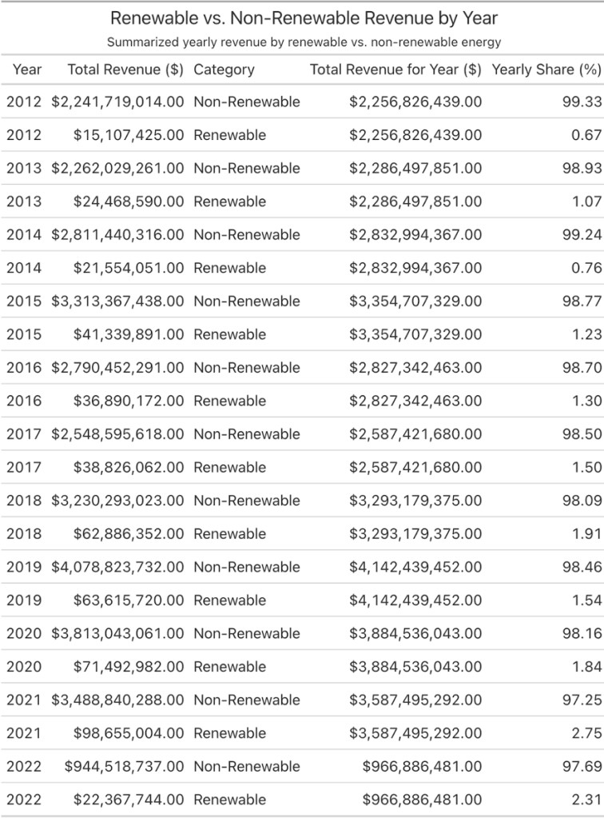

*Figure 7. Aggregated National Tax Revenues by Year and Energy type*

As mentioned previously in the state case studies, market volatility in oil and gas prices during the 2016 exposed states to significantly decreased revenues at the national level. Nevertheless, increases in oil production in subsequent years continue along with increases in energy demand. From Figure 7 and Figure 8, it’s clear that despite immense gaps in overall tax revenue production, revenues from renewable sources are showing a consistent upward trend.

Diversification in energy production will likely result in reduced exposure to price-shocks and market dynamics that could result in significant shifts in prices and therefore tax revenue.

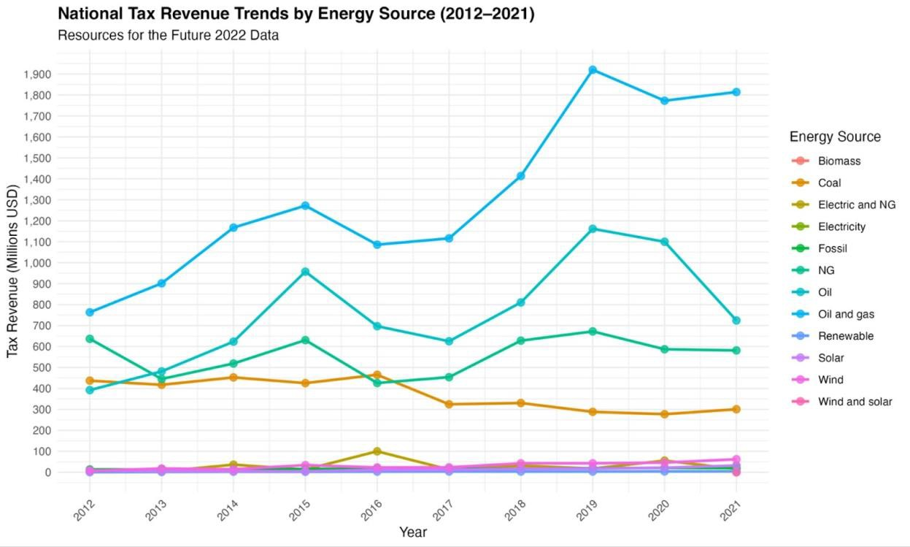

*Figure 8. National Tax Revenue Trends by Energy Source*

## Recipients

Tax revenues represent a significant source of revenue to fund essential public services. Financial analysis suggests that schools and school districts receive and overwhelming amount of financial resources from energy-related taxes. Facing significant cutbacks in federal spending, policies related to the collection and use of energy taxes will inevitably impact educational programs which are largely funded through state budgets. Although counties are the second largest recipient at the national level some counties are much more heavily impacted than others. Since energy production is usually concentrated in specific areas within states, the effects of policies are equally heterogeneous and region dependent.

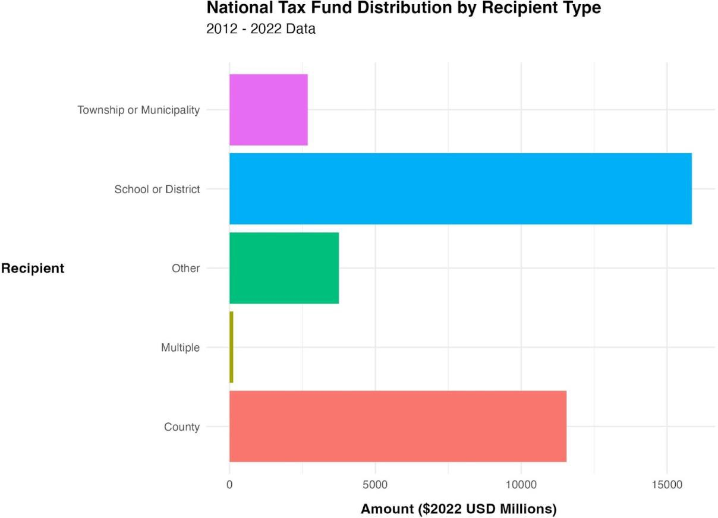

*Figure 9. National Tax Revenue by Recipient Type*

# Appendix A: Interviews

## Clean Energy Experts

*Sarah Mills, Associate Professor of Practice in Urban and Regional Planning, University of Michigan; Director, Center for EmPowering Communities, Graham Sustainability Institute, University of Michigan*

Key Takeaways:

* **Ad valorem taxes depreciate**: This form of taxation is commonly used across states, but causes declines in revenue over time, causing concerns for long-term revenue maintenance.
* **Oklahoma’s failed zero-emissions tax credit**: Oklahoma used a tax credit to incentivize wind development that ultimately led to financial instability.
* **Concerns of Washington policymakers**: Policymakers in Washington are worried about how to effectively sustain services funded by new clean energy tax revenue.
* **Economic diversification is essential**: States should avoid dependence on clean energy revenues, instead building a diverse tax revenue stream.

Sarah Mills is the Director of the Center for Empowering Communities at the University of Michigan’s Graham Sustainability Institute. Ms. Mills emphasized the challenges of maintaining a stable tax revenue while transitioning to clean energy, especially as it relates to current, incomplete approaches. For example, Ms. Mills noted that ad valorem taxation, the most common clean energy tax type across states, is vulnerable to depreciation—renewable energy assets lose value over time and tax revenue declines as a result. Since investments in services are typically based on initial revenue projections, this depreciation is a significant challenge for local governments as they work to maintain stable revenue. Ms. Mills also noted that clean energy revenue cannot fully replace revenue from fossil fuels. As a result, she emphasized the need for economic diversification, suggesting that over-reliance on clean energy revenues is misguided.

Ms. Mills also provided state-level examples of clean energy incentive strategies and related policy concerns. For example, she discussed Oklahoma’s refundable zero-emission tax credit. She explained that while the tax credit successfully attracted wind developers, it led to significant financial instability. She noted that Oklahoma’s failure can be used to inform future policy structures. Ms. Mills also discussed Washington, as an example of policymakers’ ongoing concerns. She said that state policymakers are worried about how to sustain public services supported by clean energy revenue without using tax increases.

## Tax Experts

*Anna Phillips: Policy Analyst, State Fiscal Policy Team, Center on Budget and Policy Priorities and Wesley Tharpe: Senior Advisor for State Tax Policy, Center on Budget and Policy Priorities*

Key Takeaways:

* **Vermont and New York are implementing unique strategies:** These states are utilizing superfunds and cap-and-invest policies to tax polluters, offering examples of possible program innovations.
* **A decline in federal support for localities has strained resources:** Local level federal funding has declined from 25% in the 1970s to 5-10% today.
* **Tax Cuts and Jobs Act (TCJA) and Inflation Reduction Act (IRA) are key policies:** These policies are shaping federal and state tax policies and opportunities for clean energy financing.

Anna Phillips and Welsey Tharpe work on the State Fiscal Policy Team at the CBPP. Ms. Phillips is a Policy Analyst and Mr. Tharpe is the Senior Advisor for State Tax Policy. They discussed the importance of sustainable revenue generation, while also emphasizing the challenges states face in doing so. For example, they noted that many states struggle to balance property tax policies because universities and corporations often receive tax exemptions that reduce the overall revenue available for public services. If not carefully designed, these policies could create long-term fiscal imbalances, such as those created by oil and gas subsidies. In particular, they expressed the need to ensure that clean energy incentives do not lead to undue financial burdens on local governments, especially as economic structures shift. They discussed innovative strategies in Vermont and New York, including superfunds and cap-and-invest programs, which are being used to generate revenue for clean energy transitions by taxing polluters. However, they suggest that states may want to rely on broader, more general tax policy tools to maintain revenue stability over time.

Ms. Phillips and Mr. Tharpe also emphasized federal policy as a key factor in state tax decisions, especially during times of economic transition. They discussed that while federal funding constitutes approximately one-third of state budgets, it has significantly declined at the local level, dropping from 25% in the 1970s to 5-10% today. This decline has forced local governments to more heavily rely on regressive taxation mechanisms, including property and sales taxes. They explained that “conformity” laws, which require states to align their tax codes with federal tax policies, have significantly impacted state tax structures, as evidenced by the Tax Cuts and Jobs Act (TCJA). They also highlighted the importance of the Inflation Reduction Act (IRA) and its ongoing influence on how states will finance clean energy transitions. Some states, for example, have implemented “millionaire taxes” to support infrastructure and climate initiatives.

## State Experts

*Paige Knight: Deputy Policy Director, New Mexico Voices for Children*

Key Takeaways:

* **New Mexico is heavily dependent on fossil fuel revenue:** Approximately one-third of New Mexico's general revenue comes from oil and gas production, adding challenges to clean energy development.
* **State leaders are making revenue diversification efforts:** Recent policy measures, including increased corporate income tax rates and royalty rates, are being used to diversify revenue from energy taxes.
* **Influence of fossil fuel industry presents challenges:** Strong fossil fuel industry influence in New Mexico has impacted opportunities for clean energy initiatives
* **Equity is a key policy consideration in New Mexico:** Policymakers and advocates are emphasizing the need for an equitable, or just, transition, especially as it relates to supporting affected workers.

Paige Knight is the Deputy Policy Director at New Mexico Voices for Children. She emphasized New Mexico’s unique challenges as a result of their substantial economic reliance on fossil fuel revenues. She highlighted that oil and gas production contributes approximately one-third of the state’s general revenue. While recent legislative efforts (corporate tax increases, royalty rate adjustments, and more) demonstrate a commitment to economic diversification, political influence from the fossil fuel industry is an ongoing obstacle to climate legislation.

Ms. Knight emphasized the need for equitable policy design and community investments, especially as a result of New Mexico’s persistent poverty issue. The Clean Horizons New Mexico program is an example of policy efforts to address equity concerns. This program allocates resources for energy efficiency improvements, grid modernization, and workforce development. These measures are designed to mitigate the disproportionate impacts of clean energy transitions on vulnerable communities, especially as a result of potential job loss. Ms. Knight noted that a successful clean energy transition will require economic diversification strategies, investments in vulnerable populations, and development of alternative revenue streams.

*Javier Balmaceda: Senior Policy Analyst on Puerto Rico, Federal Fiscal Policy Team, Center on Budget and Policy Priorities*

Key Takeaways:

* **Puerto Rico faces structural inequities in federal programs:** Puerto Rico is excluded from key tax credits, including the Earned Income Tax Credit (EITC), and clean energy incentives under the IRA, which has exacerbated poverty and stifled clean energy development.
* **Energy transition is complicated by outdated infrastructure:** Puerto Rico’s energy grid is outdated—the territory relies on plants that were mostly developed in the 1970s. Clean energy development has suffered as a result.

Javier Balmaceda is a Policy Analyst at the CBPP with a focus on Puerto Rico. Mr. Balmaceda emphasized how Puerto Rico’s territorial status has led to systemic inequities, such as exclusion from IRA tax credits. He discussed Puerto Rico’s unique energy challenges as a result of an outdated energy grid and political instability. For example, he noted that investment in clean energy has been stifled by reliance on federal aid and Puerto Rico’s debt crisis. Mr. Balmaceda highlighted PR100, a study that outlines energy system investment options in Puerto Rico, as a key resource to explore further.

# Appendix B: Case Study Revenue Figures

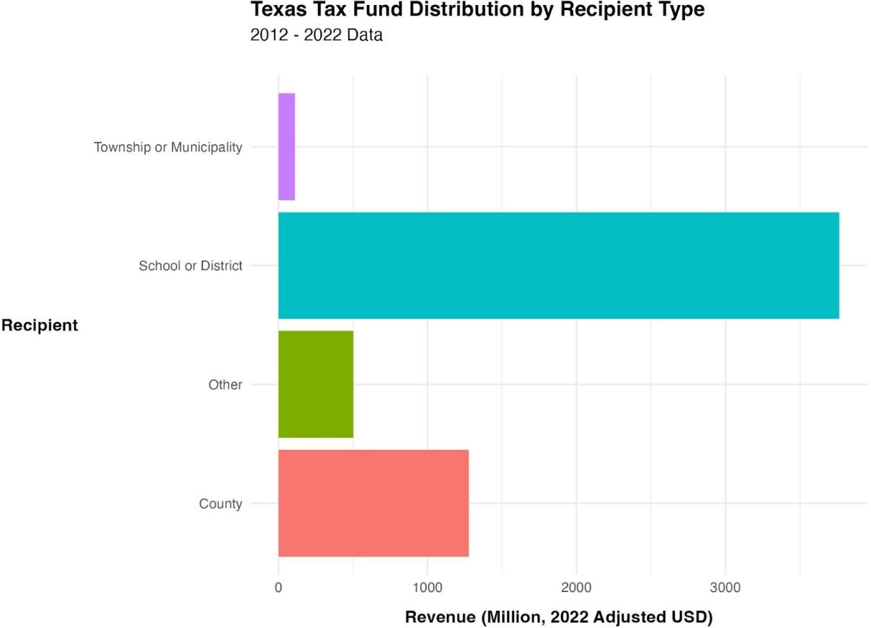

*Figure 10. Texas Tax Revenue by Recipient Type*

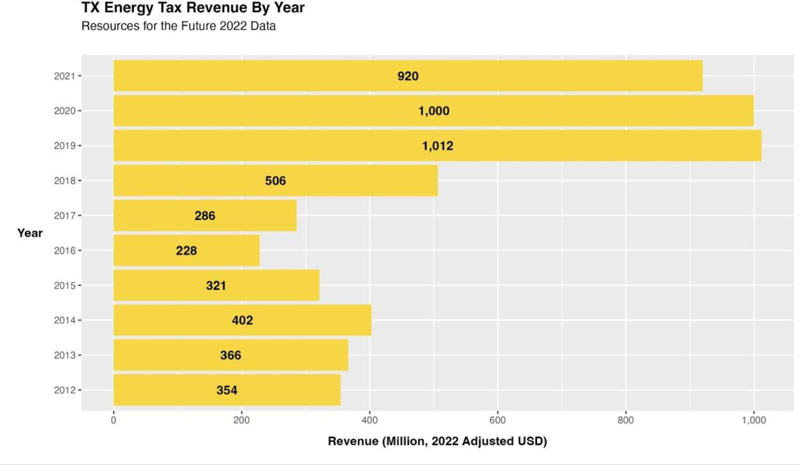

*Figure 11. Texas Tax Revenue by Year*

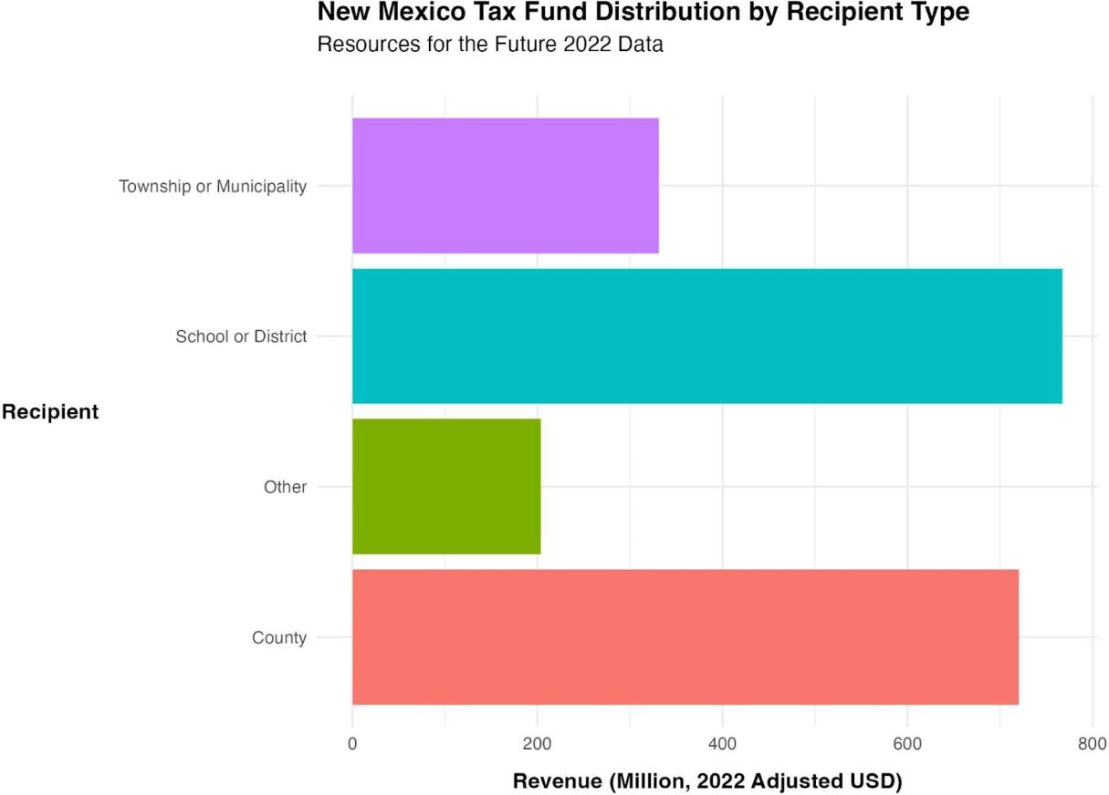

*Figure 12. New Mexico Tax Revenue by Recipient Type*

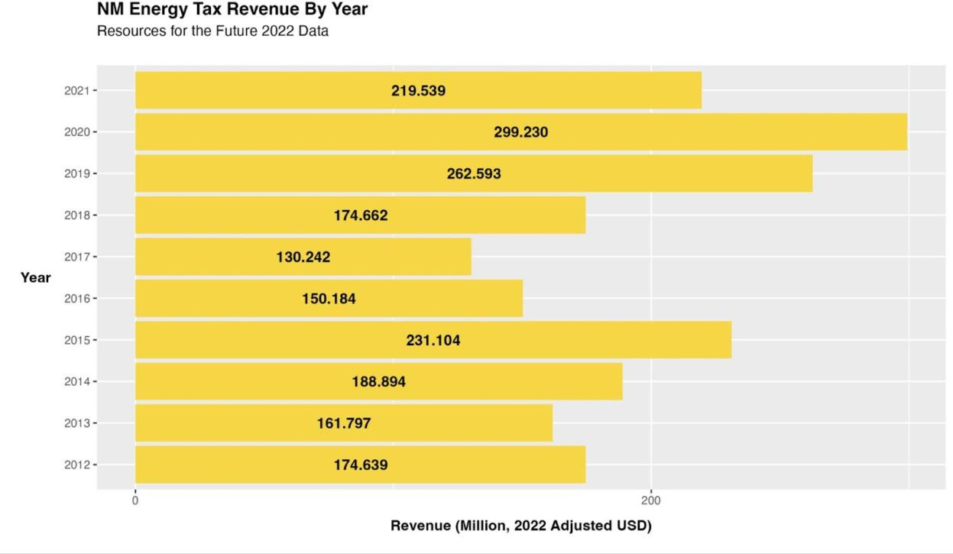

*Figure 13. Texas Tax Revenue by Year*

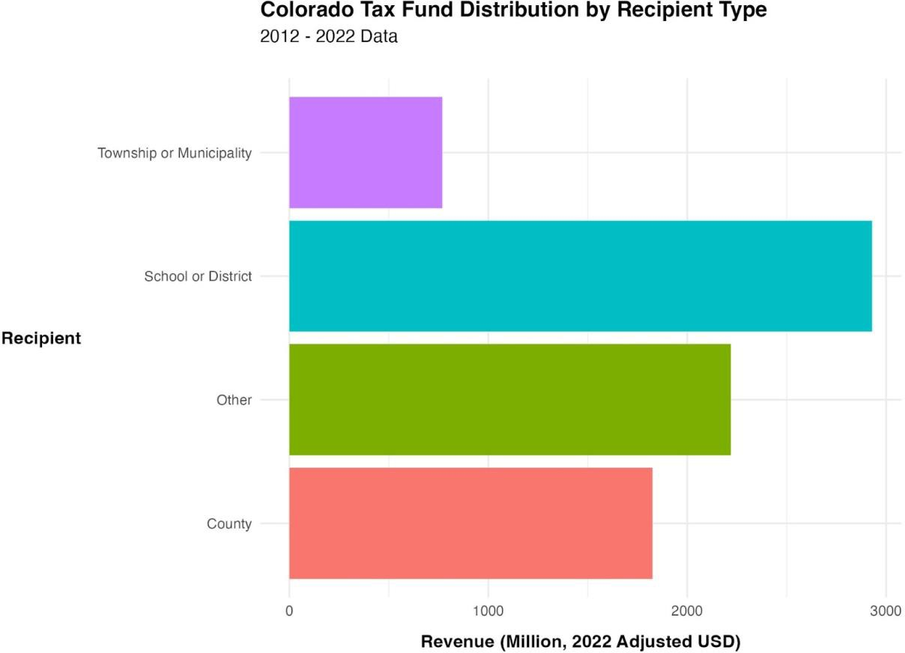

*Figure 14. Colorado Tax Revenue by Recipient Type*

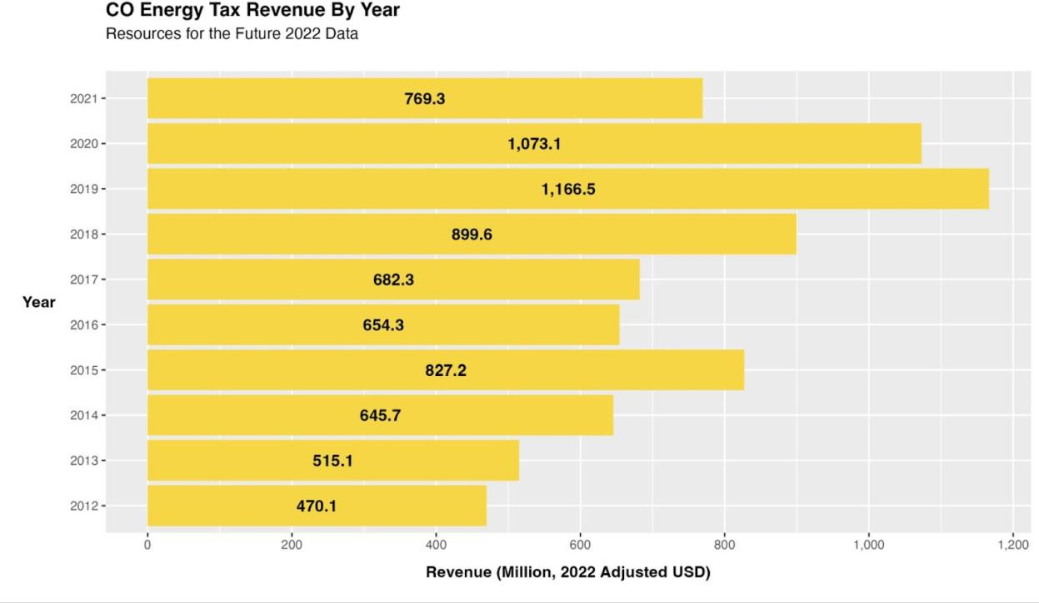

*Figure 15. Colorado Tax Revenue by Year*

# Endnotes

1. IEA. “Electricity 2024 – Analysis,” January 24, 2024. [https://www.iea.org/reports/electricity-](https://www.iea.org/reports/electricity-2024)

[2024](https://www.iea.org/reports/electricity-2024).

1. “Electricity 2024 – Analysis.”
2. Daniel Raimi et al., “The Fiscal Implications of the US Transition Away from Fossil Fuels,” *Review of Environmental Economics and Policy* 17, no. 2 (June 1, 2023): 295–315, [https://doi.org/10.1086/725250.](https://doi.org/10.1086/725250)
3. [Daniel Raimi et al., “The Energy Transition and Local Government Finance: New Data and](https://www.zotero.org/google-docs/?xfIA7t) [Insights from 10 US States,” *Environmental Research: Energy* 1, no. 3 (September 1, 2024):](https://www.zotero.org/google-docs/?xfIA7t) [035003,](https://www.zotero.org/google-docs/?xfIA7t) <https://doi.org/10.1088/2753-3751/ad5e81>[.](https://www.zotero.org/google-docs/?xfIA7t)
4. [Raimi et al.](https://www.zotero.org/google-docs/?uzjEL8)
5. [Daniel Raimi, “More Than Just Jobs: Assessing the Public Finance Implications of the](https://www.zotero.org/google-docs/?Wy3Jna) [Energy Transition,” Resources for the Future, accessed March 30, 2025,](https://www.zotero.org/google-docs/?Wy3Jna) [https://www.resources.org/common-resources/more-than-just-jobs-assessing-the-public-finance-](https://www.resources.org/common-resources/more-than-just-jobs-assessing-the-public-finance-implications-of-the-energy-transition/) [implications-of-the-energy-transition/](https://www.resources.org/common-resources/more-than-just-jobs-assessing-the-public-finance-implications-of-the-energy-transition/)[.](https://www.zotero.org/google-docs/?Wy3Jna)
6. [Raimi.](https://www.zotero.org/google-docs/?XxHkVL)
7. [Raimi.](https://www.zotero.org/google-docs/?beF3Cm)
8. [Daniel Raimi, Sanya Carley, and David Konisky, “Mapping County-Level Vulnerability to](https://www.zotero.org/google-docs/?bkcoTX) [the Energy Transition in US Fossil Fuel Communities,” *Scientific Reports* 12, no. 1 (September](https://www.zotero.org/google-docs/?bkcoTX) [21, 2022): 15748,](https://www.zotero.org/google-docs/?bkcoTX) <https://doi.org/10.1038/s41598-022-19927-6>[.](https://www.zotero.org/google-docs/?bkcoTX)
9. [Raimi, Carley, and Konisky.](https://www.zotero.org/google-docs/?XcNwGo)
10. [G. Jason Jolley et al., “The Economic, Fiscal, and Workforce Impacts of Coal‐fired Power](https://www.zotero.org/google-docs/?MddkOf) [Plant Closures in Appalachian Ohio,” *Regional Science Policy & Practice* 11, no. 2 (June 1,](https://www.zotero.org/google-docs/?MddkOf) [2019): 403–23,](https://www.zotero.org/google-docs/?MddkOf) <https://doi.org/10.1111/rsp3.12191>[.](https://www.zotero.org/google-docs/?MddkOf)
11. [Jolley et al.](https://www.zotero.org/google-docs/?O7xVUi)
12. [US Legal Inc, “Gas and Oil Rights in State and Local Government Lands – Oil and Gas,”](https://www.zotero.org/google-docs/?UTFggY) [accessed March 9, 2025,](https://www.zotero.org/google-docs/?UTFggY) [https://oilandgas.uslegal.com/gas-and-oil-rights-in-state-and-local-](https://oilandgas.uslegal.com/gas-and-oil-rights-in-state-and-local-government/) [government/](https://oilandgas.uslegal.com/gas-and-oil-rights-in-state-and-local-government/)[.](https://www.zotero.org/google-docs/?UTFggY)
13. [Inc.](https://www.zotero.org/google-docs/?f3uUf2)
14. [Daniel Raimi et al., “The Fiscal Implications of the US Transition Away from Fossil Fuels,”](https://www.zotero.org/google-docs/?97tBUg) [*Review of Environmental Economics and Policy* 17, no. 2 (June 1, 2023): 295–315,](https://www.zotero.org/google-docs/?97tBUg) <https://doi.org/10.1086/725250>[.](https://www.zotero.org/google-docs/?97tBUg)
15. [Raimi et al.](https://www.zotero.org/google-docs/?VAsOL9)
16. [Raimi et al.](https://www.zotero.org/google-docs/?JhqrO9)
17. [“The Economic Impacts of Clean Power,” Brookings, accessed March 30, 2025,](https://www.zotero.org/google-docs/?bMP6RS) <https://www.brookings.edu/articles/the-economic-impacts-of-clean-power/>[.](https://www.zotero.org/google-docs/?bMP6RS)
18. [“The Economic Impacts of Clean Power.”](https://www.zotero.org/google-docs/?wwuIIL)
19. [Joshua D Rhodes, “The Economic Impact of Renewable Energy and Energy Storage in](https://www.zotero.org/google-docs/?o2prHJ) [Rural Texas,” n.d.](https://www.zotero.org/google-docs/?o2prHJ)
20. [ACP, “Economy-Wide Impacts of the Inflation Reduction Act Energy Provisions,” ACP,](https://www.zotero.org/google-docs/?kOlpCL) [accessed March 30, 2025,](https://www.zotero.org/google-docs/?kOlpCL) [https://cleanpower.org/resources/economy-wide-benefits-of-energy-](https://cleanpower.org/resources/economy-wide-benefits-of-energy-tax-credits/) [tax-credits/](https://cleanpower.org/resources/economy-wide-benefits-of-energy-tax-credits/)[.](https://www.zotero.org/google-docs/?kOlpCL)
21. [Nicholas Roy et al., “Beyond Clean Energy: The Financial Incidence and Health Effects of](https://www.zotero.org/google-docs/?TWWkC3) [the IRA,” n.d.](https://www.zotero.org/google-docs/?TWWkC3)
22. [Roy et al.](https://www.zotero.org/google-docs/?5SQzKd)
23. [John Bistline, Neil Mehrotra, and Catherine Wolfram, “Economic Implications of the](https://www.zotero.org/google-docs/?reXPKM) [Climate Provisions of the Inflation Reduction Act,” Working Paper, Working Paper Series](https://www.zotero.org/google-docs/?reXPKM) [(National Bureau of Economic Research, May 2023),](https://www.zotero.org/google-docs/?reXPKM) <https://doi.org/10.3386/w31267>[.](https://www.zotero.org/google-docs/?reXPKM)
24. [Amanda Levin and Jackie Ennis, “Clean Electricity Tax Credits in the Inflation Reduction](https://www.zotero.org/google-docs/?N7Ga2Y) [Act Will Reduce Emissions, Grow Jobs, and Lower Bills,” September 2022,](https://www.zotero.org/google-docs/?N7Ga2Y) [https://www.nrdc.org/resources/clean-electricity-tax-credits-inflation-reduction-act-will-reduce-](https://www.nrdc.org/resources/clean-electricity-tax-credits-inflation-reduction-act-will-reduce-emissions-grow-jobs-and) [emissions-grow-jobs-and](https://www.nrdc.org/resources/clean-electricity-tax-credits-inflation-reduction-act-will-reduce-emissions-grow-jobs-and).
25. [Levin and Ennis.](https://www.zotero.org/google-docs/?VhEBxV)
26. “Native American Lands | Ownership and Governance.” Accessed March 8, 2025. <https://revenuedata.doi.gov/how-revenue-works/native-american-ownership-governance/>.
27. “Native American Lands | Ownership and Governance.”
28. “Native American Lands | Ownership and Governance.”
29. “Native American Lands | Ownership and Governance.”
30. Raimi, Daniel, and Alana Davicino. “Securing Energy Sovereignty: A Review of Key Barriers and Opportunities for Energy-Producing Native Nations in the United States.” *Energy Research & Social Science* 107 (January 1, 2024): 103324. <https://doi.org/10.1016/j.erss.2023.103324>.
31. “Native American Lands | Revenue | Natural Resources Revenue Data | Natural Resources Revenue Data.” Accessed March 8, 2025. [https://archive.revenuedata.doi.gov/how-it-](https://archive.revenuedata.doi.gov/how-it-works/native-american-revenue/) [works/native-american-revenue/.](https://archive.revenuedata.doi.gov/how-it-works/native-american-revenue/)
32. “Native American Lands | Revenue.”
33. Slanger, Dan. “Native Energy: From Fossil Fuels Below to Renewables Above.” RMI, July 23, 2014. [https://rmi.org/native-energy-fossil-fuels-renewables/.](https://rmi.org/native-energy-fossil-fuels-renewables/)
34. “Native American Lands | Revenue.”
35. “Native American Energy Sovereignty Is Key to American Energy Security | Wilson Center,” March 10, 2025. [https://www.wilsoncenter.org/article/native-american-energy-](https://www.wilsoncenter.org/article/native-american-energy-sovereignty-key-american-energy-security) [sovereignty-key-american-energy-security.](https://www.wilsoncenter.org/article/native-american-energy-sovereignty-key-american-energy-security)
36. Resources for the Future. “Native Nations in the Energy Transition.” Accessed March 8, 2025. [https://www.resources.org/common-resources/native-nations-in-the-energy-transition/.](https://www.resources.org/common-resources/native-nations-in-the-energy-transition/)
37. “Renewable Energy Unlocks Energy Sovereignty.”
38. “Native American Energy Sovereignty.”
39. “Renewable Energy Unlocks Energy Sovereignty.”
40. “Native American Energy Sovereignty.”
41. “Native American Energy Sovereignty.”
42. “Native American Energy Sovereignty.”
43. Plautz, Jason. “‘We Have Real Lives at Stake’: Trump Impedes Arizona Tribe’s Energy Lifeline.” E&E News by POLITICO, February 14, 2025. [https://www.eenews.net/articles/we-](https://www.eenews.net/articles/we-have-real-lives-at-stake-trump-impedes-arizona-tribes-energy-lifeline/) [have-real-lives-at-stake-trump-impedes-arizona-tribes-energy-lifeline/](https://www.eenews.net/articles/we-have-real-lives-at-stake-trump-impedes-arizona-tribes-energy-lifeline/).
44. Grist. “‘It’s Demoralizing’: Trump’s Climate Funding Freeze Has Left Tribes in Limbo.” ICT News, February 17, 2025. [https://ictnews.org/news/its-demoralizing-trumps-climate-](https://ictnews.org/news/its-demoralizing-trumps-climate-funding-freeze-has-left-tribes-in-limbo) [funding-freeze-has-left-tribes-in-limbo.](https://ictnews.org/news/its-demoralizing-trumps-climate-funding-freeze-has-left-tribes-in-limbo)
45. Center for American Progress. “State Budgets Tied to Fossil Fuels Are Slowing the Energy Transition and Leaving Workers and Communities Behind,” December 7, 2021. [https://www.americanprogress.org/article/state-budgets-tied-to-fossil-fuels-are-slowing-the-](https://www.americanprogress.org/article/state-budgets-tied-to-fossil-fuels-are-slowing-the-energy-transition-and-leaving-workers-and-communities-behind/) [energy-transition-and-leaving-workers-and-communities-behind/.](https://www.americanprogress.org/article/state-budgets-tied-to-fossil-fuels-are-slowing-the-energy-transition-and-leaving-workers-and-communities-behind/)
46. [“How Do State and Local Severance Taxes Work?,” Tax Policy Center, accessed February 6,](https://www.zotero.org/google-docs/?broken=E5yUoR) [2025,](https://www.zotero.org/google-docs/?broken=E5yUoR) <https://taxpolicycenter.org/briefing-book/how-do-state-and-local-severance-taxes-work>[.](https://www.zotero.org/google-docs/?broken=X9mAlr)

48. [“How Do State and Local Severance Taxes Work?”](https://www.zotero.org/google-docs/?broken=siM5sD)

49. Inc, US Legal. “Gas and Oil Rights in State and Local Government Lands – Oil and Gas.” Accessed March 9, 2025. [https://oilandgas.uslegal.com/gas-and-oil-rights-in-state-and-local-](https://oilandgas.uslegal.com/gas-and-oil-rights-in-state-and-local-government/) [government/.](https://oilandgas.uslegal.com/gas-and-oil-rights-in-state-and-local-government/)

50. Raimi, Daniel, Emily Grubert, Jake Higdon, Gilbert Metcalf, Sophie Pesek, and Devyani Singh. “The Fiscal Implications of the US Transition Away from Fossil Fuels.” *Review of Environmental Economics and Policy* 17, no. 2 (June 1, 2023): 295–315. [https://doi.org/10.1086/725250.](https://doi.org/10.1086/725250)

51. [Leah Sarnoff, “Vermont Officially Becomes 1st State to Charge Big Oil for Climate Change](https://www.zotero.org/google-docs/?broken=ufXLls) [Damage,” ABC News, accessed February 6, 2025,](https://www.zotero.org/google-docs/?broken=ufXLls) [https://abcnews.go.com/US/vermont-bill-](https://abcnews.go.com/US/vermont-bill-charge-big-oil-climate-change-damage/story?id=110148158) [charge-big-oil-climate-change-damage/story?id=110148158](https://abcnews.go.com/US/vermont-bill-charge-big-oil-climate-change-damage/story?id=110148158)[.](https://www.zotero.org/google-docs/?broken=acP5mu)

52. [Adam Aton Clark Lesley, “A Superfund for Climate? These States Are Pushing for It.,” E&E](https://www.zotero.org/google-docs/?broken=d0Qhof) [News by POLITICO, March 6, 2024,](https://www.zotero.org/google-docs/?broken=d0Qhof) [https://www.eenews.net/articles/a-superfund-for-climate-](https://www.eenews.net/articles/a-superfund-for-climate-these-states-are-pushing-for-it/) [these-states-are-pushing-for-it/](https://www.eenews.net/articles/a-superfund-for-climate-these-states-are-pushing-for-it/)[.](https://www.zotero.org/google-docs/?broken=WHXUPu)

53. [“Cap and Trade Basics,” *Center for Climate and Energy Solutions* (blog), accessed February](https://www.zotero.org/google-docs/?broken=gqHYrO) [6, 2025,](https://www.zotero.org/google-docs/?broken=gqHYrO) <https://www.c2es.org/content/cap-and-trade-basics/>[.](https://www.zotero.org/google-docs/?broken=ttXvMz)

54. [“Cap and Trade Basics.”](https://www.zotero.org/google-docs/?broken=ZDg2hA)

55. [“The Regional Greenhouse Gas Initiative,” accessed February 6, 2025,](https://www.zotero.org/google-docs/?broken=sBXlYl) <https://www.rggi.org/>[.](https://www.zotero.org/google-docs/?broken=G1xFJz)

56. [Sarah Graddy, “Federal Energy Royalty Rates” (The Wilderness Society, n.d.),](https://www.zotero.org/google-docs/?broken=la1tmm) [https://www.wilderness.org/sites/default/files/media/file/Fact%20sheet%20-](https://www.wilderness.org/sites/default/files/media/file/Fact%20sheet%20-%20Federal%20Energy%20Royalty%20Rates.pdf#%3A~%3Atext%3DA%20royalty%20is%20the%20percentage%2Cpublic%20lands%20is%2012.5%20percent)

[%20Federal%20Energy%20Royalty%20Rates.pdf#:~:text=A%20royalty%20is%20the%20perce](https://www.wilderness.org/sites/default/files/media/file/Fact%20sheet%20-%20Federal%20Energy%20Royalty%20Rates.pdf#%3A~%3Atext%3DA%20royalty%20is%20the%20percentage%2Cpublic%20lands%20is%2012.5%20percent) [ntage,public%20lands%20is%2012.5%20percent](https://www.wilderness.org/sites/default/files/media/file/Fact%20sheet%20-%20Federal%20Energy%20Royalty%20Rates.pdf#%3A~%3Atext%3DA%20royalty%20is%20the%20percentage%2Cpublic%20lands%20is%2012.5%20percent)[.](https://www.zotero.org/google-docs/?broken=d1VP41)

57. [“State and Local Revenue Options for Advancing a Brighter Future,” Center on Budget and](https://www.zotero.org/google-docs/?broken=mnQARF) [Policy Priorities, accessed February 6, 2025,](https://www.zotero.org/google-docs/?broken=mnQARF) [https://www.cbpp.org/research/state-budget-and-](https://www.cbpp.org/research/state-budget-and-tax/state-revenue-options-for-advancing-equity-and-prosperity) [tax/state-revenue-options-for-advancing-equity-and-prosperity](https://www.cbpp.org/research/state-budget-and-tax/state-revenue-options-for-advancing-equity-and-prosperity)[.](https://www.zotero.org/google-docs/?broken=PBgwii)

58. Raimi et al., “Fiscal Implications,” 305.

59. [“State and Local Revenue Options for Advancing a Brighter Future.”](https://www.zotero.org/google-docs/?broken=QcqTQj)

60. [“State and Local Revenue Options for Advancing a Brighter Future.”](https://www.zotero.org/google-docs/?broken=n5Fn1D)

61. Raimi et al., “Fiscal Implications,” 305.

1. “Renewable Energy Explained - Incentives - U.S. Energy Information Administration (EIA).” Accessed March 9, 2025. [https://www.eia.gov/energyexplained/renewable-](https://www.eia.gov/energyexplained/renewable-sources/incentives.php) [sources/incentives.php.](https://www.eia.gov/energyexplained/renewable-sources/incentives.php)
2. “Renewable Energy Explained.”
3. “Renewable Energy Explained.”
4. “Renewable Energy Explained.”
5. “Renewable Energy Explained.”
6. “Renewable Energy Explained.”
7. “Renewable Energy Explained.”
8. “Renewable Energy Explained.”
9. “Renewable Energy Explained.”
10. Ph.D, Kris Smith. “Federal Fossil Fuel Disbursements to States.” Headwaters Economics, June 16, 2021. [https://headwaterseconomics.org/tax-policy/federal-fossil-fuel-disbursements-to-](https://headwaterseconomics.org/tax-policy/federal-fossil-fuel-disbursements-to-states/) [states/.](https://headwaterseconomics.org/tax-policy/federal-fossil-fuel-disbursements-to-states/)
11. Ph.D, Kris Smith. “Federal Fossil Fuel Disbursements to States.” Headwaters Economics, June 16, 2021. [https://headwaterseconomics.org/tax-policy/federal-fossil-fuel-disbursements-to-](https://headwaterseconomics.org/tax-policy/federal-fossil-fuel-disbursements-to-states/) [states/.](https://headwaterseconomics.org/tax-policy/federal-fossil-fuel-disbursements-to-states/)
12. Raimi et al., “Fiscal Implications,” 305.
13. Tax Foundation. “What Is a Value-Added Tax (VAT)?,” January 28, 2025. [https://taxfoundation.org/taxedu/glossary/value-added-tax-vat/.](https://taxfoundation.org/taxedu/glossary/value-added-tax-vat/)
14. Harvard Business School. “Breaking up with Fossil Fuel Taxes Is Hard to Do | Institute for Business in Global Society,” August 23, 2024. [https://www.hbs.edu/bigs/breaking-up-with-](https://www.hbs.edu/bigs/breaking-up-with-fossil-fuel-taxes-is-hard) [fossil-fuel-taxes-is-hard.](https://www.hbs.edu/bigs/breaking-up-with-fossil-fuel-taxes-is-hard)
15. Lincoln Institute of Land Policy. “Revenue Diversification and the Financing of Large American Central Cities.” Accessed March 20, 2025. [https://www.lincolninst.edu/publications/working-papers/revenue-diversification-financing-](https://www.lincolninst.edu/publications/working-papers/revenue-diversification-financing-large-american-central-cities/) [large-american-central-cities/.](https://www.lincolninst.edu/publications/working-papers/revenue-diversification-financing-large-american-central-cities/)
16. Smith, “Federal Fossil Fuel Disbursements.”
17. “Renewable Energy Policy in Texas | Center for Local, State, and Urban Policy.” Accessed March 14, 2025. [https://closup.umich.edu/research/working-papers/renewable-energy-policy-](https://closup.umich.edu/research/working-papers/renewable-energy-policy-texas) [texas.](https://closup.umich.edu/research/working-papers/renewable-energy-policy-texas)
18. “U.S. Energy Information Administration - EIA - Independent Statistics and Analysis,” accessed March 13, 2025, <https://www.eia.gov/state/analysis.php?sid=TX>.
19. “U.S. Energy Information Administration - EIA - Independent Statistics and Analysis.”
20. Glen Hegar, “The 2016-17 Certification Revenue Estimate,” Texas Comptroller of Public Accounts, accessed March 29, 2025, [https://comptroller.texas.gov/transparency/reports/certification-revenue-estimate/2016-](https://comptroller.texas.gov/transparency/reports/certification-revenue-estimate/2016-17/overview.php) [17/overview.php.](https://comptroller.texas.gov/transparency/reports/certification-revenue-estimate/2016-17/overview.php)
21. Hegar, “The 2016-17 Certification Revenue Estimate.”
22. “Electric Reliability Council of Texas,” accessed March 27, 2025, <https://www.ercot.com/>.
23. “U.S. Energy Information Administration - EIA - Independent Statistics and Analysis.”
24. “Renewable Energy Policy in Texas | Center for Local, State, and Urban Policy,” accessed March 14, 2025, [https://closup.umich.edu/research/working-papers/renewable-energy-policy-](https://closup.umich.edu/research/working-papers/renewable-energy-policy-texas) [texas.](https://closup.umich.edu/research/working-papers/renewable-energy-policy-texas)
25. “About the PUCT,” accessed March 27, 2025, [https://www.puc.texas.gov/agency/about/.](https://www.puc.texas.gov/agency/about/)
26. “About the PUCT.”
27. “About the Railroad Commission of Texas,” accessed March 30, 2025, [https://www.rrc.texas.gov/about-us/.](https://www.rrc.texas.gov/about-us/)
28. Texas Oil & Gas Association. “About Us.” Accessed March 27, 2025. [https://www.txoga.org/about-us/.](https://www.txoga.org/about-us/)
29. “Power Up Texas - Supporting Renewable Energy in Texas.” Accessed March 27, 2025. [https://poweruptexas.org/.](https://poweruptexas.org/)
30. “032025 Stakeholder Input for the Oil and Gas Monitoring and Enforcement Plan.” Accessed March 25, 2025. [https://www.rrc.texas.gov/announcements/032025-stakeholder-input-](https://www.rrc.texas.gov/announcements/032025-stakeholder-input-for-the-oil-and-gas-monitoring-and-enforcement-plan/) [for-the-oil-and-gas-monitoring-and-enforcement-plan/](https://www.rrc.texas.gov/announcements/032025-stakeholder-input-for-the-oil-and-gas-monitoring-and-enforcement-plan/).
31. “040124 Texas Oil and Gas Production Statistics for January 2024.” Accessed March 25, 2025. [https://www.rrc.texas.gov/news/040124-texas-oil-and-gas-production-statistics-for-](https://www.rrc.texas.gov/news/040124-texas-oil-and-gas-production-statistics-for-january-2024/) [january-2024/.](https://www.rrc.texas.gov/news/040124-texas-oil-and-gas-production-statistics-for-january-2024/)
32. “RDCEP | RPS Calculator | Texas.” Accessed March 27, 2025. [http://rpscalc.rdcep.org/state/texas/.](http://rpscalc.rdcep.org/state/texas/)
33. “Renewable Energy Policy in Texas | Center for Local, State, and Urban Policy.” Accessed March 14, 2025. [https://closup.umich.edu/research/working-papers/renewable-energy-policy-](https://closup.umich.edu/research/working-papers/renewable-energy-policy-texas) [texas.](https://closup.umich.edu/research/working-papers/renewable-energy-policy-texas)
34. “Renewable Energy Policy in Texas | Center for Local, State, and Urban Policy.”
35. “79(1) SB 20 - Enrolled Version - Bill Text.” Accessed March 27, 2025. [https://capitol.texas.gov/tlodocs/791/billtext/html/SB00020F.htm.](https://capitol.texas.gov/tlodocs/791/billtext/html/SB00020F.htm)
36. “Renewable Energy Policy in Texas | Center for Local, State, and Urban Policy.”
37. “79(1) SB 20 - Enrolled Version - Bill Text.”
38. “Texas’ Transmission Troubles and CREZ II | Texas Solar Energy Society.” Accessed March 13, 2025. [https://txses.org/texas-transmission-troubles-and-crez-ii/.](https://txses.org/texas-transmission-troubles-and-crez-ii/)
39. Power Up Texas. “Power Up Texas - Supporting Renewable Energy in Texas.” Accessed March 27, 2025. [https://poweruptexas.org/.](https://poweruptexas.org/)
40. Network, Conservative Environment. “COMPETITIVE RENEWABLE ENERGY ZONES.” CEN, October 23, 2024. [https://www.cen.uk.com/post/competitive-renewable-energy-](https://www.cen.uk.com/post/competitive-renewable-energy-zones) [zones.](https://www.cen.uk.com/post/competitive-renewable-energy-zones)
41. Jankovska, Olivera, and Julie A. Cohn. “Texas CREZ Lines: How Stakeholders Shape Major Energy Infrastructure Projects.” *Research Paper*, November 17, 2020. [https://www.bakerinstitute.org/research/texas-crez-lines-how-stakeholders-shape-major-energy-](https://www.bakerinstitute.org/research/texas-crez-lines-how-stakeholders-shape-major-energy-infrastructure-projects) [infrastructure-projects.](https://www.bakerinstitute.org/research/texas-crez-lines-how-stakeholders-shape-major-energy-infrastructure-projects)
42. “Texas’ Transmission Troubles and CREZ II | Texas Solar Energy Society.”
43. “TAX CODE CHAPTER 312. PROPERTY REDEVELOPMENT AND TAX

ABATEMENT ACT.” Accessed March 16, 2025. <https://statutes.capitol.texas.gov/Docs/TX/htm/TX.312.HTM>.

1. “Texas Economic Development Act.” Accessed March 16, 2025. <https://comptroller.texas.gov/economy/development/prop-tax/ch313/>.
2. Lavine, Dick. “HB 5 Is Still Chapter 313. And Still Bad. - Every Texan.” *Every Texan -* (blog), May 9, 2023. [https://everytexan.org/2023/05/09/hb-5-is-still-chapter-313-and-still-not-](https://everytexan.org/2023/05/09/hb-5-is-still-chapter-313-and-still-not-good/) [good/.](https://everytexan.org/2023/05/09/hb-5-is-still-chapter-313-and-still-not-good/)
3. “Tax Exemptions and Tax Incidence Report.” Accessed March 27, 2025. [https://comptroller.texas.gov/transparency/reports/tax-exemptions-and-incidence/.](https://comptroller.texas.gov/transparency/reports/tax-exemptions-and-incidence/)
4. “Texas Enacts Incentives Program to Replace Expired Ch. 313 School Value Limitation Program.” Accessed March 27, 2025. [https://taxnews.ey.com.](https://taxnews.ey.com/)
5. Lavine, Dick. “Chapter 313’s Replacement: Better in Some Ways, Worse in Others - Every Texan.” *Every Texan -* (blog), September 15, 2023. [https://everytexan.org/2023/09/15/chapter-](https://everytexan.org/2023/09/15/chapter-313-replacement-hb-5/) [313-replacement-hb-5/.](https://everytexan.org/2023/09/15/chapter-313-replacement-hb-5/)
6. Ferman, By Mandi Cai, Erin Douglas and Mitchell. “How Texas’ Power Grid Failed in 2021 — and Who’s Responsible for Preventing a Repeat.” The Texas Tribune, February 15, 2022. [https://www.texastribune.org/2022/02/15/texas-power-grid-winter-storm-2021/.](https://www.texastribune.org/2022/02/15/texas-power-grid-winter-storm-2021/)
7. Lyu, Chen, Sam Fleckenstein, and Zach Nerod. “Texas Energy Policy Landscape and Analysis Report,” n.d.
8. “Renewable Energy Policy in Texas | Center for Local, State, and Urban Policy.” Accessed March 14, 2025. [https://closup.umich.edu/research/working-papers/renewable-energy-policy-](https://closup.umich.edu/research/working-papers/renewable-energy-policy-texas) [texas.](https://closup.umich.edu/research/working-papers/renewable-energy-policy-texas)
9. Lyu, Fleckenstein, and Nerod, “Texas Energy Policy Landscape and Analysis Report.”
10. US News & World Report. “With Texas Facing Soaring Electricity Demand, the Politics of Energy Quietly Shift at the Capitol.” Accessed March 14, 2025. [//www.usnews.com/news/best-](https://doi.org/www.usnews.com/news/best-states/texas/articles/2025-03-06/with-texas-facing-soaring-electricity-demand-the-politics-of-energy-quietly-shift-at-the-capitol)

[states/texas/articles/2025-03-06/with-texas-facing-soaring-electricity-demand-the-politics-of-](https://doi.org/www.usnews.com/news/best-states/texas/articles/2025-03-06/with-texas-facing-soaring-electricity-demand-the-politics-of-energy-quietly-shift-at-the-capitol) [energy-quietly-shift-at-the-capitol.](https://doi.org/www.usnews.com/news/best-states/texas/articles/2025-03-06/with-texas-facing-soaring-electricity-demand-the-politics-of-energy-quietly-shift-at-the-capitol)

1. “With Texas Facing Soaring Electricity Demand, the Politics of Energy Quietly Shift at the Capitol.”
2. BillTrack50. “TX - SB388.” Accessed March 14, 2025. [https://www.billtrack50.com/billdetail/1753215.](https://www.billtrack50.com/billdetail/1753215)
3. Advanced Power Alliance. “Senate Bill 388 (King),” March 5, 2025. <https://poweralliance.org/2025/03/05/senate-bill-388-king/>.
4. Lavine, “HB 5 Is Still Chapter 313. And Still Bad. - Every Texan.”
5. “U.S. Energy Information Administration - EIA - Independent Statistics and Analysis.” Accessed March 16, 2025. <https://www.eia.gov/state/analysis.php?sid=NM>.
6. “U.S. Energy Information Administration - EIA - Independent Statistics and Analysis.”
7. “New Mexico Draws on Energy, Trade to Spur Economy.” Accessed March 16, 2025. <https://www.dallasfed.org/research/swe/2024/swe2416>.
8. “U.S. Energy Information Administration - EIA - Independent Statistics and Analysis.”
9. “U.S. Energy Information Administration - EIA - Independent Statistics and Analysis.”
10. Grover, Hannah. “Trump Looks to Save Coal, What Could That Mean for New Mexico.” New Mexico Political Report, March 18, 2025. [http://nmpoliticalreport.com/2025/03/18/trump-](http://nmpoliticalreport.com/2025/03/18/trump-looks-to-save-coal-what-could-that-mean-for-new-mexico/) [looks-to-save-coal-what-could-that-mean-for-new-mexico/.](http://nmpoliticalreport.com/2025/03/18/trump-looks-to-save-coal-what-could-that-mean-for-new-mexico/)
11. “Navajo Transitional Energy Company with Enchant Energy as the CO2 Capture Project Developer Selected for Award Negotiations with U.S. Department of Energy’s Office of Clean Energy Demonstrations (OCED) « Enchant Energy.” Accessed March 27, 2025. [https://enchantenergy.com/navajo-transitional-energy-company-with-enchant-energy-as-the-co2-](https://enchantenergy.com/navajo-transitional-energy-company-with-enchant-energy-as-the-co2-capture-project-developer-selected-for-award-negotiations-with-u-s-department-of-energys-oced/) [capture-project-developer-selected-for-award-negotiations-with-u-s-department-of-energys-](https://enchantenergy.com/navajo-transitional-energy-company-with-enchant-energy-as-the-co2-capture-project-developer-selected-for-award-negotiations-with-u-s-department-of-energys-oced/) [oced/.](https://enchantenergy.com/navajo-transitional-energy-company-with-enchant-energy-as-the-co2-capture-project-developer-selected-for-award-negotiations-with-u-s-department-of-energys-oced/)
12. U.S. Energy Information Administration - EIA - Independent Statistics and Analysis, “Crude Oil Production,” accessed March 29, 2025, [https://www.eia.gov/dnav/pet/pet_crd_crpdn_adc_mbblpd_a.htm.](https://www.eia.gov/dnav/pet/pet_crd_crpdn_adc_mbblpd_a.htm)
13. New Mexico Energy, Minerals and Natural Resources Department, “Renewable Energy Production Tax Credit (REPTC),” *Energy Conservation and Management* (blog), accessed March 29, 2025, [https://www.emnrd.nm.gov/ecmd/tax-incentives/renewable-energy-production-](https://www.emnrd.nm.gov/ecmd/tax-incentives/renewable-energy-production-tax-credit-reptc/) [tax-credit-reptc/.](https://www.emnrd.nm.gov/ecmd/tax-incentives/renewable-energy-production-tax-credit-reptc/)
14. “Renewable Energy Production Tax Act,” Pub. L. No. HB45 (n.d.).
15. New Mexico Oil & Gas Association. “About Us.” Accessed March 21, 2025. [https://www.nmoga.org/about_us.](https://www.nmoga.org/about_us)
16. Oil Conservation. “OCD Home.” Accessed March 21, 2025. [https://www.emnrd.nm.gov/ocd/.](https://www.emnrd.nm.gov/ocd/)
17. NTEC. “About NTEC | We Operate A World Class Energy Company.” Accessed March 27, 2025. [https://navenergy.com/about-ntec/.](https://navenergy.com/about-ntec/)
18. NTEC. “Our Operations | Navajo Transitional Energy Company.” Accessed March 27, 2025. [https://navenergy.com/our-operations/.](https://navenergy.com/our-operations/)
19. Energy Conservation and Management. “ECAM Home.” Accessed March 21, 2025. [https://www.emnrd.nm.gov/ecmd/.](https://www.emnrd.nm.gov/ecmd/)
20. Storrow, Benjamin. “N.M. Enacted a Climate Law 3 Years Ago. Then Things Got Hard.” E&E News by POLITICO, October 14, 2022. [https://www.eenews.net/articles/n-m-enacted-a-](https://www.eenews.net/articles/n-m-enacted-a-climate-law-3-years-ago-then-things-got-hard/) [climate-law-3-years-ago-then-things-got-hard/.](https://www.eenews.net/articles/n-m-enacted-a-climate-law-3-years-ago-then-things-got-hard/)
21. “Energy Transition Act.” Accessed March 27, 2025. <https://www.dws.state.nm.us/ETA>.
22. “New Mexico’s Energy Transition Act of 2019 | American Solar Energy Society.” Accessed March 27, 2025. [https://ases.org/new-mexicos-energy-transition-act-of-2019/.](https://ases.org/new-mexicos-energy-transition-act-of-2019/)
23. “Legislation - New Mexico Legislature.” Accessed March 19, 2025. [https://www.nmlegis.gov/Legislation/Legislation?Chamber=S&LegType=B&LegNo=4&year=2](https://www.nmlegis.gov/Legislation/Legislation?Chamber=S&LegType=B&LegNo=4&year=25) [5](https://www.nmlegis.gov/Legislation/Legislation?Chamber=S&LegType=B&LegNo=4&year=25).
24. “Handouts List - New Mexico Legislature.” Accessed March 27, 2025. <https://www.nmlegis.gov/committee/Handouts_List?CommitteeCode=RSTP&Date=12/16/2024>.
25. “Handouts List - New Mexico Legislature.” Accessed March 27, 2025. <https://www.nmlegis.gov/committee/Handouts_List?CommitteeCode=RSTP&Date=12/5/2023>.
26. “EDD State Plan - New Mexico EDD,” August 11, 2023. [https://edd.newmexico.gov/state-](https://edd.newmexico.gov/state-plan/) [plan/.](https://edd.newmexico.gov/state-plan/)
27. Redfern, Jerry. “New Mexico Governor Kickstarts Effort to Overhaul Oil and Gas Regulation,” December 5, 2023. [https://capitalandmain.com/new-mexico-governor-kickstarts-](https://capitalandmain.com/new-mexico-governor-kickstarts-effort-to-overhaul-oil-and-gas-regulation) [effort-to-overhaul-oil-and-gas-regulation.](https://capitalandmain.com/new-mexico-governor-kickstarts-effort-to-overhaul-oil-and-gas-regulation)
28. Redfern, “New Mexico Governor Kickstarts Effort to Overhaul Oil and Gas Regulation.”
29. “Greenhouse Gas Emissions Inventories.” Accessed March 27, 2025. [https://www.env.nm.gov/climate-change-bureau/greenhouse-gas-emissions-inventories/.](https://www.env.nm.gov/climate-change-bureau/greenhouse-gas-emissions-inventories/)
30. Main, Jerry Redfern, Capital &. “Trump Vows to Cut Oil and Gas Rules as New Mexico Looks to Fight Back • Source New Mexico.” *Source New Mexico* (blog), February 5, 2025. [https://sourcenm.com/2025/02/05/trump-vows-to-cut-oil-and-gas-rules-as-new-mexico-looks-to-](https://sourcenm.com/2025/02/05/trump-vows-to-cut-oil-and-gas-rules-as-new-mexico-looks-to-fight-back/) [fight-back/](https://sourcenm.com/2025/02/05/trump-vows-to-cut-oil-and-gas-rules-as-new-mexico-looks-to-fight-back/)
31. Redfern, “New Mexico Governor Kickstarts Effort to Overhaul Oil and Gas Regulation.”
32. “Legislation - New Mexico Legislature.”
33. “SB0004.” Accessed March 27, 2025. [https://www.nmlegis.gov/Sessions/25%20Regular/bills/senate/SB0004.html.](https://www.nmlegis.gov/Sessions/25%20Regular/bills/senate/SB0004.html)
34. Redfern, Jerry. “In New Mexico, Democrats Strike an Oil and Gas Gusher: ‘Money Buys Access,’” December 3, 2024. [https://capitalandmain.com/in-new-mexico-democrats-strike-an-](https://capitalandmain.com/in-new-mexico-democrats-strike-an-oil-and-gas-gusher-money-buys-access) [oil-and-gas-gusher-money-buys-access.](https://capitalandmain.com/in-new-mexico-democrats-strike-an-oil-and-gas-gusher-money-buys-access)
35. Redfern, “In New Mexico, Democrats Strike an Oil and Gas Gusher.”
36. U.S. Energy Information Administration - EIA - Independent Statistics and Analysis, “Energy Consumption Per Capita.”
37. U.S. Energy Information Administration - EIA - Independent Statistics and Analysis, “Colorado Overview,” accessed March 18, 2025, [https://www.eia.gov/state/analysis.php?sid=CO#20](https://www.eia.gov/state/analysis.php?sid=CO&20).
38. U.S. Energy Information Administration - EIA - Independent Statistics and Analysis, “Colorado Energy Profile,” accessed March 22, 2025, [https://www.eia.gov/state/?sid=CO#tabs-](https://www.eia.gov/state/?sid=CO&tabs-1) [1](https://www.eia.gov/state/?sid=CO&tabs-1).
39. U.S. Energy Information Administration - EIA - Independent Statistics and Analysis, “Preliminary Monthly Electric Generator Inventory (Based on Form EIA-860M as a Supplement to Form EIA-860) - U.S. Energy Information Administration (EIA),” accessed March 22, 2025, <https://www.eia.gov/electricity/data/eia860m/index.php>.
40. U.S. Energy Information Administration - EIA - Independent Statistics and Analysis, “Colorado Energy Profile.”
41. American Clean Power Association, “Clean Energy Powers Colorado” (American Clean Power Association, September 19, 2023), [https://cleanpower.org/wp-](https://cleanpower.org/wp-content/uploads/gateway/2023/09/ACP_Clean-Energy-Powers-Colorado_2023.pdf) [content/uploads/gateway/2023/09/ACP_Clean-Energy-Powers-Colorado_2023.pdf](https://cleanpower.org/wp-content/uploads/gateway/2023/09/ACP_Clean-Energy-Powers-Colorado_2023.pdf).
42. Colorado Office of the State Auditor, “Components Used to Produce Renewable Energy Exemption,” accessed March 29, 2025, [https://leg.colorado.gov/sites/default/files/te13_components_used_to_produce_renewable_energ](https://leg.colorado.gov/sites/default/files/te13_components_used_to_produce_renewable_energy_exemption.pdf) [y_exemption.pdf.](https://leg.colorado.gov/sites/default/files/te13_components_used_to_produce_renewable_energy_exemption.pdf)
43. Colorado Office of the State Auditor, “Components Used to Produce Renewable Energy Exemption.”
44. “About Colorado Energy Office | Colorado Energy Office,” accessed March 20, 2025, <https://energyoffice.colorado.gov/about-us>.
45. “About Colorado Energy Office | Colorado Energy Office”
46. “The Office of Just Transition | Department of Labor & Employment,” accessed March 22, 2025, [https://cdle.colorado.gov/the-office-of-just-transition.](https://cdle.colorado.gov/the-office-of-just-transition)
47. “The Office of Just Transition | Department of Labor & Employment”
48. Colorado Public Utilities Commission, “Energy and Water,” accessed March 22, 2025, <https://puc.colorado.gov/puc-home/energy-and-water>.
49. Colorado Public Utilities Commission, “Utility Bill Help Program,” accessed March 19, 2025, [https://puc.colorado.gov/utilitybillhelp.](https://puc.colorado.gov/utilitybillhelp)
50. Colorado Department of Public Health & Environment, “CO Public Health Improvement Plan 2024,” June 2022, [https://drive.google.com/file/d/148dJjwRi1rLz-S6UkhP9BbQd1K-](https://drive.google.com/file/d/148dJjwRi1rLz-S6UkhP9BbQd1K-j2_vx/view?usp=embed_facebook) [j2_vx/view.](https://drive.google.com/file/d/148dJjwRi1rLz-S6UkhP9BbQd1K-j2_vx/view?usp=embed_facebook)
51. “Colorado Electric Utilities | Colorado Energy Office,” accessed March 20, 2025, <https://energyoffice.colorado.gov/climate-energy/energy-in-colorado/colorado-electric-utilities>.
52. “Colorado Electric Utilities | Colorado Energy Office”
53. American Clean Power Association, “Clean Energy Powers Colorado”
54. “Vestas North American Manufacturing Operations | Pueblo Colorado,” Colorado Office of Economic Development & International Trade, accessed March 22, 2025, [https://choosecolorado.com/success-stories/vestas/.](https://choosecolorado.com/success-stories/vestas/)
55. American Clean Power Association, “Clean Energy Powers Colorado”
56. Kerry Donovan et al., “Just Transition From Coal-Based Electrical Energy Economy,” Pub.

L. No. HB19-1314 (n.d.).

1. Donovan et al., Just Transition From Coal-based Electrical Energy Economy.
2. Angela Williams et al., “Climate Action Plan To Reduce Pollution,” Pub. L. No. HB19- 1261 (n.d.).
3. Williams et al., Climate Action Plan To Reduce Pollution.
4. Williams et al., Climate Action Plan To Reduce Pollution.
5. K. C. Becker et al., “Sunset Public Utilities Commission,” Pub. L. No. SB19-236 (n.d.).
6. Becker et al., Sunset Public Utilities Commission.
7. Colorado Department of Public Health & Environment, “GHG Emissions Reduction Progress Report to the Colorado Legislature,” December 2021, [https://spl.cde.state.co.us/artemis/heserials/he171021internet/he1710212021internet.pdf.](https://spl.cde.state.co.us/artemis/heserials/he171021internet/he1710212021internet.pdf?utm_source=chatgpt.com)
8. Colorado Department of Local Affairs Division of Property Taxation, “Renewable and Clean Energy Assessment,” accessed March 22, 2025, [https://dpt.colorado.gov/renewable-](https://dpt.colorado.gov/renewable-energy) [energy.](https://dpt.colorado.gov/renewable-energy)
9. Chris Stiffler and Pegah Jalali, “The Real Costs and Benefits of Oil and Gas for Colorado” (Colorado Fiscal Institute, n.d.).
10. National Conference of State Legislatures, “State Renewable Portfolio Standards and Goals,” accessed March 22, 2025, [https://www.ncsl.org/energy/state-renewable-portfolio-](https://www.ncsl.org/energy/state-renewable-portfolio-standards-and-goals) [standards-and-goals.](https://www.ncsl.org/energy/state-renewable-portfolio-standards-and-goals)
11. Nathan Perry, “The Economic Contribution of Coal Power and Coal Mining, and the Economic Impact of Solar Power and Natural Gas Power,” n.d. <https://www.coloradomesa.edu/energy/documents/economic-impact-of-coal-solar-gas-nw-co.pdf>
12. Raimi et al., “The Fiscal Implications of the US Transition Away from Fossil Fuels.”

# Bibliography

“79(1) SB 20 - Enrolled Version - Bill Text.” Accessed March 25, 2025. [https://capitol.texas.gov/tlodocs/791/billtext/html/SB00020F.htm.](https://capitol.texas.gov/tlodocs/791/billtext/html/SB00020F.htm)

“032025 Stakeholder Input for the Oil and Gas Monitoring and Enforcement Plan.” Accessed March 25, 2025. [https://www.rrc.texas.gov/announcements/032025-stakeholder-input-for-](https://www.rrc.texas.gov/announcements/032025-stakeholder-input-for-the-oil-and-gas-monitoring-and-enforcement-plan/) [the-oil-and-gas-monitoring-and-enforcement-plan/.](https://www.rrc.texas.gov/announcements/032025-stakeholder-input-for-the-oil-and-gas-monitoring-and-enforcement-plan/)

“040124 Texas Oil and Gas Production Statistics for January 2024.” Accessed March 25, 2025. [https://www.rrc.texas.gov/news/040124-texas-oil-and-gas-production-statistics-for-january-](https://www.rrc.texas.gov/news/040124-texas-oil-and-gas-production-statistics-for-january-2024/) [2024/.](https://www.rrc.texas.gov/news/040124-texas-oil-and-gas-production-statistics-for-january-2024/)

“About Colorado Energy Office | Colorado Energy Office.” Accessed March 22, 2025. <https://energyoffice.colorado.gov/about-us>.

“About the PUCT.” Accessed March 27, 2025. [https://www.puc.texas.gov/agency/about/.](https://www.puc.texas.gov/agency/about/) “About the Railroad Commission of Texas.” Accessed March 14, 2025.

[https://www.rrc.texas.gov/about-us/.](https://www.rrc.texas.gov/about-us/)

Accounts, Texas Comptroller of Public. “New Tax Incentive Program Succeeds Chapter 313.” Accessed March 16, 2025. [https://comptroller.texas.gov/economy/fiscal-](https://comptroller.texas.gov/economy/fiscal-notes/government/2024/jeti/) [notes/government/2024/jeti/.](https://comptroller.texas.gov/economy/fiscal-notes/government/2024/jeti/)

ACP. “Economy-Wide Impacts of the Inflation Reduction Act Energy Provisions.” ACP. Accessed March 30, 2025. [https://cleanpower.org/resources/economy-wide-benefits-of-](https://cleanpower.org/resources/economy-wide-benefits-of-energy-tax-credits/) [energy-tax-credits/.](https://cleanpower.org/resources/economy-wide-benefits-of-energy-tax-credits/)

Advanced Power Alliance. “Senate Bill 388 (King),” March 5, 2025. <https://poweralliance.org/2025/03/05/senate-bill-388-king/>.

American Clean Power Association. “Clean Energy Powers Colorado.” American Clean Power, September 19, 2023. [https://cleanpower.org/wp-](https://cleanpower.org/wp-content/uploads/gateway/2023/09/ACP_Clean-Energy-Powers-Colorado_2023.pdf) [content/uploads/gateway/2023/09/ACP_Clean-Energy-Powers-Colorado_2023.pdf](https://cleanpower.org/wp-content/uploads/gateway/2023/09/ACP_Clean-Energy-Powers-Colorado_2023.pdf).

Becker, K. C., Chris Hansen, Stephen Fenberg, and Leroy Garcia. Sunset Public Utilities Commission, Pub. L. No. SB19-236 (n.d.).

BillTrack50. “TX - SB388.” Accessed March 14, 2025. [https://www.billtrack50.com/billdetail/1753215.](https://www.billtrack50.com/billdetail/1753215)

Bistline, John, Neil Mehrotra, and Catherine Wolfram. “Economic Implications of the Climate Provisions of the Inflation Reduction Act.” Working Paper. Working Paper Series. National Bureau of Economic Research, May 2023. [https://doi.org/10.3386/w31267.](https://doi.org/10.3386/w31267)

Brookings. “The Economic Impacts of Clean Power.” Accessed March 30, 2025. [https://www.brookings.edu/articles/the-economic-impacts-of-clean-power/.](https://www.brookings.edu/articles/the-economic-impacts-of-clean-power/)

Bureau, US Census. “2012 State Government Tax Tables.” Census.gov. Accessed March 12, 2025. [https://www.census.gov/data/tables/2012/econ/stc/2012-annual.html.](https://www.census.gov/data/tables/2012/econ/stc/2012-annual.html)

“2013 State Government Tax Tables.” Census.gov. Accessed March 12, 2025. [https://www.census.gov/data/tables/2013/econ/stc/2013-annual.html.](https://www.census.gov/data/tables/2013/econ/stc/2013-annual.html)

“2014 State Government Tax Tables.” Census.gov. Accessed March 12, 2025. [https://www.census.gov/data/tables/2014/econ/stc/2014-annual.html.](https://www.census.gov/data/tables/2014/econ/stc/2014-annual.html)

“2015 State Government Tax Tables.” Census.gov. Accessed March 12, 2025. [https://www.census.gov/data/tables/2015/econ/stc/2015-annual.html.](https://www.census.gov/data/tables/2015/econ/stc/2015-annual.html)

“2016 State Government Tax Tables.” Census.gov. Accessed March 12, 2025. [https://www.census.gov/data/tables/2016/econ/stc/2016-annual.html.](https://www.census.gov/data/tables/2016/econ/stc/2016-annual.html)

“2017 State Government Tax Tables.” Census.gov. Accessed March 12, 2025. [https://www.census.gov/data/tables/2017/econ/stc/2017-annual.html.](https://www.census.gov/data/tables/2017/econ/stc/2017-annual.html)

“2018 State Government Tax Tables.” Census.gov. Accessed March 12, 2025. [https://www.census.gov/data/tables/2018/econ/stc/2018-annual.html.](https://www.census.gov/data/tables/2018/econ/stc/2018-annual.html)

“2019 State Government Tax Tables.” Census.gov. Accessed March 12, 2025. [https://www.census.gov/data/tables/2019/econ/stc/2019-annual.html.](https://www.census.gov/data/tables/2019/econ/stc/2019-annual.html)

“2020 State Government Tax Tables.” Census.gov. Accessed March 12, 2025. [https://www.census.gov/data/tables/2020/econ/stc/2020-annual.html.](https://www.census.gov/data/tables/2020/econ/stc/2020-annual.html)

“2021 State Government Tax Tables.” Census.gov. Accessed March 12, 2025. [https://www.census.gov/data/tables/2021/econ/stc/2021-annual.html.](https://www.census.gov/data/tables/2021/econ/stc/2021-annual.html)

“2022 State Government Tax Tables.” Census.gov. Accessed March 12, 2025. [https://www.census.gov/data/tables/2022/econ/stc/2021-annual.html.](https://www.census.gov/data/tables/2022/econ/stc/2021-annual.html)

Center for American Progress. “State Budgets Tied to Fossil Fuels Are Slowing the Energy Transition and Leaving Workers and Communities Behind,” December 7, 2021. [https://www.americanprogress.org/article/state-budgets-tied-to-fossil-fuels-are-slowing-the-](https://www.americanprogress.org/article/state-budgets-tied-to-fossil-fuels-are-slowing-the-energy-transition-and-leaving-workers-and-communities-behind/) [energy-transition-and-leaving-workers-and-communities-behind/.](https://www.americanprogress.org/article/state-budgets-tied-to-fossil-fuels-are-slowing-the-energy-transition-and-leaving-workers-and-communities-behind/)

Center for Climate and Energy Solutions. “Cap and Trade Basics.” Accessed March 9, 2025. [https://www.c2es.org/content/cap-and-trade-basics/.](https://www.c2es.org/content/cap-and-trade-basics/)

Clark, Adam Aton, Lesley. “A Superfund for Climate? These States Are Pushing for It.” E&E News by POLITICO, March 6, 2024. [https://www.eenews.net/articles/a-superfund-for-](https://www.eenews.net/articles/a-superfund-for-climate-these-states-are-pushing-for-it/) [climate-these-states-are-pushing-for-it/.](https://www.eenews.net/articles/a-superfund-for-climate-these-states-are-pushing-for-it/)

Colorado Department of Local Affairs Division of Property Taxation. “Renewable and Clean Energy Assessment.” Accessed March 22, 2025. <https://dpt.colorado.gov/renewable-energy>.

Colorado Department of Public Health & Environment. “CO Public Health Improvement Plan 2024,” June 2022. [https://drive.google.com/file/d/148dJjwRi1rLz-S6UkhP9BbQd1K-](https://drive.google.com/file/d/148dJjwRi1rLz-S6UkhP9BbQd1K-j2_vx/view?usp=embed_facebook) [j2_vx/view?usp=embed_facebook.](https://drive.google.com/file/d/148dJjwRi1rLz-S6UkhP9BbQd1K-j2_vx/view?usp=embed_facebook)

“GHG Emissions Reduction Progress Report to the Colorado Legislature,” December 2021. [https://spl.cde.state.co.us/artemis/heserials/he171021internet/he1710212021internet.pdf?utm](https://spl.cde.state.co.us/artemis/heserials/he171021internet/he1710212021internet.pdf?utm_source=chatgpt.com)

[_source=chatgpt.com.](https://spl.cde.state.co.us/artemis/heserials/he171021internet/he1710212021internet.pdf?utm_source=chatgpt.com)

“Colorado Electric Utilities | Colorado Energy Office.” Accessed March 22, 2025. [https://energyoffice.colorado.gov/climate-energy/energy-in-colorado/colorado-electric-](https://energyoffice.colorado.gov/climate-energy/energy-in-colorado/colorado-electric-utilities) [utilities.](https://energyoffice.colorado.gov/climate-energy/energy-in-colorado/colorado-electric-utilities)

Colorado Office of Economic Development & International Trade. “Vestas North American Manufacturing Operations | Pueblo Colorado.” Accessed March 22, 2025. [https://choosecolorado.com/success-stories/vestas/.](https://choosecolorado.com/success-stories/vestas/)

Colorado Office of the State Auditor. “Components Used to Produce Renewable Energy Exemption.” Accessed March 29, 2025. [https://leg.colorado.gov/sites/default/files/te13_components_used_to_produce_renewable_e](https://leg.colorado.gov/sites/default/files/te13_components_used_to_produce_renewable_energy_exemption.pdf) [nergy_exemption.pdf.](https://leg.colorado.gov/sites/default/files/te13_components_used_to_produce_renewable_energy_exemption.pdf)

Colorado Public Utilities Commission. “Energy and Water.” Accessed March 22, 2025. <https://puc.colorado.gov/puc-home/energy-and-water>.

“Utility Bill Help Program.” Accessed March 22, 2025. [https://puc.colorado.gov/utilitybillhelp.](https://puc.colorado.gov/utilitybillhelp) Donovan, Kerry, Faith Winter, Rochelle Galindo, and K. C. Becker. Just Transition From Coal-

based Electrical Energy Economy, Pub. L. No. HB19-1314 (n.d.).

DSIRE. “Database of State Incentives for Renewables & Efficiency®.” Accessed March 22, 2025. [https://www.dsireusa.org/.](https://www.dsireusa.org/)

“EDD State Plan - New Mexico EDD,” August 11, 2023. [https://edd.newmexico.gov/state-plan/.](https://edd.newmexico.gov/state-plan/) “Electric Reliability Council of Texas.” Accessed March 27, 2025. <https://www.ercot.com/>.

Energy Conservation and Management. “ECAM Home.” Accessed March 21, 2025. [https://www.emnrd.nm.gov/ecmd/.](https://www.emnrd.nm.gov/ecmd/)

“Energy Transition Act.” Accessed March 18, 2025. <https://www.dws.state.nm.us/ETA>. “ERCOT Blackout 2021 | Energy Institute.” Accessed March 14, 2025.

<https://energy.utexas.edu/research/ercot-blackout-2021>.

Ferman, By Mandi Cai, Erin Douglas and Mitchell. “How Texas’ Power Grid Failed in 2021 — and Who’s Responsible for Preventing a Repeat.” The Texas Tribune, February 15, 2022. <https://www.texastribune.org/2022/02/15/texas-power-grid-winter-storm-2021/>.

“Five-Year US Load Growth Forecast Surges 456%, to 128 GW: Grid Strategies.” Accessed March 19, 2025. [https://www.utilitydive.com/news/shocking-forecast-us-electricity-load-](https://www.utilitydive.com/news/shocking-forecast-us-electricity-load-could-grow-128-gw-over-next-5-years-Grid-Strategies/734820/) [could-grow-128-gw-over-next-5-years-Grid-Strategies/734820/.](https://www.utilitydive.com/news/shocking-forecast-us-electricity-load-could-grow-128-gw-over-next-5-years-Grid-Strategies/734820/)

“Greenhouse Gas Emissions Inventories.” Accessed March 27, 2025. <https://www.env.nm.gov/climate-change-bureau/greenhouse-gas-emissions-inventories/>.

Grist. “‘It’s Demoralizing’: Trump’s Climate Funding Freeze Has Left Tribes in Limbo.” ICT News, February 17, 2025. [https://ictnews.org/news/its-demoralizing-trumps-climate-](https://ictnews.org/news/its-demoralizing-trumps-climate-funding-freeze-has-left-tribes-in-limbo) [funding-freeze-has-left-tribes-in-limbo.](https://ictnews.org/news/its-demoralizing-trumps-climate-funding-freeze-has-left-tribes-in-limbo)

Grover, Hannah. “Trump Looks to Save Coal, What Could That Mean for New Mexico.” New Mexico Political Report, March 18, 2025. [http://nmpoliticalreport.com/2025/03/18/trump-](http://nmpoliticalreport.com/2025/03/18/trump-looks-to-save-coal-what-could-that-mean-for-new-mexico/) [looks-to-save-coal-what-could-that-mean-for-new-mexico/.](http://nmpoliticalreport.com/2025/03/18/trump-looks-to-save-coal-what-could-that-mean-for-new-mexico/)

“Handouts List - New Mexico Legislature.” Accessed March 27, 2025. [https://www.nmlegis.gov/committee/Handouts_List?CommitteeCode=RSTP&Date=12/16/2](https://www.nmlegis.gov/committee/Handouts_List?CommitteeCode=RSTP&Date=12/16/2024) [024](https://www.nmlegis.gov/committee/Handouts_List?CommitteeCode=RSTP&Date=12/16/2024).

“Handouts List - New Mexico Legislature.” Accessed March 27, 2025. [https://www.nmlegis.gov/committee/Handouts_List?CommitteeCode=RSTP&Date=12/5/20](https://www.nmlegis.gov/committee/Handouts_List?CommitteeCode=RSTP&Date=12/5/2023) [23](https://www.nmlegis.gov/committee/Handouts_List?CommitteeCode=RSTP&Date=12/5/2023).

Harvard Business School. “Breaking up with Fossil Fuel Taxes Is Hard to Do | Institute for Business in Global Society,” August 23, 2024. [https://www.hbs.edu/bigs/breaking-up-with-](https://www.hbs.edu/bigs/breaking-up-with-fossil-fuel-taxes-is-hard) [fossil-fuel-taxes-is-hard.](https://www.hbs.edu/bigs/breaking-up-with-fossil-fuel-taxes-is-hard)

Hegar, Glen. “The 2016-17 Certification Revenue Estimate.” Texas Comptroller of Public Accounts. Accessed March 29, 2025. [https://comptroller.texas.gov/transparency/reports/certification-revenue-estimate/2016-](https://comptroller.texas.gov/transparency/reports/certification-revenue-estimate/2016-17/overview.php) [17/overview.php.](https://comptroller.texas.gov/transparency/reports/certification-revenue-estimate/2016-17/overview.php)

“How Do State and Local Severance Taxes Work? | Tax Policy Center.” Accessed March 9, 2025. [https://taxpolicycenter.org/briefing-book/how-do-state-and-local-severance-taxes-](https://taxpolicycenter.org/briefing-book/how-do-state-and-local-severance-taxes-work) [work](https://taxpolicycenter.org/briefing-book/how-do-state-and-local-severance-taxes-work).

IEA. “Electricity 2024 – Analysis,” January 24, 2024. [https://www.iea.org/reports/electricity-](https://www.iea.org/reports/electricity-2024)

[2024](https://www.iea.org/reports/electricity-2024).

IEA. “Executive Summary – Renewables 2023 – Analysis.” Accessed March 28, 2025. [https://www.iea.org/reports/renewables-2023/executive-summary.](https://www.iea.org/reports/renewables-2023/executive-summary)

Inc, US Legal. “Gas and Oil Rights in State and Local Government Lands – Oil and Gas.” Accessed March 9, 2025. [https://oilandgas.uslegal.com/gas-and-oil-rights-in-state-and-local-](https://oilandgas.uslegal.com/gas-and-oil-rights-in-state-and-local-government/) [government/.](https://oilandgas.uslegal.com/gas-and-oil-rights-in-state-and-local-government/)

Jankovska, Olivera, and Julie A. Cohn. “Texas CREZ Lines: How Stakeholders Shape Major Energy Infrastructure Projects.” *Research Paper*, November 17, 2020. [https://www.bakerinstitute.org/research/texas-crez-lines-how-stakeholders-shape-major-](https://www.bakerinstitute.org/research/texas-crez-lines-how-stakeholders-shape-major-energy-infrastructure-projects) [energy-infrastructure-projects.](https://www.bakerinstitute.org/research/texas-crez-lines-how-stakeholders-shape-major-energy-infrastructure-projects)

Jolley, G. Jason, Christelle Khalaf, Gilbert Michaud, and Austin M. Sandler. “The Economic, Fiscal, and Workforce Impacts of Coal‐fired Power Plant Closures in Appalachian Ohio.” *Regional Science Policy & Practice* 11, no. 2 (June 1, 2019): 403–23. [https://doi.org/10.1111/rsp3.12191.](https://doi.org/10.1111/rsp3.12191)

Lavine, Dick. “Chapter 313’s Replacement: Better in Some Ways, Worse in Others - Every Texan.” *Every Texan -* (blog), September 15, 2023. [https://everytexan.org/2023/09/15/chapter-313-replacement-hb-5/.](https://everytexan.org/2023/09/15/chapter-313-replacement-hb-5/)

“HB 5 Is Still Chapter 313. And Still Bad. - Every Texan.” *Every Texan -* (blog), May 9, 2023. [https://everytexan.org/2023/05/09/hb-5-is-still-chapter-313-and-still-not-good/.](https://everytexan.org/2023/05/09/hb-5-is-still-chapter-313-and-still-not-good/)

“Legislation - New Mexico Legislature.” Accessed March 19, 2025. [https://www.nmlegis.gov/Legislation/Legislation?Chamber=S&LegType=B&LegNo=4&ye](https://www.nmlegis.gov/Legislation/Legislation?Chamber=S&LegType=B&LegNo=4&year=25) [ar=25.](https://www.nmlegis.gov/Legislation/Legislation?Chamber=S&LegType=B&LegNo=4&year=25)

Levin, Amanda, and Jackie Ennis. “Clean Electricity Tax Credits in the Inflation Reduction Act Will Reduce Emissions, Grow Jobs, and Lower Bills,” September 2022.

Lincoln Institute of Land Policy. “Revenue Diversification and the Financing of Large American Central Cities.” Accessed March 20, 2025. [https://www.lincolninst.edu/publications/working-papers/revenue-diversification-financing-](https://www.lincolninst.edu/publications/working-papers/revenue-diversification-financing-large-american-central-cities/) [large-american-central-cities/.](https://www.lincolninst.edu/publications/working-papers/revenue-diversification-financing-large-american-central-cities/)

Lyu, Chen, Sam Fleckenstein, and Zach Nerod. “Texas Energy Policy Landscape and Analysis Report,” n.d.

Main, Jerry Redfern, Capital &. “Trump Vows to Cut Oil and Gas Rules as New Mexico Looks to Fight Back • Source New Mexico.” *Source New Mexico* (blog), February 5, 2025. [https://sourcenm.com/2025/02/05/trump-vows-to-cut-oil-and-gas-rules-as-new-mexico-](https://sourcenm.com/2025/02/05/trump-vows-to-cut-oil-and-gas-rules-as-new-mexico-looks-to-fight-back/) [looks-to-fight-back/.](https://sourcenm.com/2025/02/05/trump-vows-to-cut-oil-and-gas-rules-as-new-mexico-looks-to-fight-back/)

McBride, Jameson, and Juzel Lloyd. “Oil and Gas Assets at Risk: How Will Clean Energy’s Rise Impact….” The Breakthrough Institute. Accessed March 30, 2025. [https://thebreakthrough.org/articles/oil-and-gas-assets-at-risk-impacts-of-declining-fossil-](https://thebreakthrough.org/articles/oil-and-gas-assets-at-risk-impacts-of-declining-fossil-production-in-climate-scenarios-in-the-us) [production-in-climate-scenarios-in-the-us.](https://thebreakthrough.org/articles/oil-and-gas-assets-at-risk-impacts-of-declining-fossil-production-in-climate-scenarios-in-the-us)

McGinty, Tom, and Scott Patterson. “WSJ News Exclusive | Texas Electric Bills Were $28 Billion Higher Under Deregulation.” *Wall Street Journal*, February 24, 2021, sec. Markets. [https://www.wsj.com/articles/texas-electric-bills-were-28-billion-higher-under-deregulation-](https://www.wsj.com/articles/texas-electric-bills-were-28-billion-higher-under-deregulation-11614162780) [11614162780](https://www.wsj.com/articles/texas-electric-bills-were-28-billion-higher-under-deregulation-11614162780).

National Conference of State Legislatures. “State Renewable Portfolio Standards and Goals.” Accessed March 22, 2025. [https://www.ncsl.org/energy/state-renewable-portfolio-standards-](https://www.ncsl.org/energy/state-renewable-portfolio-standards-and-goals) [and-goals.](https://www.ncsl.org/energy/state-renewable-portfolio-standards-and-goals)

“Native American Energy Sovereignty Is Key to American Energy Security | Wilson Center,” March 10, 2025. [https://www.wilsoncenter.org/article/native-american-energy-sovereignty-](https://www.wilsoncenter.org/article/native-american-energy-sovereignty-key-american-energy-security) [key-american-energy-security.](https://www.wilsoncenter.org/article/native-american-energy-sovereignty-key-american-energy-security)

“Native American Lands | Ownership and Governance.” Accessed March 8, 2025. <https://revenuedata.doi.gov/how-revenue-works/native-american-ownership-governance/>.

“Native American Lands | Revenue | Natural Resources Revenue Data | Natural Resources Revenue Data.” Accessed March 8, 2025. [https://archive.revenuedata.doi.gov/how-it-](https://archive.revenuedata.doi.gov/how-it-works/native-american-revenue/) [works/native-american-revenue/.](https://archive.revenuedata.doi.gov/how-it-works/native-american-revenue/)

“Navajo Transitional Energy Company with Enchant Energy as the CO2 Capture Project Developer Selected for Award Negotiations with U.S. Department of Energy’s Office of Clean Energy Demonstrations (OCED) « Enchant Energy.” Accessed March 27, 2025.

[https://enchantenergy.com/navajo-transitional-energy-company-with-enchant-energy-as-the-](https://enchantenergy.com/navajo-transitional-energy-company-with-enchant-energy-as-the-co2-capture-project-developer-selected-for-award-negotiations-with-u-s-department-of-energys-oced/) [co2-capture-project-developer-selected-for-award-negotiations-with-u-s-department-of-](https://enchantenergy.com/navajo-transitional-energy-company-with-enchant-energy-as-the-co2-capture-project-developer-selected-for-award-negotiations-with-u-s-department-of-energys-oced/) [energys-oced/.](https://enchantenergy.com/navajo-transitional-energy-company-with-enchant-energy-as-the-co2-capture-project-developer-selected-for-award-negotiations-with-u-s-department-of-energys-oced/)

Network, Conservative Environment. “COMPETITIVE RENEWABLE ENERGY ZONES.” CEN, October 23, 2024. <https://www.cen.uk.com/post/competitive-renewable-energy-zones>.

“New Mexico Draws on Energy, Trade to Spur Economy.” Accessed March 16, 2025. <https://www.dallasfed.org/research/swe/2024/swe2416>.

New Mexico Energy, Minerals and Natural Resources Department. “Renewable Energy Production Tax Credit (REPTC).” *Energy Conservation and Management* (blog). Accessed March 29, 2025. [https://www.emnrd.nm.gov/ecmd/tax-incentives/renewable-energy-](https://www.emnrd.nm.gov/ecmd/tax-incentives/renewable-energy-production-tax-credit-reptc/) [production-tax-credit-reptc/.](https://www.emnrd.nm.gov/ecmd/tax-incentives/renewable-energy-production-tax-credit-reptc/)

New Mexico Oil & Gas Association. “About Us.” Accessed March 21, 2025. [https://www.nmoga.org/about_us.](https://www.nmoga.org/about_us)

“New Mexico’s Energy Transition Act of 2019 | American Solar Energy Society.” Accessed March 27, 2025. [https://ases.org/new-mexicos-energy-transition-act-of-2019/.](https://ases.org/new-mexicos-energy-transition-act-of-2019/)

“New Mexico’s Legislative Push for Oil and Gas Reform - EHN.” Accessed March 19, 2025. <https://capitalandmain.com/oil-and-gas-revenues-again-fuel-new-mexico-budget>.

News, A. B. C. “Vermont Officially Becomes 1st State to Charge Big Oil for Climate Change Damage.” ABC News. Accessed March 9, 2025. [https://abcnews.go.com/US/vermont-bill-](https://abcnews.go.com/US/vermont-bill-charge-big-oil-climate-change-damage/story?id=110148158) [charge-big-oil-climate-change-damage/story?id=110148158](https://abcnews.go.com/US/vermont-bill-charge-big-oil-climate-change-damage/story?id=110148158).

NTEC. “About NTEC | We Operate A World Class Energy Company.” Accessed March 27, 2025. [https://navenergy.com/about-ntec/.](https://navenergy.com/about-ntec/)

NTEC. “Our Operations | Navajo Transitional Energy Company.” Accessed March 27, 2025. [https://navenergy.com/our-operations/.](https://navenergy.com/our-operations/)

Oil Conservation. “OCD Home.” Accessed March 21, 2025. [https://www.emnrd.nm.gov/ocd/.](https://www.emnrd.nm.gov/ocd/) Oxendine, Levi Rickert, Brian Edwards, Chez. “Federal Grant Freeze Could Impact Tribal

Programs, Treaty Obligations.” Tribal Business News, January 28, 2025. [https://tribalbusinessnews.com/sections/policy-and-law/14991-trump-administration-orders-](https://tribalbusinessnews.com/sections/policy-and-law/14991-trump-administration-orders-pause-on-federal-grant-loan-programs) [pause-on-federal-grant-loan-programs.](https://tribalbusinessnews.com/sections/policy-and-law/14991-trump-administration-orders-pause-on-federal-grant-loan-programs)

Perry, Nathan. “The Economic Contribution of Coal Power and Coal Mining, and the Economic Impact of Solar Power and Natural Gas Power,” n.d. [https://www.coloradomesa.edu/energy/documents/economic-impact-of-coal-solar-gas-nw-](https://www.coloradomesa.edu/energy/documents/economic-impact-of-coal-solar-gas-nw-co.pdf) [co.pdf.](https://www.coloradomesa.edu/energy/documents/economic-impact-of-coal-solar-gas-nw-co.pdf)

Ph.D, Kris Smith. “Federal Fossil Fuel Disbursements to States.” Headwaters Economics, June 16, 2021. [https://headwaterseconomics.org/tax-policy/federal-fossil-fuel-disbursements-to-](https://headwaterseconomics.org/tax-policy/federal-fossil-fuel-disbursements-to-states/) [states/.](https://headwaterseconomics.org/tax-policy/federal-fossil-fuel-disbursements-to-states/)

Plautz, Jason. “‘We Have Real Lives at Stake’: Trump Impedes Arizona Tribe’s Energy Lifeline.” E&E News by POLITICO, February 14, 2025. [https://www.eenews.net/articles/we-have-real-lives-at-stake-trump-impedes-arizona-tribes-](https://www.eenews.net/articles/we-have-real-lives-at-stake-trump-impedes-arizona-tribes-energy-lifeline/) [energy-lifeline/.](https://www.eenews.net/articles/we-have-real-lives-at-stake-trump-impedes-arizona-tribes-energy-lifeline/)

“Power Up Texas - Supporting Renewable Energy in Texas.” Accessed March 27, 2025. [https://poweruptexas.org/.](https://poweruptexas.org/)

Raimi, Daniel. “More Than Just Jobs: Assessing the Public Finance Implications of the Energy Transition.” Resources for the Future. Accessed March 30, 2025. [https://www.resources.org/common-resources/more-than-just-jobs-assessing-the-public-](https://www.resources.org/common-resources/more-than-just-jobs-assessing-the-public-finance-implications-of-the-energy-transition/) [finance-implications-of-the-energy-transition/.](https://www.resources.org/common-resources/more-than-just-jobs-assessing-the-public-finance-implications-of-the-energy-transition/)

Raimi, Daniel, Sanya Carley, and David Konisky. “Mapping County-Level Vulnerability to the Energy Transition in US Fossil Fuel Communities.” *Scientific Reports* 12, no. 1 (September 21, 2022): 15748. <https://doi.org/10.1038/s41598-022-19927-6>.

Raimi, Daniel, Elena Davert, Haley Neuenfeldt, Amy Van Zanen, and Zachary Whitlock. “The Energy Transition and Local Government Finance: New Data and Insights from 10 US States.” *Environmental Research: Energy* 1, no. 3 (September 1, 2024): 035003. [https://doi.org/10.1088/2753-3751/ad5e81.](https://doi.org/10.1088/2753-3751/ad5e81)

Raimi, Daniel, and Alana Davicino. “Securing Energy Sovereignty: A Review of Key Barriers and Opportunities for Energy-Producing Native Nations in the United States.” *Energy Research & Social Science* 107 (January 1, 2024): 103324. <https://doi.org/10.1016/j.erss.2023.103324>.

Raimi, Daniel, Emily Grubert, Jake Higdon, Gilbert Metcalf, Sophie Pesek, and Devyani Singh. “The Fiscal Implications of the US Transition Away from Fossil Fuels.” *Review of Environmental Economics and Policy* 17, no. 2 (June 1, 2023): 295–315. [https://doi.org/10.1086/725250.](https://doi.org/10.1086/725250)

“RDCEP | RPS Calculator | Texas.” Accessed March 13, 2025. [http://rpscalc.rdcep.org/state/texas/.](http://rpscalc.rdcep.org/state/texas/)

“Record Growth Drives Cost Advantage of Renewable Power,” September 24, 2024. [https://www.irena.org/News/pressreleases/2024/Sep/Record-Growth-Drives-Cost-](https://www.irena.org/News/pressreleases/2024/Sep/Record-Growth-Drives-Cost-Advantage-of-Renewable-Power) [Advantage-of-Renewable-Power.](https://www.irena.org/News/pressreleases/2024/Sep/Record-Growth-Drives-Cost-Advantage-of-Renewable-Power)

Redfern, Jerry. “In New Mexico, Democrats Strike an Oil and Gas Gusher: ‘Money Buys Access,’” December 3, 2024. [https://capitalandmain.com/in-new-mexico-democrats-strike-](https://capitalandmain.com/in-new-mexico-democrats-strike-an-oil-and-gas-gusher-money-buys-access) [an-oil-and-gas-gusher-money-buys-access](https://capitalandmain.com/in-new-mexico-democrats-strike-an-oil-and-gas-gusher-money-buys-access).

“New Mexico Governor Kickstarts Effort to Overhaul Oil and Gas Regulation,” December 5, 2023. [https://capitalandmain.com/new-mexico-governor-kickstarts-effort-to-overhaul-oil-](https://capitalandmain.com/new-mexico-governor-kickstarts-effort-to-overhaul-oil-and-gas-regulation) [and-gas-regulation.](https://capitalandmain.com/new-mexico-governor-kickstarts-effort-to-overhaul-oil-and-gas-regulation)

“Renewable Energy Explained - Incentives - U.S. Energy Information Administration (EIA).” Accessed March 9, 2025. [https://www.eia.gov/energyexplained/renewable-](https://www.eia.gov/energyexplained/renewable-sources/incentives.php) [sources/incentives.php.](https://www.eia.gov/energyexplained/renewable-sources/incentives.php)

“Renewable Energy Makes up Less than 1% of Record-Breaking State Land Revenue | Business

| Abqjournal.Com.” Accessed March 27, 2025. <https://www.abqjournal.com/business/article_5c13d2ce-9f96-11ee-890d-3fbb2c8cf8d4.html>.

“Renewable Energy Policy in Texas | Center for Local, State, and Urban Policy.” Accessed March 14, 2025. [https://closup.umich.edu/research/working-papers/renewable-energy-](https://closup.umich.edu/research/working-papers/renewable-energy-policy-texas) [policy-texas.](https://closup.umich.edu/research/working-papers/renewable-energy-policy-texas)

Renewable Energy Production Tax Act, Pub. L. No. HB45 (n.d.).

“Renewable Energy Unlocks Energy Sovereignty for Tribal Nations, Changing Lives | Article | EESI.” Accessed March 8, 2025. [https://www.eesi.org/articles/view/renewable-energy-](https://www.eesi.org/articles/view/renewable-energy-unlocks-energy-sovereignty-tribal-nations-changing-lives) [unlocks-energy-sovereignty-tribal-nations-changing-lives](https://www.eesi.org/articles/view/renewable-energy-unlocks-energy-sovereignty-tribal-nations-changing-lives).

Resources for the Future. “Can Federal Efforts Help Build Economic Resilience in New Mexico’s Oil and Gas Communities?” Accessed March 16, 2025. [https://www.rff.org/publications/reports/economic-resilience-new-mexico-oil-and-gas-](https://www.rff.org/publications/reports/economic-resilience-new-mexico-oil-and-gas-communities-energy-transition/) [communities-energy-transition/.](https://www.rff.org/publications/reports/economic-resilience-new-mexico-oil-and-gas-communities-energy-transition/)

Resources for the Future. “Native Nations in the Energy Transition.” Accessed March 8, 2025. <https://www.resources.org/common-resources/native-nations-in-the-energy-transition/>.

Rhodes, Joshua D. “The Economic Impact of Renewable Energy and Energy Storage in Rural Texas,” n.d.

Roy, Nicholas, Maya Domeshek, Dallas Burtraw, Karen Palmer, Kevin Rennert, Shyang Shih, and Seth Villanueva. “Beyond Clean Energy: The Financial Incidence and Health Effects of the IRA,” n.d.

“SB0004.” Accessed March 27, 2025. <https://www.nmlegis.gov/Sessions/25%20Regular/bills/senate/SB0004.html>.

Slanger, Dan. “Native Energy: From Fossil Fuels Below to Renewables Above.” RMI, July 23, 2014. [https://rmi.org/native-energy-fossil-fuels-renewables/.](https://rmi.org/native-energy-fossil-fuels-renewables/)

“SLOPE.” Accessed March 16, 2025. [https://maps.nrel.gov/slope.](https://maps.nrel.gov/slope)

“State and Local Revenue Options for Advancing a Brighter Future | Center on Budget and Policy Priorities.” Accessed March 9, 2025. [https://www.cbpp.org/research/state-budget-](https://www.cbpp.org/research/state-budget-and-tax/state-revenue-options-for-advancing-equity-and-prosperity) [and-tax/state-revenue-options-for-advancing-equity-and-prosperity](https://www.cbpp.org/research/state-budget-and-tax/state-revenue-options-for-advancing-equity-and-prosperity).

Stiffler, Chris, and Pegah Jalali. “The Real Costs and Benefits of Oil and Gas for Colorado.” Colorado Fiscal Institute, n.d.

Storrow, Benjamin. “N.M. Enacted a Climate Law 3 Years Ago. Then Things Got Hard.” E&E News by POLITICO, October 14, 2022. [https://www.eenews.net/articles/n-m-enacted-a-](https://www.eenews.net/articles/n-m-enacted-a-climate-law-3-years-ago-then-things-got-hard/) [climate-law-3-years-ago-then-things-got-hard/.](https://www.eenews.net/articles/n-m-enacted-a-climate-law-3-years-ago-then-things-got-hard/)

“TAX CODE CHAPTER 312. PROPERTY REDEVELOPMENT AND TAX ABATEMENT

ACT.” Accessed March 16, 2025. <https://statutes.capitol.texas.gov/Docs/TX/htm/TX.312.HTM>.

“Tax Exemptions and Tax Incidence Report.” Accessed March 27, 2025. [https://comptroller.texas.gov/transparency/reports/tax-exemptions-and-incidence/.](https://comptroller.texas.gov/transparency/reports/tax-exemptions-and-incidence/)

Tax Foundation. “What Is a Value-Added Tax (VAT)?,” January 28, 2025. [https://taxfoundation.org/taxedu/glossary/value-added-tax-vat/.](https://taxfoundation.org/taxedu/glossary/value-added-tax-vat/)

“Texas Economic Development Act.” Accessed March 16, 2025. <https://comptroller.texas.gov/economy/development/prop-tax/ch313/>.

“Texas Enacts Incentives Program to Replace Expired Ch. 313 School Value Limitation Program.” Accessed March 27, 2025. [https://taxnews.ey.com.](https://taxnews.ey.com/)

Texas Oil & Gas Association. “About Us.” Accessed March 27, 2025. [https://www.txoga.org/about-us/.](https://www.txoga.org/about-us/)

“Texas Oil and Gas Producers by Rank.” Accessed March 25, 2025. [https://www.rrc.texas.gov/oil-and-gas/research-and-statistics/operator-information/texas-oil-](https://www.rrc.texas.gov/oil-and-gas/research-and-statistics/operator-information/texas-oil-and-gas-producers-by-rank-2022/) [and-gas-producers-by-rank-2022/.](https://www.rrc.texas.gov/oil-and-gas/research-and-statistics/operator-information/texas-oil-and-gas-producers-by-rank-2022/)

“Texas’ Transmission Troubles and CREZ II | Texas Solar Energy Society.” Accessed March 13, 2025. [https://txses.org/texas-transmission-troubles-and-crez-ii/.](https://txses.org/texas-transmission-troubles-and-crez-ii/)

“The Office of Just Transition | Department of Labor & Employment.” Accessed March 22, 2025. [https://cdle.colorado.gov/the-office-of-just-transition.](https://cdle.colorado.gov/the-office-of-just-transition)

U.S. Energy Information Administration - EIA - Independent Statistics and Analysis. “Colorado Energy Profile.” Accessed March 22, 2025. [https://www.eia.gov/state/?sid=CO#tabs-1](https://www.eia.gov/state/?sid=CO&tabs-1).

“Colorado Overview.” Accessed March 18, 2025. [https://www.eia.gov/state/analysis.php?sid=CO#20](https://www.eia.gov/state/analysis.php?sid=CO&20).

“Crude Oil Production.” Accessed March 29, 2025. [https://www.eia.gov/dnav/pet/pet_crd_crpdn_adc_mbblpd_a.htm.](https://www.eia.gov/dnav/pet/pet_crd_crpdn_adc_mbblpd_a.htm)

“Energy Consumption Per Capita.” Accessed March 18, 2025. [https://www.eia.gov/state/seds/data.php?incfile=/state/seds/sep_sum/html/rank_use_capita.h](https://www.eia.gov/state/seds/data.php?incfile=/state/seds/sep_sum/html/rank_use_capita.html&sid=US) [tml&sid=US.](https://www.eia.gov/state/seds/data.php?incfile=/state/seds/sep_sum/html/rank_use_capita.html&sid=US)

“Preliminary Monthly Electric Generator Inventory (Based on Form EIA-860M as a Supplement to Form EIA-860) - U.S. Energy Information Administration (EIA).” Accessed March 22, 2025. <https://www.eia.gov/electricity/data/eia860m/index.php>.

“U.S. Energy Information Administration - EIA - Independent Statistics and Analysis.” Accessed March 13, 2025. <https://www.eia.gov/state/analysis.php?sid=TX>.

“U.S. Energy Information Administration - EIA - Independent Statistics and Analysis.” Accessed March 16, 2025. <https://www.eia.gov/state/analysis.php?sid=NM>.

US News & World Report. “With Texas Facing Soaring Electricity Demand, the Politics of Energy Quietly Shift at the Capitol.” Accessed March 14, 2025.

[//www.usnews.com/news/best-states/texas/articles/2025-03-06/with-texas-facing-soaring-](https://doi.org/www.usnews.com/news/best-states/texas/articles/2025-03-06/with-texas-facing-soaring-electricity-demand-the-politics-of-energy-quietly-shift-at-the-capitol) [electricity-demand-the-politics-of-energy-quietly-shift-at-the-capitol.](https://doi.org/www.usnews.com/news/best-states/texas/articles/2025-03-06/with-texas-facing-soaring-electricity-demand-the-politics-of-energy-quietly-shift-at-the-capitol)

“UTILITIES CODE CHAPTER 39. RESTRUCTURING OF ELECTRIC UTILITY

INDUSTRY.” Accessed March 27, 2025. [https://statutes.capitol.texas.gov/Docs/UT/htm/UT.39.htm#39.904.](https://statutes.capitol.texas.gov/Docs/UT/htm/UT.39.htm#39.904)

“Welcome | RGGI, Inc.” Accessed March 9, 2025. <https://www.rggi.org/>.

Williams, Angela, Faith Winter, Dominique Jackson, and K. C. Becker. Climate Action Plan To Reduce Pollution, Pub. L. No. HB19-1261 (n.d.).

Writer, Megan Gleason / Journal Staff. “Renewable Energy Makes up Less than 1% of Record- Breaking State Land Revenue.” Albuquerque Journal, December 20, 2023. <https://www.abqjournal.com/business/article_5c13d2ce-9f96-11ee-890d-3fbb2c8cf8d4.html>.